

Web Applications II

Slides recap and notes from the course of Prof. Giovanni Malnati

**A.A. 2024/25**

Web Applications II

# The Gradle build tool

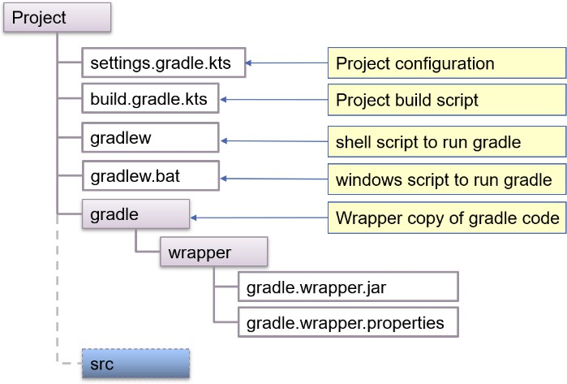Gradle is a build and automation tool implemented in Java and open source. It is used to build apps in different ecosystems (Java, Kotlin, C, Android).   
It is a **convention-based** tool that makes assumptions about the locations of source files, test files and resources (general vs tests). It supports **multi-project** builds, and it is customizable via **scripts** (scritti in kotlin o groovy). It supports dependency management by automatically downloading needed modules and libraries from listed repositories (library-version). The entire build process is described in one or more script files (build.gradle.kt -> insieme di step)

The **project script file** contains a description of the

build process in terms of **plugins** (define which tasks should be executed when we build a project), **repositories** (web sites from which libraries can be downloaded) and **dependencies** (list of libraries with their version that are part of the project) together with furtherconfiguration information.

A project is the description of how a given software artifact is built. Sometimes, more than one artifact needs to be built: in this case a build can have more than one project (multi-modules project). A project has one or more tasks and **plugins extend projects**. The project script file (*build.gradle.kts*) specifies all the tasks, while an optional settings file (*settings.gradle.kts*) provides build level information (i.e., pertaining all projects).

**The build system is triggered by a set of **commands**, each targeted to a specific goal. The set of all available task is accessible using the "tasks" task name. *Each task can depend on zero ore more other tasks: if Gradle is requested to execute a given task, all the tasks it depends on are executed first*.

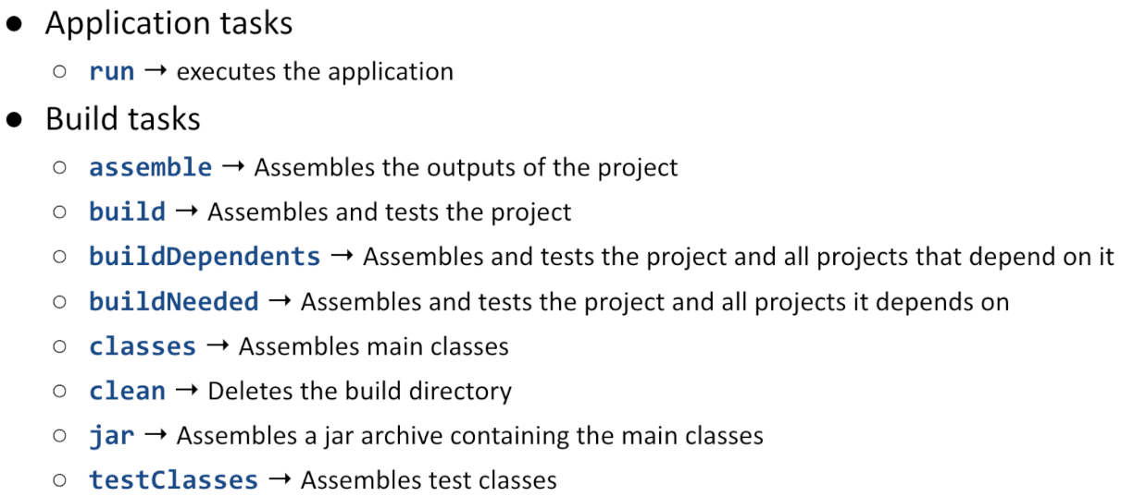

Plugins are software artifacts that extends project's capabilities that are Introduced by the plugins block. Each plugin can introduce custom tasks, set-up dependencies, trigger specific behavior.

By default, Gradle operates on conventions, so it expects source files to be located in folder "./src/main", test files in "./src/test". It is possible to deviate from these conventions by specifying proper entries in the project script file.

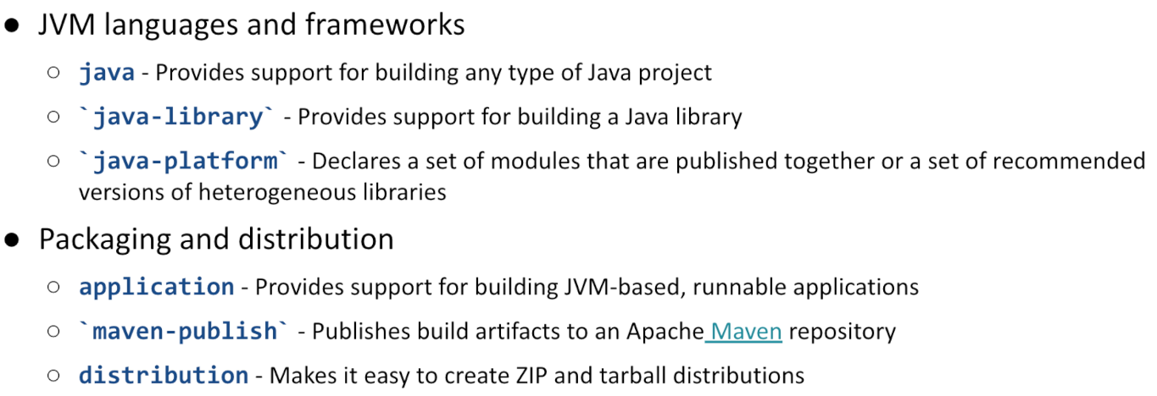By applying the 'application' plugin, the 'run' task becomes available and it allows to launch the artefact that has been built. The application plugin extends the java plugin, and the application block is used to specify the name of the main class.

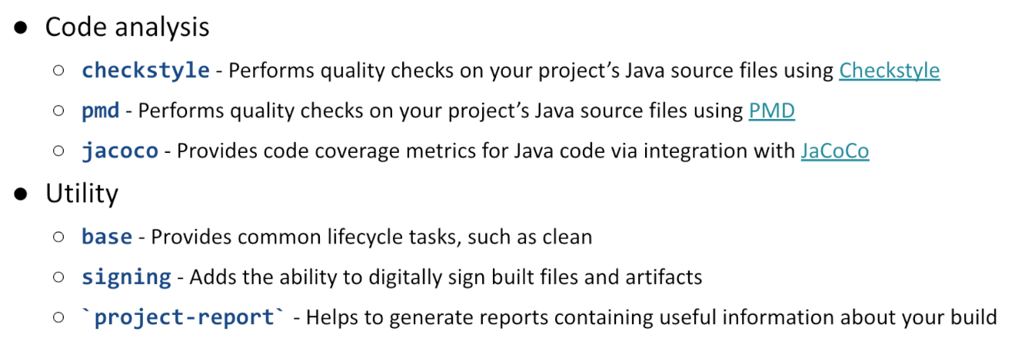When the java plugin (or any other plugin that extends it) is applied, the java block can be used to configure the compilation and runtime environments.

The kotlin plugin must be applied, specifying the language version. The kotlin block can then be used to specify alternates folder for source and test files, if needed. To define the proper jvm target version, the compileKotlin and compileTestKotlin tasks can be overridden.

A project often requires libraries or other externally provided resources. These are collectively named **dependencies**. Being out of control of the project, care should be taken to identify the correct **version** of the artefact and **location** where it can be downloaded from. Gradle allows to specify this information in different blocks: the **dependencies** block lists the artefacts needed by the project, together with their version while the **repositories** block list the web sites where they should be looked up. Dependencies can be located: In other projects, in the local file system, in Maven repositories or in Ivy repositories. Dependencies are needed

at **compile time** and all though the artefact's life; at **compile time only** (being provided form other sources at runtime); at **runtime only;** at **test compilation time;** at **test execution time**.

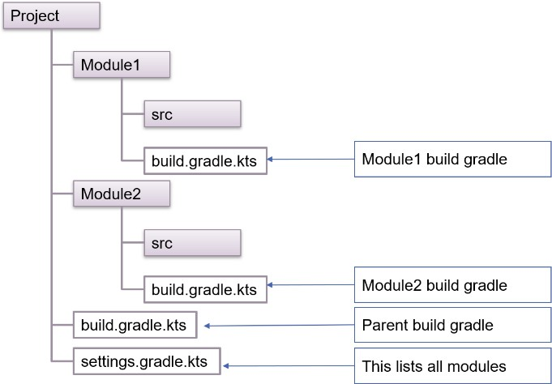Given a set of locations where dependencies may be downloaded from, two more pieces of information are needed: what exact piece of dependency is needed and in which phase of the build process it is needed. Dependencies are named out of three pieces of information: the **group name**, the **artifact name,** and the **artifact version.**

Most projects start with a single codebase and build script (build.gradle.kts) but, as they grow, they are often split into several interdependent modules to improve readability and maintainability.

A module is a sub-project that targets the creation of an individual software artifact (e.g., a jar file): modules have their own codebases, and they can have different dependencies.

Task execution

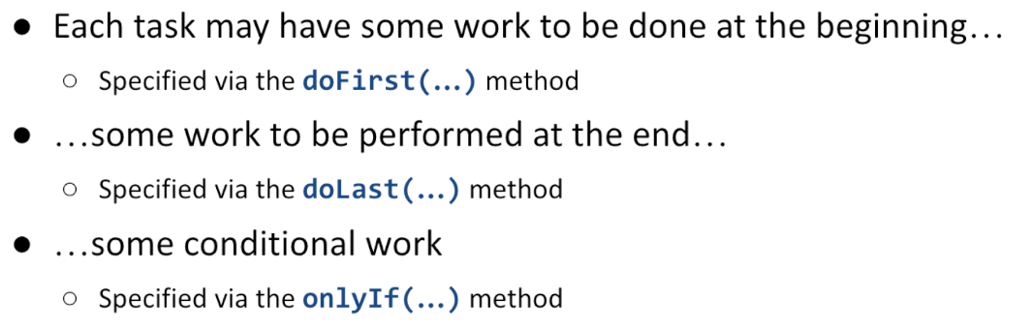

Task dependencies:

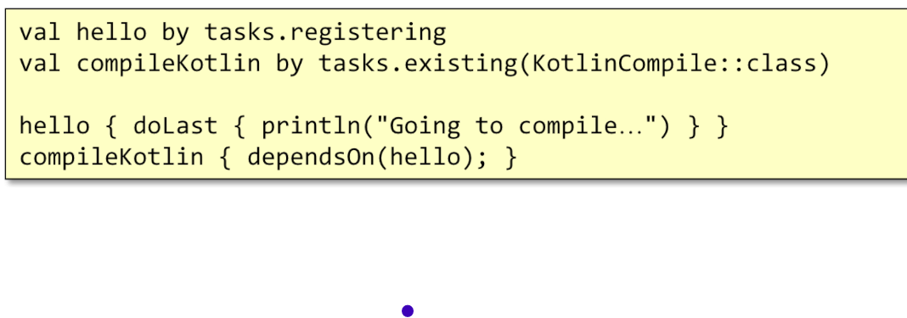Mi permettono di svolgere dei task particolari, usati solo in alcuni casi

* Ogni volta che runno compile kotlin, lancio prima hello

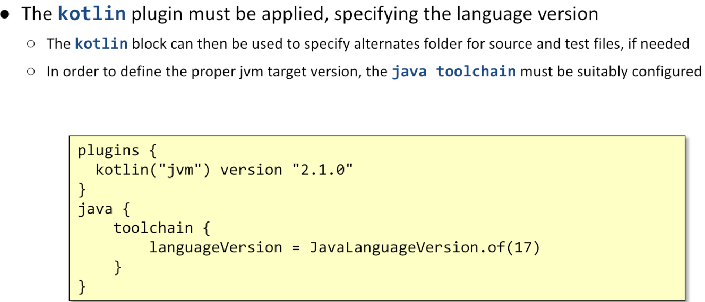

# Kotlin Annotations

Annotations are a special kind of class used to define custom metadata and bind them to other elements (declarations, expressions, functions) of the source code. Frameworks and processing tools use this feature to express configuration or to instrument code. Annotations are introduced by the @ character.

*The Kotlin language defines a syntax to declare an annotation class, a syntax to annotate source code, reflection APIs to access annotations bound to a given class, function, or expression, a standard way to store annotations in bytecode and a set of platform specific mechanisms to let the compiler access and process code annotations*.

Annotations can be used to:

* **Inform** the compiler about programmer intents and knowledge of possible misbehaviour

(@Suppress (elimina worning) , @UseExperimental (so che non è sicura questa versione ma ok) …)

* **Generate** extra code/data at compile/deploy time: using an annotation processor plugin, the compiler can be augmented with some extra-code that further processes the original content
* **Affect program execution**: using reflection, code can be inspected at run-time, detecting annotations, and behaving accordingly

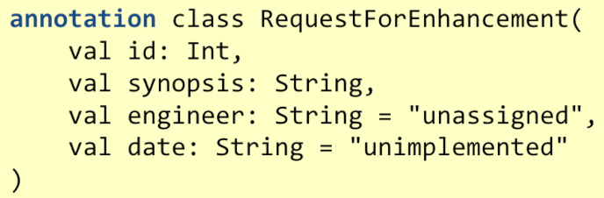Annotation classes implicitly derive from the Any class and the empty Annotation interface. Annotation classes can have neither subtypes nor supertypes, other than Any and **no code** can be placed inside an annotation (act as a container for their properties). Properties are **immutable** and **non-nullable**.

Annotation classes can be annotated with some special **meta-annotations**. These provide specify how the compiler should manage the declared annotation.

* 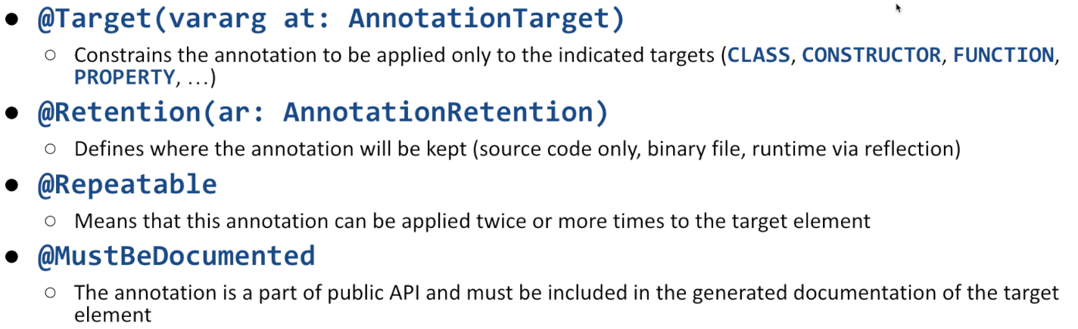restringe il dominio a cui può essere applicata
* Chi è interessato all’annotation (loader/compiler/runitime
* Quante volte deve essere esguita
* Se deve essere inserita nel javado

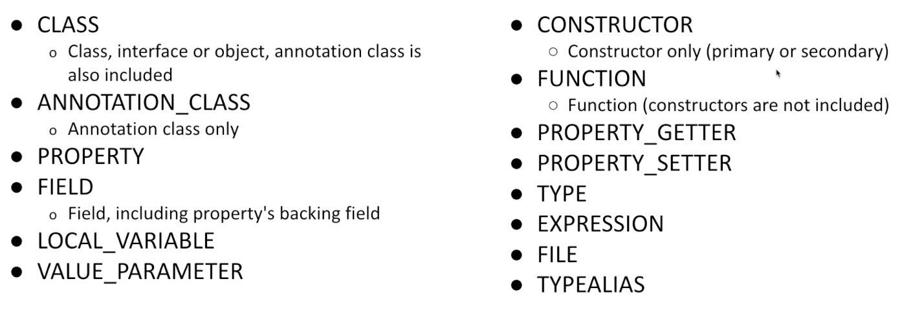Cosa posso annotare:

Annotations can be processed:

* At **compile time**, by using the kapt compiler plugin
  + Prima di runnare il compiler, leggi il codice sorgente e trova le annotation.
    - Applica a queste annotation l’extra code necessario
* By **inspecting compiled classes**, using a tool capable to process bytecode
* At **runtime**, via reflection

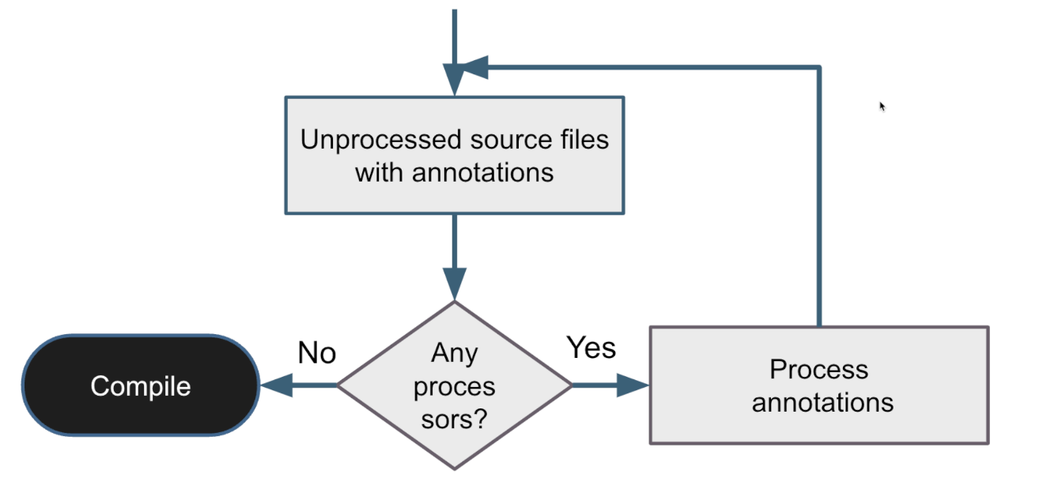In the precompile phase the Java compiler, that backs up the Kotlin compilation process, is capable of scanning annotations and can delegate their processing to a suitable plug-in. This can derive a new source file from the existing one, that will be further inspected and then compiled.

The 𝑗𝑎𝑣𝑎𝑥.𝑎𝑛𝑛𝑜𝑡𝑎𝑡𝑖𝑜𝑛.𝑝𝑟𝑜𝑐𝑒𝑠𝑠𝑖𝑛𝑔.𝐴𝑏𝑠𝑡𝑟𝑎𝑐𝑡𝑃𝑟𝑜𝑐𝑒𝑠𝑠𝑜𝑟 class can be extended to supply the custom annotation processing code. All annotation processors must extend the 𝐴𝑏𝑠𝑡𝑟𝑎𝑐𝑡𝑃𝑟𝑜𝑐𝑒𝑠𝑠𝑜𝑟 class and

𝑝𝑟𝑜𝑐𝑒𝑠𝑠(… ) is the core method. It must return true to state that annotations have been properly processed. Returning false, allows other processors to deal with the current annotations.

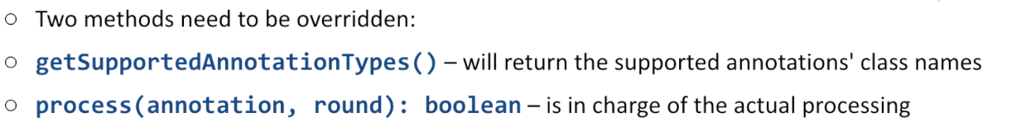The annotation processing happens in rounds. In each round, only some annotation may be considered: these are passed in the first argument. The second argument contains all the elements of the source file that contain one of the currently processed annotations.

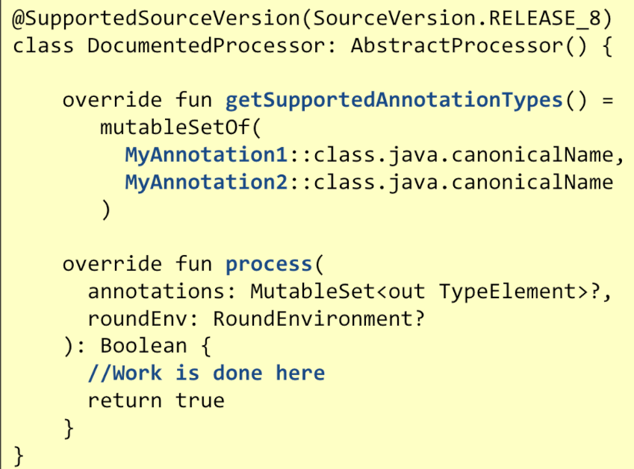

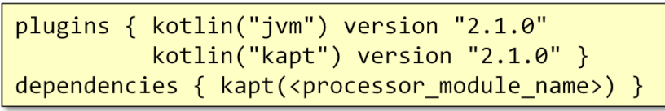To be available to the compiler, a Processor need to be included in a Jar file to be supplied at compile time. The Jar file must contain a *𝑀𝐸𝑇𝐴 − 𝐼𝑁𝐹/𝑠𝑒𝑟𝑣𝑖𝑐𝑒𝑠/𝑗𝑎𝑣𝑎𝑥. 𝑎𝑛𝑛𝑜𝑡𝑎𝑡𝑖𝑜𝑛. 𝑝𝑟𝑜𝑐𝑒𝑠𝑠𝑖𝑛𝑔. 𝑃𝑟𝑜𝑐𝑒𝑠𝑠𝑜𝑟* text file listing all the processor class names that should be considered by the compilation process. Moreover, the kapt plugin should be declared as part of the Gradle configuration.

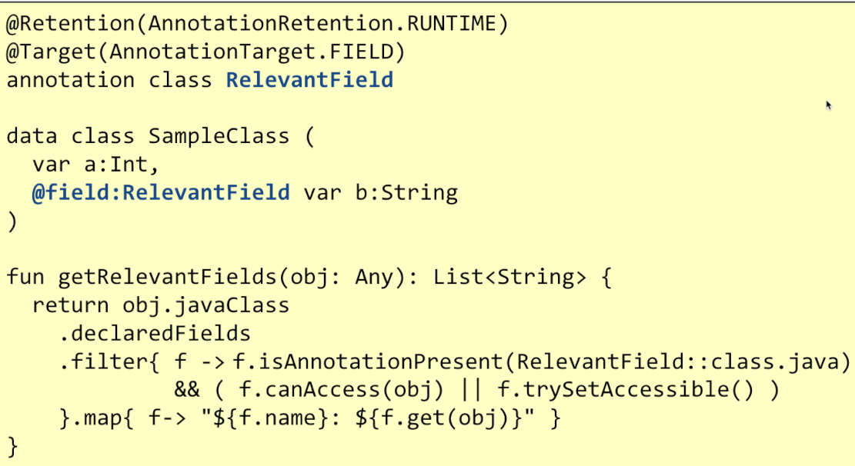If a given annotation has **runtime retention**, it can be processed via reflection. Given an object obj, it is possible to get a reference to its class via *obj.javaClass*. The Class object contains a lot of information about it, among the others the **set of annotations it was labelled with.** Annotation's properties can be accessed and used to guide computation.

Annotations provide a standard way to decorate code with meta-data and offer a powerful tool to support automatic data-structure and programming pattern generation. Annotations do not have any direct consequence on code semantics, but they allow to largely reduce the amount of boiler-plate code needed to implement repetitive patterns.

# Architectures of Web Applications

## Distributed systems

A distributed system is a system composed of two or more interconnected sub-systems that co-operate to achieve a common goal. The interconnection is supported by a network while communication is based on message passing.

The driving forces are:

* **Composability**: complex behaviour can be achieved splitting the whole into smaller, more manageable, loosely connected parts.
* **Scalability** – can deal with larger problems or larger number of users
* **High Availability** – can leverage redundancy to support partial failure
* **Resource sharing** – make available (location-, capacity-, …) constrained resources to larger audiences
* **Reusability**: existing services can be combined into new
* **Cost efficiency**: distributed systems can leverage commodity hardware instead of expensive centralized systems
* **Compliance and data localization**: requisiti legislativi possono richiedere che i dati siano storati in determinati limiti geografici

### The challenges of distributed systems are:

* **Complexity** in design, implementation, testing, deployment, operations mainly due to *concurrency*

(subsystems work in parallel), complex interactions, time dependence, …

* **Partial failures**: a single process is either working or broken. One or more subsystems can slow down, stop working or network may be partitioned, preventing communication.
* **Lack of a global clock:** coordination needs to be based on message exchange (which introduces a delay between the sender and the receiver)
* **Security:** it is possible to tamper with the system by injecting, removing, replacing, duplicating messages across the network. Extra complexity must be introduced to deal with this issue.

### Main attriubutes of distributed systems:

### A distributed system is characterized by a set of attributes that are interdependent: any attempt to maximise one of these will inevitably lead to reduce some other properties

### Consistency: all nodes in the system have a consistent view of the data (even in the presence of concurrent updates, failures, delays)

### Strong: all nodes in the distributed system see the same data at the same time

### *After a write operation completes, subsequent reads will always return the latest written value*

### Casual: the order of operations that are causally related is preserved

### *If one operation depends on another, the system guarantees that all nodes will see them in the correct order*

### Eventual: all nodes in the system will eventually converge to the same state, if no new updates are made

### *This weaker property reduces the need of coordination between nodes and favours increased availability and scalability as well as faster response times to the client application*

### *Availability: ability of a system to respond to requests from users or other systems in a timely manner, even in the presence of failures*

### Uptime*: the percentage of time the system is operational (99%, 99.9%, 99.99%, …)*

### Timely response: *in order to be considered available, a system must respond to user requests within an acceptable time frame, regardless of failures and workload*

### Fault tolerance: *availability implies the ability to tolerate and recover from hardware or software failures without significant service interruption*

### Graceful degradation: in cases of partial failure or resource constraints, the system may reduce functionality but remain available in a limited capacity

### Partition tolerance: The system's ability to continue operating correctly even when communication between some of its components is disrupted due to a network partition

### Deve scegliere se favorire consistency o availability

### Consistency: blocco, aggiorno per tutti e poi sistema di nuovo online

### Availability: per un po’ info diverse

### Quando si risolve una partition, bisogno riconcilliare facendo i corretti aggiornamenti

### Latency: The time it takes for a request to travel from the source to its destination and for a corresponding response to be received

### Delay in milliseconds

### Sum of:

### Propagation delay: time for travel across a phisical medium

### Transmission delay: time needed to transimt a message, based on the data size and the transmission rate

### Processing delay: time needed to the receiver to process the request and generate a response

### Queuing delay: time spent qaiting in queues when resources are oveloaded

### Scalability: the ability of a system to handle an increasing amount of work or accommodate growth in demand by adding resources; without losing performance

### Elasticity: scale-up/down in risposta alle necessità

### Performance consistency: mantenere performance anche con incremento del carico

### Resource efficiency: risorse aggiuntive usate in modo effettivo, senza sprechi

### Predictable behaviour: il comportamento del sistema può essere predetto e anticipato

### Reliability: The ability of a system to perform its intended functions correctly and consistently over time, even in the presence of failures

### Correctness: sistema ritorna risultato corretto, errori non causano corruzione dei risultati.

### Fault tolerance: sistema rimane operativo e gestisce i fallimenti

### Resilienza, ridondanza, error detection e recoveri…

### Graceful degradation: blocco parte del sistema

### Error recovery: abilità di recuperare dai fallimenti e tornare a operazioni normali

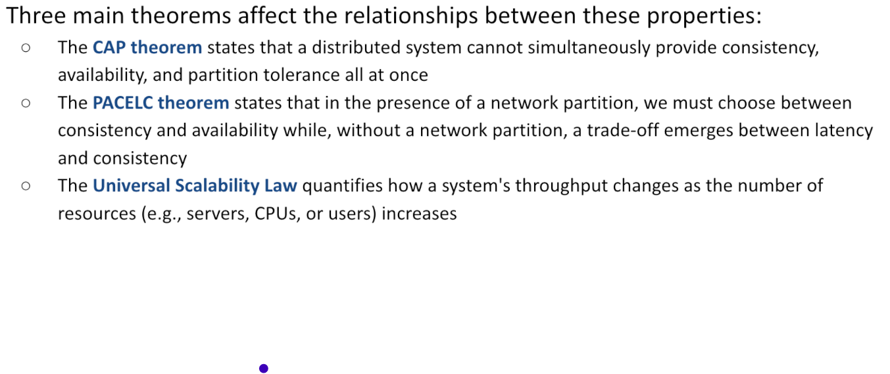

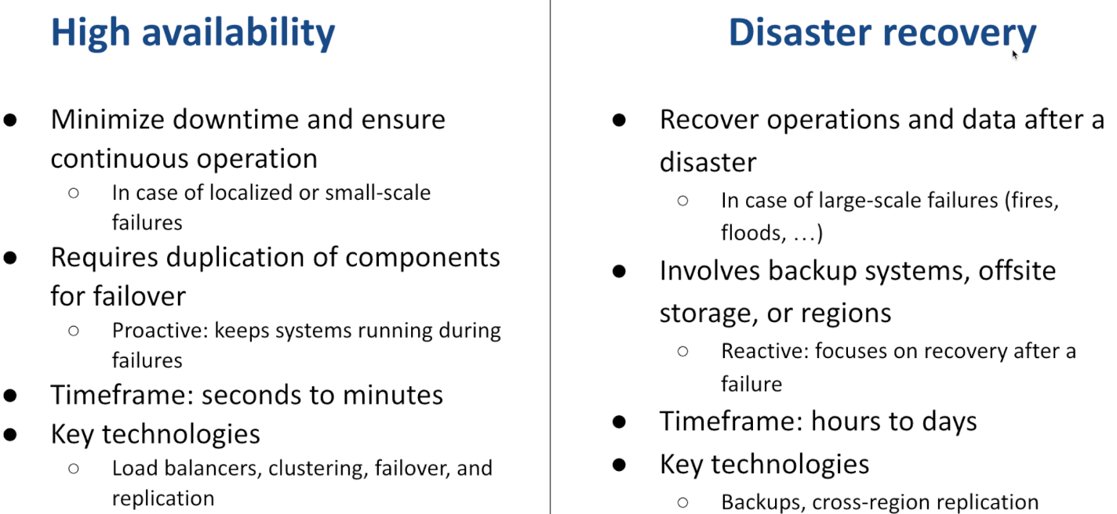

Reliable distributed systems

To overcome the challenges, and benefit from the opportunities provided by the distributed paradigm, a **proper architecture** must be chosen as well as be sure that each of underlying subsystem support a bunch of properties that make them **robust** and **reliable** on their own. Moreover, care must be taken not to fall in one of the well-known fallacies of distributed systems that have been distilled along the years by the developer community.

## Governing distributed systems evolution

Bisogna mantenere un controllo sull’evoluzione dei sottosistemi e una documentazione comprensiva.

* Gestione tramite un Version Control System (es: git)
  + Monorepo: va bene per piccoli team, semplifica gestione dipendenze e assicura consistenza
  + Polyrepo: va bene per grandi team o servizi loosely-coupled, permette evoluzione e deployment indipendenti
* Bisogna definire una modalità per gestire cambiamenti e relases:
  + GitFlow: creo branch, lavoro per un po’ (un po’ tanto) e poi mergio sul principale
  + Trunk-based: ognuno crea proprio branch, piccola modifica e poi mergia
* Bisogna efffettuare code reviews prima del merge
* Automatizzare testing e validation come parte della pipeline CI/CD
* Usare semantic versioning (M.m.p) per comunicare impatto dei cambiamenti:
  + 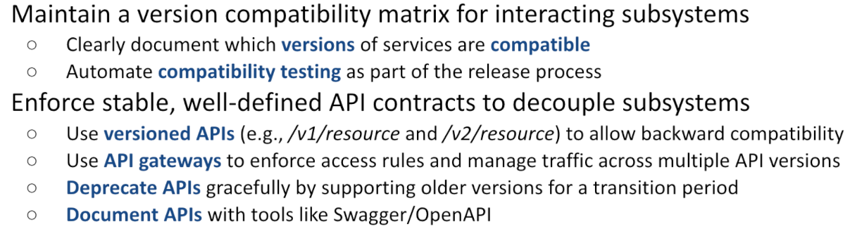MAJOR: breaking changes
  + MINOR: aggiunto nuova feature, compatibile con versione precedente
  + PATCH: fix bug, compatibile con versione precedente
* Minimizzare e gestire dipendenze tra sottosistemi
  + Dependency injection per gestire dimanicamente e isolare dipendenze
  + Mantenere un registro interno delle librerie e dei servizi approvati per standardizzare le dipendenze
* Gestire cambiamenti a db e al data-model in modo tale che siano backward-compatible
  + Usare schema migration tool (come Flyway o Liquibase) per applicare cambiamenti
  + Applicare cambiamenti che aggiungono piuttosto che distruggere
  + Mantenere un sistema di versionamento dello schema
* Adottare strategie di sviluppo ben definite

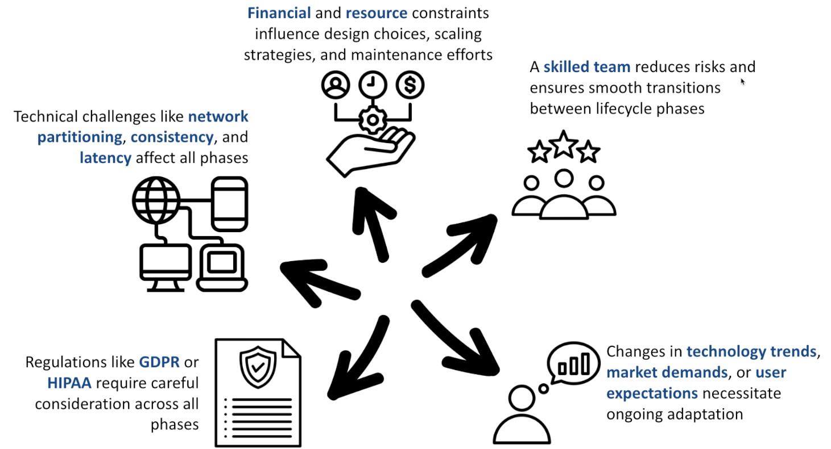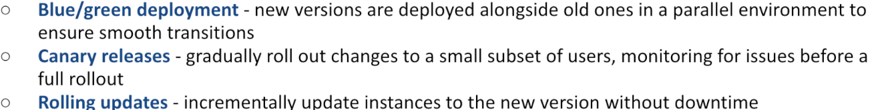

## Design phase challenges:

* Domain partitioning:
  + Come dividere servizi e componenti
  + Trade-off
* Consistency vs Availability
  + CAP theorem implications
* Faul tollerance e ridondanza
  + Replication vs not
  + Come gestire inconsistenze interne
* Scalabilty planning
  + Orrizzontale -> aggiungere nodi
  + Verticale -> aggiornando le risorse

## Development phase challenges

* Gestione dello stato:
  + Componenti statefull vs stateless
  + Dove è salvato lo stato (db, file-system, distributed file system)
  + Come vengono gestiti sincronizzazione e recovery dello stato
* Concurrency control
  + Se due persone nello stesso momento, volgiono modificar ela stessa cosa, bisogna dare la priorità ad uno
  + Che approccio usare (distributed lock, algoritmi di consenso, etc)
  + Ci sono race conditions o deadlocks?
* Testing for failures
  + Cosa accade in caso di crash di nodi?
  + Cosa succede se c’è una partizione di rete?
  + Come l’alta latenza impatta sul nostro sistema

## Deployment phase challenges

* Deployment strategies
  + Come avviene lo sviluppo di un nuovo componente?
  + È possibile effettuare un rollback di uno sviluppo?
* Configuration management
  + Supporto per gestione centralizzata
    - Firewall e altre cose per proteggere accessi
  + Consistenza tra nodi
  + Caricare programma su server e configurarlo per fare in modo che funzioni
    - Docker conteiner: funziona su singolo host
    - Kubernetis
* Service discovery
  + Come sono localizzati gli altri servizi in un environment in cambiamento
* Distributed logging and monitoring

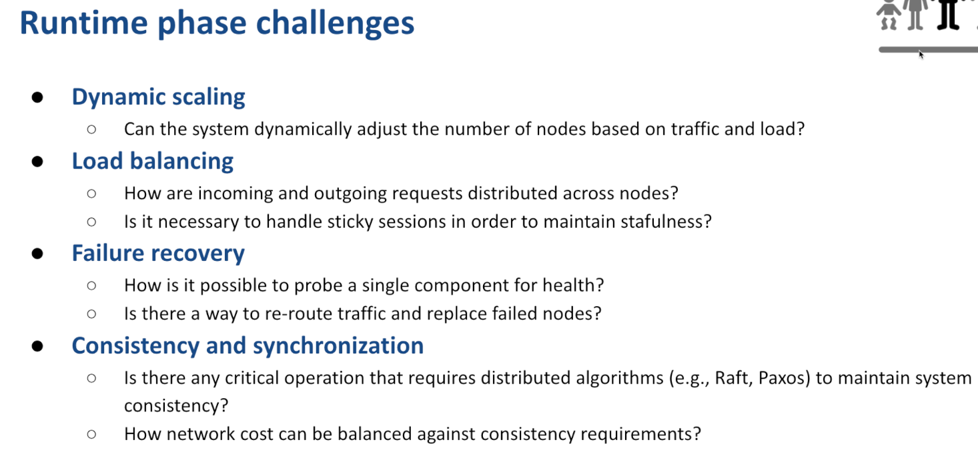

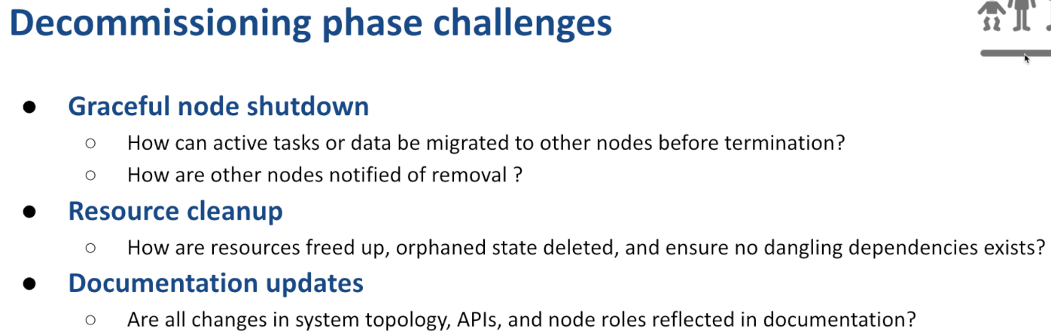

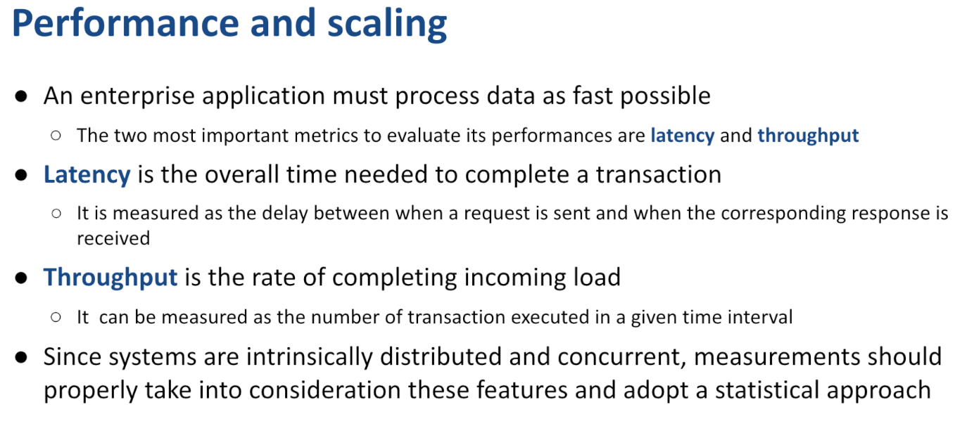

* Alcune volte misurato client side, altre volte misurato user side
* System point of view

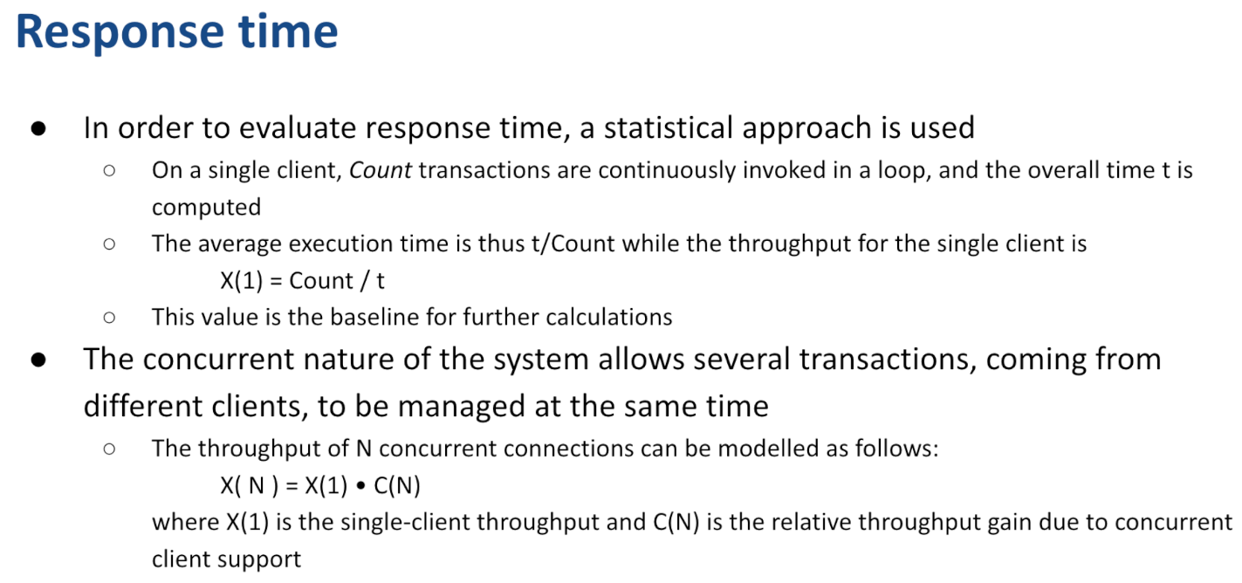

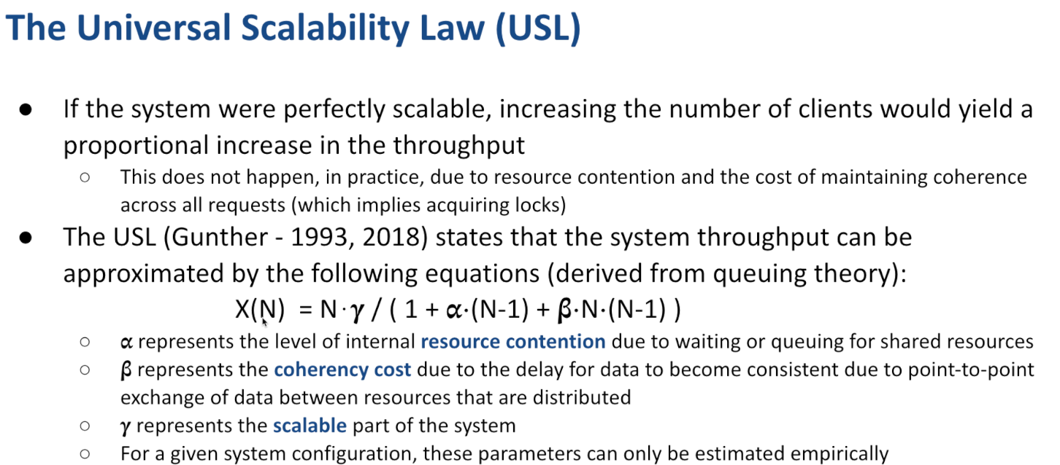

*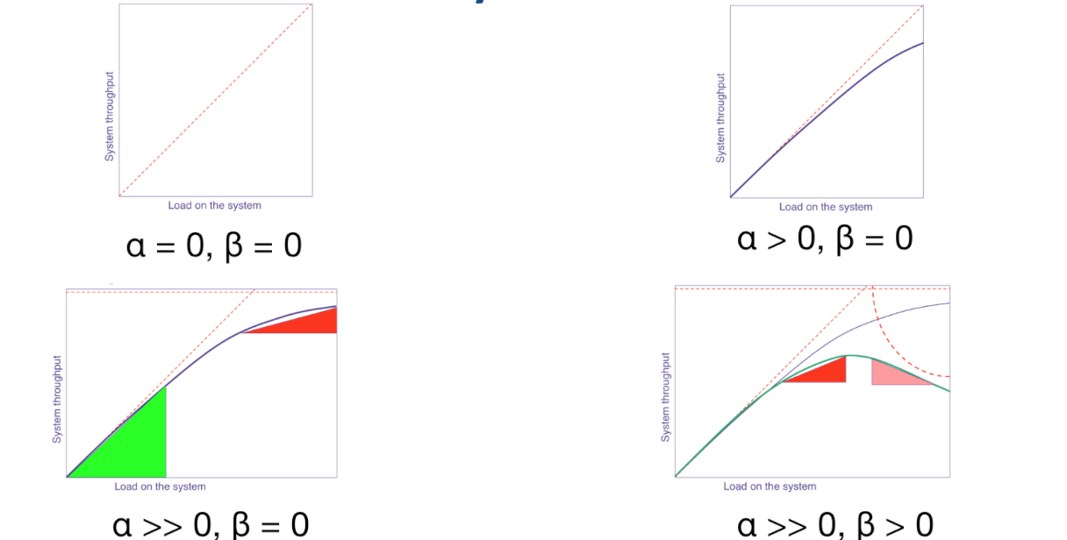  
  
Impossibile avere alpha e beta =0*

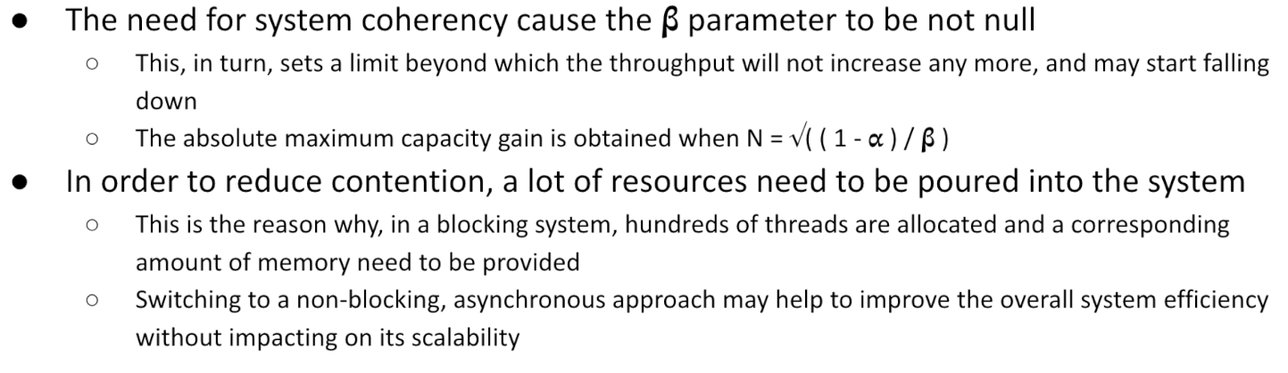

Dopo aver creato il web server, si può usare Apache Bench per ottenere delle misurazioni riguardanti il comportamento del nostro sistema.



Queste statistiche possono essere valutate con la libreria codahale

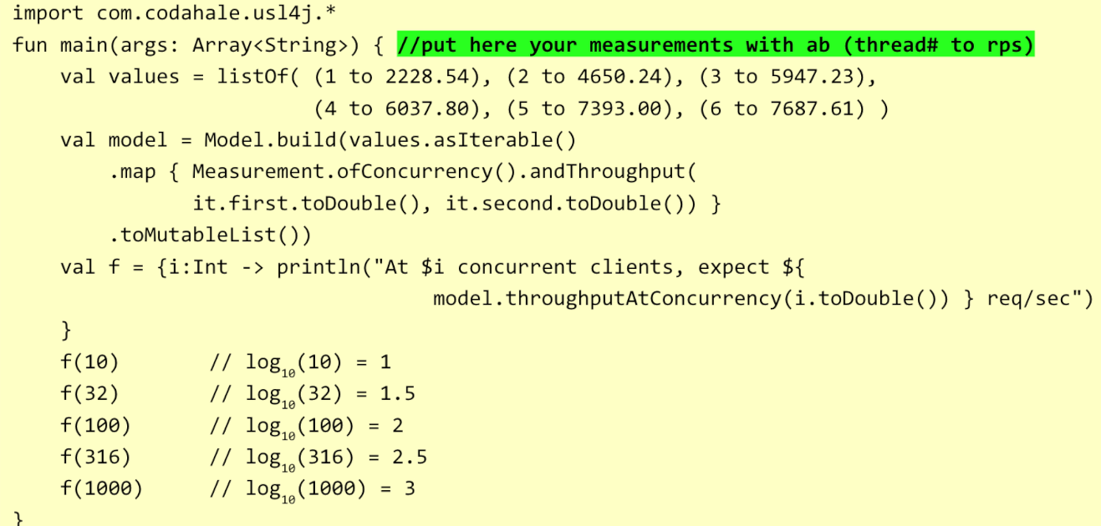

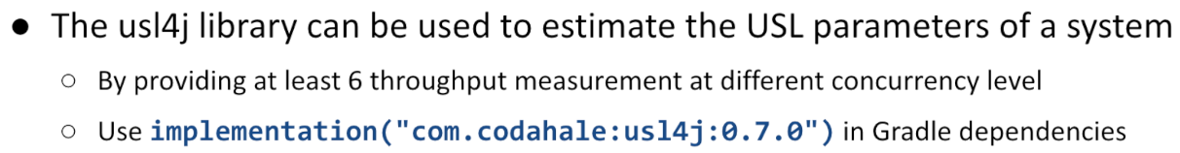

# **Software architecture**

The software architecture of a given product/service defines:

* the **fundamental structures** of a software system
* the **software elements** they are made by
* the **relationships** among them
* the **properties elements** and **relationships** have

This high-level picture helps making the major design choices and evaluate their implication by choosing the proper compromise in terms of both functional and non-functional features the system must exhibit.

## Reliable application properties

* **Idempotence:** an application will not duplicate the effect if it receives a duplicate message. Helps dealing with unreliable communications
* **Immutability:** no data is ever overwritten, nor it is deleted: information increases *monotonically*. It helps keeping a record of what happened in a system
* **Location independence:** the behaviour of an application does not depend on where it is deployed. It helps composing the overall system out of single parts
* **Versioning:** an application will tolerate changes over time of the data it manages and of the behaviour it exerts. It helps dealing with change.

**Fallacies** of distributed systems (by Peter Deutsch, 1994): -> Falsità

* 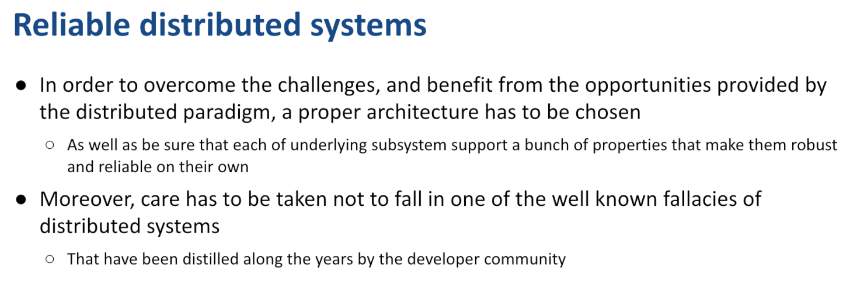*The network is* ***reliable***
* ***Latency*** *is zero*
* ***Bandwidth*** *is infinite*
* *The network is* ***secure***
* ***Topology*** *does not change*
* *There is one* ***administrator***
* ***Transport*** *cost is zero*
* *The network is* ***homogeneous***

## Embracing failures

System must be designed knowing that something can always go wrong, so all **problems must be detected** and failing services should be restarted. Moreover, clients should not send requests to failed component instances and when problems are corrected, request must be resumed: this implies that client must be **resilient**. Dealing with these problems manually is not feasible, if the number of services increases. **Orchestrator** platforms like Kubernetes are used to this purpose.

## Network unreliability

**API calls** are not like a function call, because a function call will either succeed (returning a result) or fail (throwing an exception or returning an error code). In a network communication, the request may not reach the recipient (thus never being processed), or the response **can fail** to reach back the invoker (preventing the result of the remote computation from being known to the caller). **Timeouts** need to be introduced to deal with this kind of failures, but they only allow to detect the problem.

Implementing **idempotent APIs** helps addressing the problem:

* **REST based architectures** tend to be error-prone since they allow POST messages which need not to be idempotent by design.
* **POST methods** are typically used to create new resources in the recipient, returning the identifier of those resources: if such ID is generated on the server-side, **idempotence is violated**.
  + PUT: idempotente, update operation
  + POST: non idempotente, inserimento, creare nuovo

## Topology changes

People tend to assume that resources (e.g., a centralized DBMS) are stable and there is no need to fail over to a backup one. **Location independence**, on the other side, assumes that if the same message is sent to multiple instances of the same application, they must all produce the same effect.

DBMSs generating auto-increment IDs tend to break this rule: the generated ID is dependent on the location where it is produced. Again, client-generated IDs (UUIDs) and content-addressed storage (hash-based IDs) helps solving with this problem.

## Network inhomogeneity

Since systems evolve across time, it is possible that **multiple versions of the application exist at different locations**, so software artifacts (code, data, APIs) need to be explicitly **versioned**.   
CVSs make it simple to manage code versions together with CI and CD pipelines.   
**Versioning data** is more complex since it can entail handling different DB representations.   
**Versioning APIs** is the most challenging one: while several options exist, no one is perfect.

## **Web applications**

Web applications are a kind of distributed systems leveraging on **ubiquitous standard web technologies** (the HTTP(S) protocol, browsers) to reach the widest audience and limit deployment costs to the server-side only. This provides a large opportunity and a constraint at the same time: since it prescribes part of the design choices, forcing to adopt existing tools, losing some flexibility.

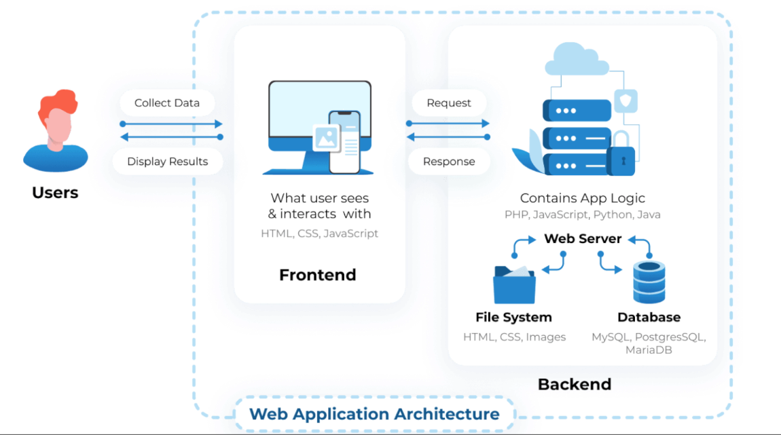Web applications support users in performing business tasks according to some specific business logic. Their distributed nature automatically provides **concurrent access**, raising the complexity of the system. **Business logic** specifies how the information managed by the application is **transformed** and/or **computed** (e.g., business logic determines how a tax total is calculated from invoice line item) and specifies how it is **routed** to people or software systems (workflow).

## Web application design

Web application design is a broad process spanning across many different domains and covering multiple dimensions. It is aimed at defining the **purpose** and **behaviour of the system** and making suitable choices about its **architecture** and **implementation**.

Design can be split into:

* **High level design** – where a suitable architecture is chosen, and major system components are identified (overall architecture)
* **Module level design** – where each single component is defined, pointing out its functionalities, constraints, and implementation-level details

## Software architecture

Software architecture describes the major components of a system, their relationships, and how they interact with each other. A **given architecture** provides an abstraction to manage the system complexity and establish communication and coordination among components. It helps define a solution to meet all the functional, technical, and operational requirements by trying to **balance diverging forces** like cost, time-to-market, performance, maintainability, overall quality, and security.

## Immagine che contiene testo, schermata, diagramma, cartone animato Il contenuto generato dall'IA potrebbe non essere corretto.Web application architecture

The client tier is usually hosted in a web browser. It offers a generic, sandboxed, execution environment suitable to display the graphical user interface (GUI) and providing easy access to the remote system via HTTP. Modern browsers typically offer very high performances both in computing and in presenting media content (2D and 3D graphics, audio, video), as well as in network communications.

In some cases, the client tier may be implemented as a full-fledged application thus allowing to overcome the limitations placed by the browser sandbox.

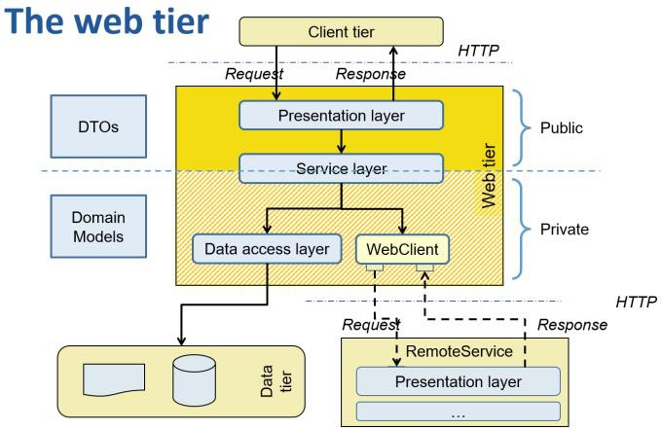The **server tier** is often built using a **layered approach**, as well. Each layer only interacts with the adjacent ones, limiting mutual dependencies and specifying contact points in term of software interfaces. Such an approach boosts code modularity and separation of concerns among modules. Layers can be part of a single, monolithic, process or can be implemented as separate (micro-) services.

Each layer is responsible for a very specific task and relies on the layer(s) immediately below, for further processing. The contact point between two adjacent layers is usually specified via a **software interface**. Since HTTP is stateless, the whole web tier can – in principle – be replicated in many different instances, to scale horizontally. A **load balancer** can be used to evenly spread requests among all available processes.

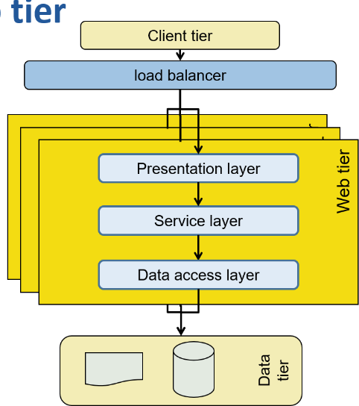The **presentation layer** is in charge to process all **incoming requests** and producing suitable **responses**. It is compliant to the HTTP standard, so requests have verbs (GET/POST/PUT/DELETE), URLs, headers and (sometimes) a body.

Requests come **concurrently** from **multiple clients**: session IDs may be used to track and relate requests coming from the same client. Arrangements need to be made if multiple instances of web tier are present.

Sometimes, I need to **maintain an history of invocation** because the web protocol is stateless by itself but application are not stateless (es: I should remember that an user logged in) -> typically done using http **session**: piece of information kept in to the server and tagged with an unique label -> sent back to the client as a **cookie** (small string that the browser receives and add authomatically to each request for that server).

Generated responses can consist of full pages or be just data structures presented on the client side by some kind of presentation logic (SPA – Single Page Application).

The **service layer** implements the application business logic. It defines the logical contract between the user and the application, but it has none of its side effects, which are delegated to the underlying layer.

Elementary operations defined by application logic maps 1:1 to the methods it provides. They coordinate the execution, in a transactional way, of the various data manipulations defined by the business logic. Since the operations need to be atomic (because of the transaction), the service layer is often **state-less**.

*(@Service @Transactional)*

The service layer manipulates **Data Transfer Objects** (DTOs): they contain the **public representation** of the concepts coming from the application domain. DTOs will be mapped to the underlaying representation defined by the data tier (i.e., **Domain models**) by suitable functions (object mappers).

Care must be taken not to leak any information pertaining to the data tier out of the service layer: this makes the layer testable and mockable.

**Domain models** represent domain concepts in a way suitable for the chosen data tier. According to it, they can be named **entities** (when using RDBMS), **documents** (in some noSQL DBMS), or **nodes** and **edges** (in case of graph DBMS).

The implementation of this representation, being it **private**, may undergo relevant tuning actions, to improve the performance of the system while guaranteeing that the business rules are preserved.

The **data access layer** persists and retrieves entities or documents into/from the data tier:

* It is responsible to **issue basic commands** to the data layer (e.g., SQL statements or other kinds of DBMS languages)
* Its **implementation** is often **automatically derived** from some high-level description of the task to be

carried out (basic CRUD operations, custom searches, …) by specific frameworks (ORM or ODM)

* It usually assumes that manipulated entities are labelled with a **unique ID**

The **data tier** is typically based on one or more DBMS in charge of persisting with the application data and guaranteeing its consistency with respect to the model and business constraints. Different kinds of DBMS may be used: relational (SQL based), document-, graph-based. Sometimes, files and file systems may be part of the data tier: this may introduce some rigidity in managing the physical deployment of the tier.

## Software components

Software components are high level elements which provide a well-defined functionality/behaviour:

* **DBMSs** (relational and not)
* 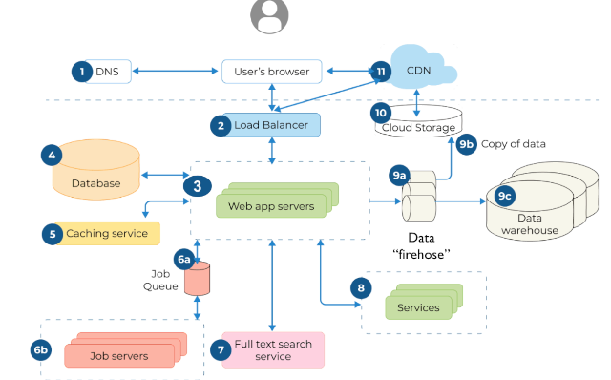**Message brokers**: tools that are capableof sotring in a transactional way, messages that need to be forwarded to a set of consumers – Apache kafka
* Cache servers:
* **Load balancers**: spread the request against a set of sources
  + **Api gateways**: distributes the coming requests to a set of possible targets, differentiating also across the kind of request path as well as performing a set of common concern (logging, tracing, security..)
* Backend application servers
* User interfaces

Each component may exist as a stand-alone process or be provided as a library to be integrated into another component. The number of processes to be deployed and monitored may grow fast and overwhelm operations.

## Web application models

Some web applications models are:

* **One application server, one database** also known as the **monolith**. This is the simplest and less reliable model -> one single process.
* **Multiple application servers, one database:** more reliable and potentially scalable, this model requires a stateless design of the server application -> with load balancer that guarantee that incoming request are evenly distributed.
* **Multiple application servers, multiple databases:** most reliable and complex model, since the multiplicity of databases introduces the limitations of the CAP theorem
  + I need to guarantee consistency

## **Microservices**

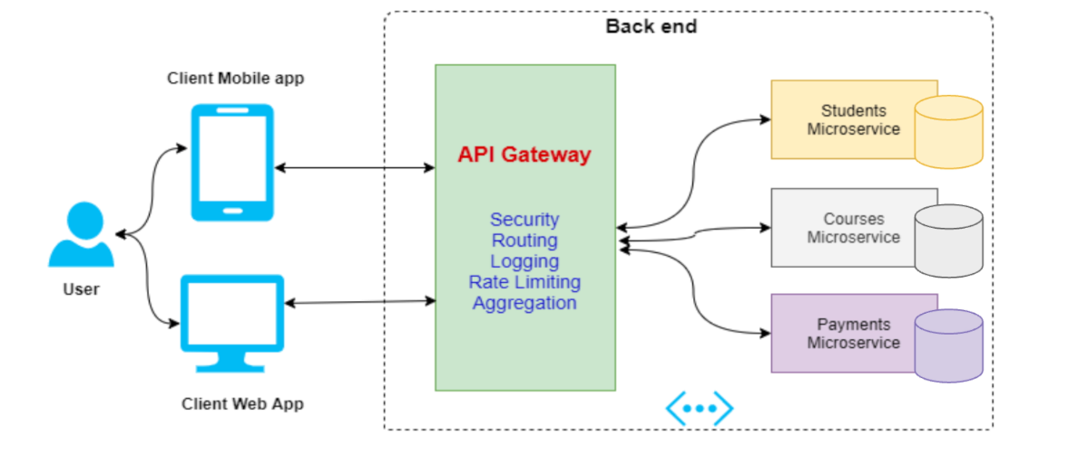Instead of having servers that are replicas of each other, we can choose a different approach: microservices based.

We can split the application logic into smaller functionality.

## **Distributed state**

**State** is “*a condition or stage in the physical being of something*” (Merriam-Webster). Virtually everything has a state, and, in computing, this is useful to make decision or take actions.

In a **centralized world**, state is represented as a set of values stored in some object. The state evolves because of events and values can be "atomically" updated to reflect the evolution of the system.

In a **distributed system**, each process can have its **own copy** of the state.

* Since event propagation requires time, these copies can become **incoherent** and lead to diverging decisions.
* Locking may be introduced to limit divergence, limiting scalability.

Distributed state issues:

### Strong consistency

* + How to make the state synced across the nodes such that all nodes return the same state even if queried separately?

### Staleness/freshness

* + Is the state returned older than the state at other nodes?

### Distributed transactions

* + How to roll back to previous state in case of part of the workflow failed?
  + ACID: Atomic, Consistent, Isolated, Durable
  + Two-fase commit protocol: funziona ma troppo lento
    - Molte volte si opra per obtimistic

## Performance issues

* Most heuristics that apply in monolithic applications are not suitable in a distributed environment, since the time scale is largely different, when seen from the CPU vintage point
* Unfortunately, it is difficult for the designer easily grasp this time scale, since the involved delays are often too far from the everyday experience to be suitably appreciated
* In order to grasp the problem, it is useful to adopt a scaled-up version of the delays

## Synchronous vs asynchronous programming

Computing systems are often designed based on a **synchronous pattern.** Sides effects are produced by function calls that block the invoker until the effect is ready, returning the outcome of the operation.

Some operations may block the execution for an unknown amount of time

* Anything concerning I/O and networking
* delay functions
* synchronizations

This may lead to a large **waste of time**.

Keeping a thread blocked while waiting for their outcome, makes the code **easier to be written** and maintained since it is possible to adopt an imperative coding approach, since the current computation remains "**stable**" (i.e., variables keep their values, the history of function invocation does not change, …) while waiting.

To **support many concurrent requests**, many **threads need to be pre-allocated** and whenever a new request arrives, a thread is selected to deal with it. If the thread blocks, other incoming requests will not be affected since they will be managed by a different thread. Once the request is done, the thread returns to the pool, and can be selected for managing other requests. Unfortunately, this approach requires a **lot of resources** since each thread need to be pre-allocated together with its execution stack.

## Performance and scaling

An enterprise application must process data as fast as possible. The two most important metrics to evaluate its performances are **response time** and **throughput.** The response time is the *overall time needed to complete a transaction* while the throughput is the *rate of completing incoming load*, which can be measured as the number of transactions executed in each time interval. Since the system is intrinsically distributed and concurrent, measurements should properly take into consideration these features.

## Response time

To evaluate **response time**, a statistical approach is chosen:

* On a single client, *Count* transactions are continuously invoked in a loop, and the overall time t is computed
* The average execution time is thus 𝑡

𝐶𝑜𝑢𝑛𝑡

while the throughput for the single client is

𝑋(1) = 𝐶𝑜𝑢𝑛𝑡

𝑡

* This value is the baseline for further calculations

## Throughput

The concurrent nature of the system allows several transactions, coming from different clients, to be managed at the same time. The throughput of N concurrent connections can be modelled as follows:

𝑋(𝑁) = 𝑋(1) × 𝐶(𝑁)

Where 𝑋(1) is the **single-client throughput** and 𝐶(𝑁) is the **relative throughput gain** due to concurrent client support. If the system were perfectly scalable, increasing the number of clients would yield a proportional increase in the throughput. This does not happen, in practice, due to resource contention and the cost of maintaining coherence across all requests (which implies acquiring locks).

## The Universal Scalability Law

The Universal Scalability Law (Gunther – 1993, 2018) states that scalability (i.e., the system throughput as function of system load) can be approximated by the following equation, derived from queuing theory

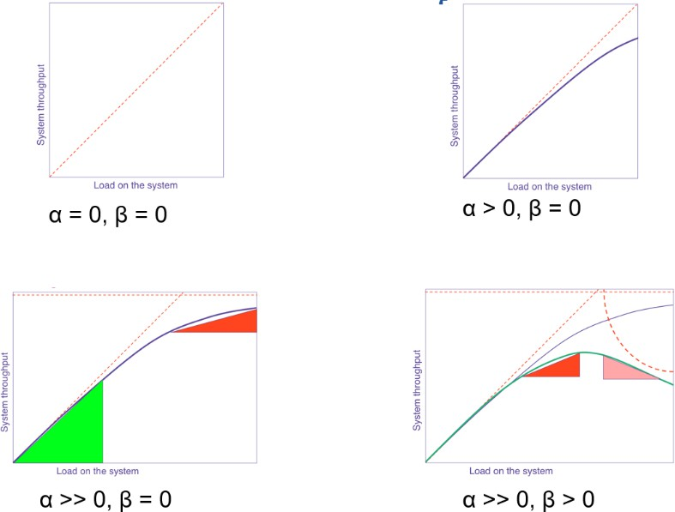𝑁𝛾

𝑋(𝑁) =

1 + 𝛼(𝑁 − 1) + 𝛽𝑁(𝑁 − 1)

Parameter 𝛼 represents internal resource **contention** due to waiting or queueing for shared resources. Parameter 𝛽 represents the **coherency cost** due to the delay for data to become consistent due to point-to-point exchange of data between resources that are distributed. Parameter 𝛾 represents the **scalable** part of the system.

The need for system coherency, cause the 𝛽

parameter to be non-null. This, in turn, sets a

limit beyond which the throughput will not increase any more, and may start falling. The absolute maximum capacity gain is obtained when

𝑁 = √

1 − 𝛼

𝛽

To reduce contention, a lot of resources need to be poured in the system. This is the reason for which, in blocking system, hundreds of threads are allocated, and a corresponding amount of memory need to be provided.

The *usl4j* library can be used to estimate the USL parameters of a system by providing at least 6 throughput measurement at different concurrency level.

# **Spring Boot**

In the object-oriented programming approach, an application consists in a set of objects that interact to provide/consume services. Each object encapsulates a part of the state, and it can contain references (dependences) to other objects.

Application code typically mixes pure **business logic** (expressed via the class hierarchy and the methods each class offers) and **configuration** (object instantiation and bindings).

This increases complexity and makes it difficult to maintain and evolve the code base.

## Splitting an application into stand-alone components

Choosing and connecting dependent objects can be extracted from procedural code and transformed into declarative knowledge.

The Spring framework provides a set of **abstractions** and **mechanisms** that allow us to **instantiate**, **assemble**, and **manage** the life cycle of elementary components to create the final application.

The programmer is responsible for defining the class of each component (named **bean**) and declare (via **annotations**) its configuration. The framework will inspect the annotations and generate the glue code that is necessary to make the system work.

## The Spring framework

The main element that allows this behaviour is named "**container**" or "**application context**". It stores a reference to all components the application is based upon, controls their life cycles, and is in charge of retrieving and connecting them one another. The container represents the **core of an architecture**, consisting of many more layers resting on top of it.

One of these layers, **Spring Boot**, offers a mechanism to **simplify** and **speed up** the creation of applications based on a single-entry point.

## Spring Boot

Spring Boot is a compact and easy-to-learn **framework for developing (web) applications**. It targets fast development based on conventions and **opinionated** assumptions. When required, conventions can be overridden with suitable configurations. It provides a set of pluggable, **ready-made** building blocks, easy to customize and assemble together with custom code. Code is selectively provided based on deduction of what might be necessary inspecting the class path and the project properties.

All available components (explicitly provided by the programmer or implicitly provided by the framework) are automatically wired together based on their type and on their annotations. This design pattern is known as **convention over configuration**. Spring Boot also provides support for building the entire project as a single, fat JAR file, including all the dependencies thus simplifying the deployment in container-based environments.

## The Gradle Boot plugin

The Spring Boot Gradle Plugin provides Spring Boot support in Gradle: it **merges all project jar files** in a single executable jar archive. It looks in the project for the 𝑚𝑎𝑖𝑛() function signature and makes it the jar entry point. It automatically applies the *Dependency Management Plugin* and configures it to import the spring- boot-starter-parent BOM. This allows to omit version numbers when declaring dependencies that are managed in the BOM.

## Starter packs

Spring Boot provides over 100 starter packs which offer a curated collection of libraries and configurations aimed at solving specific problems:

* **Web programming** (both in blocking and non-blocking versions), access to SQL and NoSQL DBMS, real-time messaging, security, I/O, caching, cloud-based support (configuration, discovery, routing, security)
* When a dependency on a specific starter pack is added to the project, Spring Boot will automatically configure and instantiate the components contained therein, based on **opinionated assumptions**.

## Program structure

Independently of the application kind (stand-alone, web), a Boot program has a **single-entry point**. If necessary, a (reactive) embedded web server is automatically added to the project and started.

How can a single annotation allow to configure, assemble, and activate a complex system made of many layers (controllers, services, repositories, message handlers, …), properly wiring them together? In order to understand what happens behind the curtains, it is necessary to step back and examine the basic principles upon which the Spring framework is based.

## The Spring Framework

The framework core is based on the following concepts:

* **Inversion of Control (IoC)**
* **Dependency Injection (DI)**
* **Aspect Oriented Programming (AOP)**

Differently from other frameworks, Spring heavily relies on **POJOs** (POKOs) that means **Plain Old Java (Kotlin) Object**. That is, most components are recognized and used because of what they **declare to do**, rather than for what they are (their inheritance hierarchy).

## Data coupling

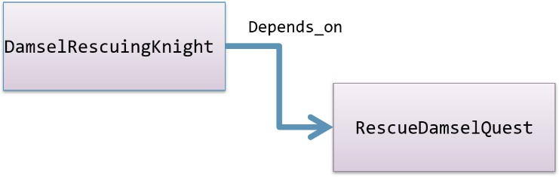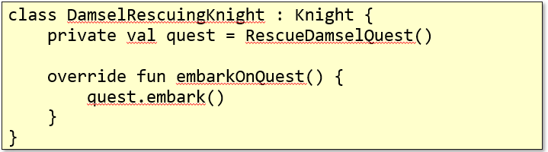All object-oriented applications are based on a set of objects that interact according to some logic. In traditional application, each object is responsible to obtain all the references to the other objects it needs to interact with: these are called "dependencies".   
This leads to create tightly coupled applications (data coupling).  
The first class depends on the second one: it cannot be compiled, tested, deployed if the other is missing. This makes the system fragile and difficult to maintain.

Letting two objects interact with each other is necessary in every program but class tight coupling makes code difficult to test, to reuse, and to understand. The two classes need to become **independent**. At source code level, removing the reference to the second class from the first one but keeping the run-time **wiring** between the two classes, since it expresses the purpose of the code.

## Immagine che contiene testo Descrizione generata automaticamenteInversion of Control

We get rid of direct dependencies in source code, by introducing **interfaces** that abstract actual behaviours.

The interface we have introduced separates two planes (**Inversion of Control**):

* **What** must be done (concrete classes that implement it take care of this)
* **When** it must be executed (this is a business of the classes that use the interface)

In more general terms, this kind of inversion is made moving from a direct invocation on an object of your own choice, to an **indirect invocation** on an object supplied by somebody else.

* Typical of **event pattern**: who rises an event is independent of those who consume it
* Typical of **plug-in pattern**: who hosts a plug-in and supports its life-cycle is independent of who supplies the plug-in

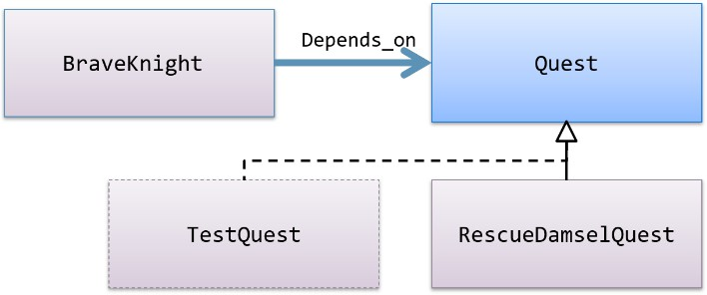This rises a problem for the piece of code in charge of instantiating the first class. A suitable parameter needs to be passed to the constructor.   
If the project contains a lot of objects and they are deeply nested, it may become very difficult to find the correct instantiation order.

## Dependency Injection

The **Dependency Injection** is a programming pattern in charge of **wiring objects at run time** instead of compile time. A dedicated software component is introduced in the project, with the role of creating and maintaining the **objects' dependency graph**. From code analysis point of view, a client object (the one that uses a service) knows only the interface provided by the server one, and not its actual class. Objects are dynamically wired on the basis of declarative pieces of information (like name, type, annotations) from a third party (supplied by the framework).

All dependencies are created and kept in a **software container**. Later on, they are injected in the code in terms of object properties. The program, thus, becomes able to make its own computation. This is in contrast with the naïve approach to application configuration. Usually, the program entry point is explicitly in charge of declaring and instantiating programmatically object dependencies.

There are several ways in which application components can be wired in a Spring project:

* **Explicit** configuration via an XML file
* **Explicit** configuration based on data type and constructor parameters
* **Implicit** bean discovery and autowiring

These three configuration styles can be freely mixed in a project.

## Aspect Oriented Programming

There are often behaviours (like logging and security) that are spread and tangled across all the code base since the purpose they support may apply to totally unrelated portion of code. Aspect Oriented Programming is a **programming paradigm** that aims at improving **code modularity** by separating cross-cutting concerns and applying them declaratively wherever they are needed. We call **cross-cutting concern**, any cohesive functionality that impacts horizontally on the system (thus crossing several "functional" modules).

AOP allows the programmer to express a given functionality in a single place without having to manually manipulate all the places where it pertains to. Cross-cutting concerns can be expressed in special classes, named **advices**. These can be applied declaratively to all methods that need them. AOP introduces two benefits:

* The aspect logic is written in a **single place**
* Classes impacted by the logic are kept **clean**, since they just contain their primary logic

Aspect logic is expressed in terms of **advice**. It defines both what and when an aspect needs to be applied.

Spring aspects support 5 types of advice:

* Before
* After (sia successfull che fail)
* After-returning (solo se success)
* After-throwing (solo se fail)
* Around (before+after)

To use AOP, a dependency must be added: *spring-boot-starter-aop*.

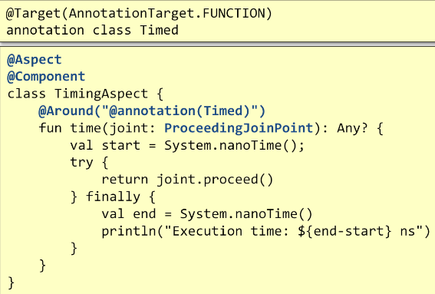From a practical point of view, in AOP, the classes written by the programmer are automatically modified at load time by inserting, in the byte code, suitable instructions or dynamically extending them in order to overwrite those methods that are influenced by one or more advices. Spring supports both methods.

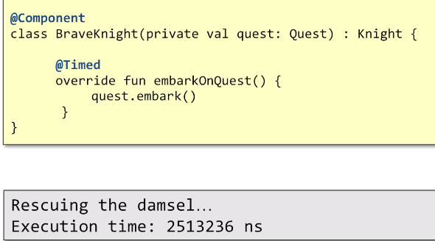Forniamo un singolo metodo Time, etichettato con Around: se qualcosa sarà editchettato con Timed, il metodo sarà invocato inserendo questo blocco di codice Around.

## Application Context

In a Spring application, objects are created and wired together by a software container that takes care of DI and aspect weaving. All objects kept inside the container have their lifecycle managed by it. Spring offers several types of container implementations which can be broadly categorized as:

* **BeanFactory** (useful in simple scenarios)
* **ApplicationContext** (which can support scenarios of any complexity)

## BeanFactory

BeanFactory is an interface providing **basic bean life-cycle management**. It:

* Supports bean **creation** (with constructor resolution), **populating** properties, **wiring** (including autowiring)
* Handles **runtime** bean **references**, resolves managed collections, calls initialization methods
* Supports **autowiring constructors**, properties by name, and properties by type

Class *XmlBeanFactory* is one of its concrete implementations. It reads bean definitions from an XML file.

## ApplicationContext

ApplicationContext is an extension of the BeanFactory interface that, to simple bean life-cycle management, adds support also for:

### Dynamic resource loading

* An **extended version** of the “observer” pattern supporting publish/subscribe of application events
* Internationalization (i18n) support
* Nested context handling

It is implemented by several concrete classes. For example, *AnnotationConfigWebApplicationContext*

provides support for web applications.

## Defining beans in Spring

All classes labelled with *@Component* are considered beans by Spring. They are automatically discovered, instantiated, wired, and registered inside the ApplicationContext, provided they are part of a scanned package. The same applies for classes labelled with annotations that include @Component in their definition, like:

* *@Controller: component speciale che si occupa delle richieste http in arrivo*
* *@Service: implementa buesiness logic*
* *@Repository: fornisce metodi per interagire con db*
* *@Configuration: fornisce metodi per configurare runtime environment*

Classes annotated with *@Configuration* are further inspected.   
- Any **method** labelled with @Bean is invoked and its result is stored as a bean in the ApplicationContext.

## Autoconfiguration

Beyond all beans explicitly declared by the programmer, Spring Boot offers a selection of more than 300 other potential beans classes defined in then *spring-boot-autoconfigure.jar* library. Each of these classes introduces one or more beans suitably configured to support a specific functionality (i.e., e-mail client, interfacing to message brokers, embedded web servers, DBMS drivers, …)

These beans are annotated with **conditional expressions** that limit their usage to those situations in which the programmer has/has not explicitly provided hints (i.e., by defining a custom bean implementing a given interface, by setting environment properties, by adding some classes to the class path, …)

## Life-cycle management

When not using a framework, object life-cycle is usually simple: the object is explicitly created by the programmer invoking one of its constructors and when no more references to the object exist, it becomes a candidate for garbage collection. Spring bean life cycle is much more elaborated: the framework oversees **instantiating** and making **available** bean instances. If a bean class is annotated or if it implements some interfaces, it will undergo further processing steps.

At start-up, the ApplicationContext locates bean definitions. Whenever a given bean is needed for the first time, it will be instantiated. Beans are populated with their dependencies and if one of the properties references another bean, the latter is built and initialized first. Depending on how a bean was declared, special cases may apply. Usually beans are **singleton**, but they can be labelled with the @Scope annotation and marked differently. If the bean class implements some given interfaces or is labelled in a particular way, the proper methods will be invoked consequently. For example, if there exist a bean implementing the *BeanPostProcessor* interface, its *postProcessBeforeInitialization(…)* method will be invoked, with a reference to the bean which is going to be configured. When the bean life-cycle terminates, further processing may happen: e.g., if it implements the *DisposableBean* interface, its *destroy()* method is invoked.

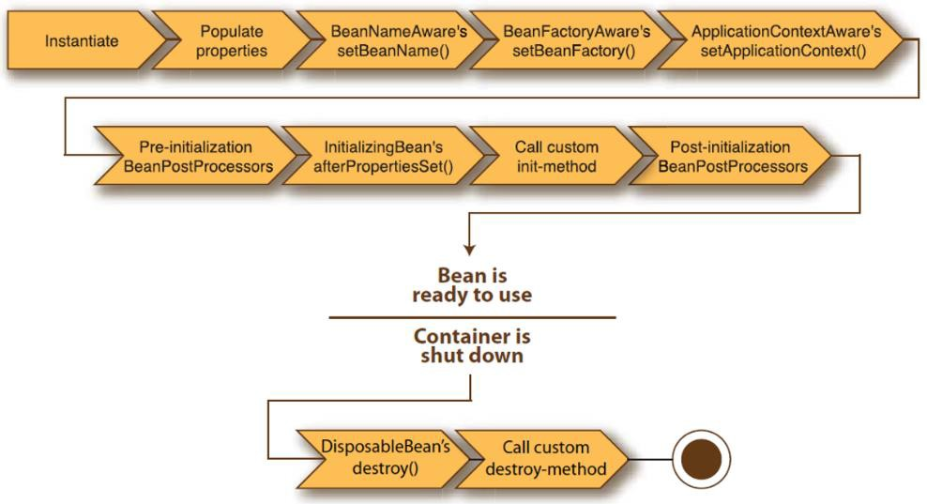

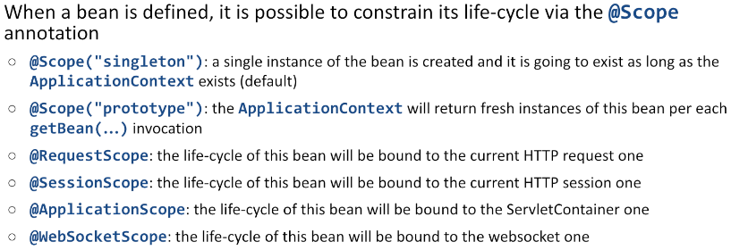When a bean is defined, it is possible to constrain its life-cycle via the *@Scope* annotation (e.g., if marked as **Singleton**: a single instance of the bean is created, and it is going to exist as long as the ApplicationContext exists (default)).

If a bean offers a method named *init(),* this will be automatically invoked (before the bean is made visible to the environment). Analogously, the cleanUp() method act as a destructor. Alternatively, a bean may implement interfaces *InitializingBean* and/or *DisposableBean.* Method *afterPropertiesSet()* will be invoked at the end of the initialization and method *destroy()* will be invoked at destruction time.

## Autowiring

**Autowiring** is a Spring feature that enables to **implicitly inject object dependencies** by searching the ApplicationContext for the requested beans. Several kinds of autowiring exist: by **constructor**, by **type** and by **name**.

## Autowire by constructor

If a bean requires one or more parameters in its constructor, the ApplicationContext will try to provide them by searching for beans conforming to the declared parameter type. If more than one bean matches, an exception is thrown. To avoid ambiguities, beans can have extra annotations:

* *@Primary* indicates that a bean should be given preference when multiple candidates are qualified to autowire a single-valued dependency.
* *@Profile(profileName)* indicates that a bean is eligible for registration when one or more specified profiles are active.

## Autowire by type

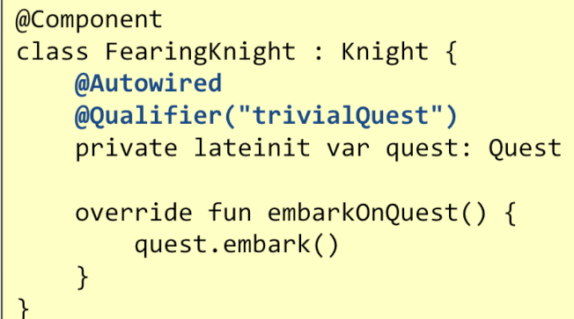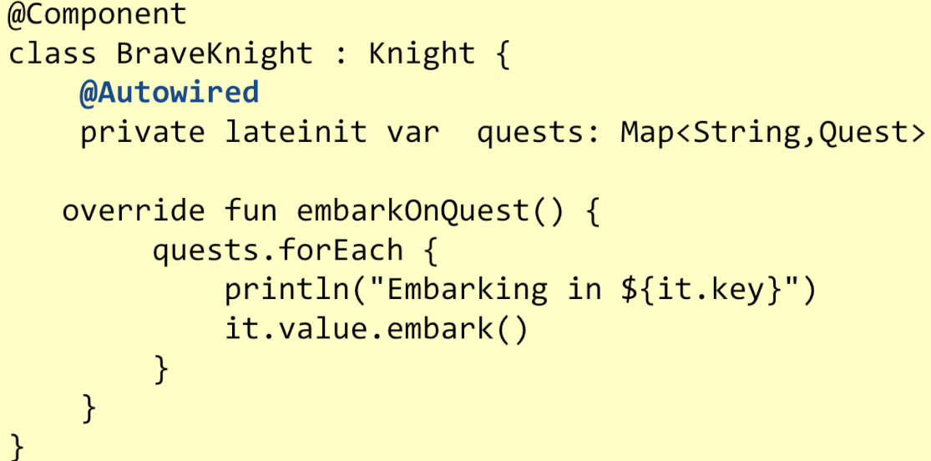Inside a bean class, *@Autowired* can be used to label lateinit var. The ApplicationContext will populate those properly, selecting a target bean according to its type. In case of an array, Collection, or Map dependency type, the ApplicationContext auto-wires all beans matching the declared value type. For such purposes, the map keys must be declared as type String which will be resolved to the corresponding bean names.

## Autowire by name

Using *@Qualifier("...")* together with *@Autowired*, it is possible to ask for a bean whose name and type match the requested ones.

## SpringBootApplication

It is an annotation applied to the main project class. @SpringBootApplication corresponds to the following three annotations:

* @**Configuration** – means that methods of the main class can be used to declare beans
* @**ComponentScan** – sets the current package as the root of packages to scan for annotated components
* @**EnableAutoConfiguration** – attempting to guess and configure beans that are likely to be needed based on classes in classpath and application properties.

Function *runApplication<MainClass>(…)* initializes Spring, runs the Spring application, creating, populating, and returning a new ApplicationContext.

## Application properties

Each Spring Boot project comes with a configuration file named *application.properties*, and located in the *src/main/resources* folder. It is implicitly loaded at start-up, and it can be used to provide configuration data. Initially, it is empty, but it is possible to add rows with the syntax ***<key>=<value>***. Valid keys and values depend on modules added to the project.

At run-time, Spring will look for the property file in the following possible locations (in order of priority): in the file system, inside the "./config" folder (being "." the folder where the jar file is located) and the in the "." folder; otherwise inside the jar file, in "/config" and then inside the jar file, in "/".

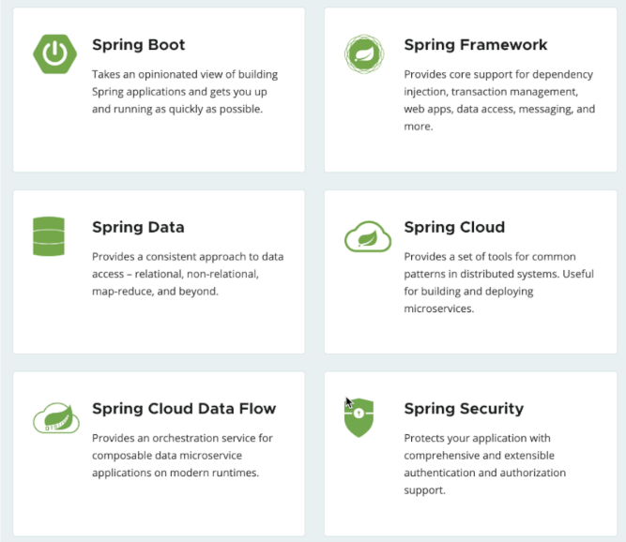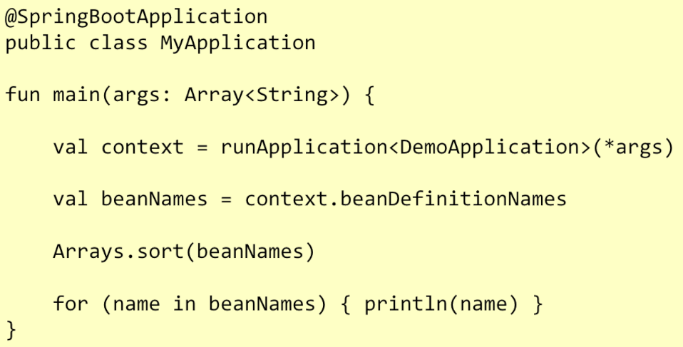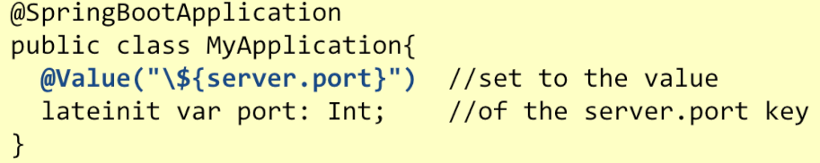The chosen order makes it easy to replace the content of the *application.properties* file without repacking the application. Values set in the property file can be assigned to properties of any classed labelled with the Component annotation by labelling the corresponding property with *@Value(…).*

# Spring Web MVC

The Spring framework supports web application in two different flavours:

* Traditional, **blocking code**, based on the servlet abstraction – supported by the Spring MVC library
* Modern, **non-blocking code**, based on the reactive streams abstraction – supported by the Spring WebFlux library

The former allows writing code using **imperative logic**, so it is simple to write and debug while the latter requires writing code using **functional programming logic**. It can largely reduce the application footprint and allows for shorter latencies and higher elasticity.

## Managing connections

Both approaches provide a similar behaviour from the client point of view:

* They leverage on a **server component** to implement an HTTP endpoint and the corresponding stack (processing headers, coding/decoding data, handling encryption, …), concurrently accepting incoming requests and returning responses
* They both **delegate the task of creating a proper response** for a given request to some programmer supplied pieces of code

However, thread management completely differs in the two flavours.

## The servlet stack

It is the traditional mode of creating Java (and Java-derived languages) web applications. Owes its name from the fact that the **code responsible to handle a given HTTP request is packaged in classes implementing the javax.servlet.Servlet interface**. It assumes the existence of a software module (named **container**) that manages the life cycle of Servlet instances

and that defines the concurrency policy to be adopted for processing incoming requests.

**Concurrency** is based on a **synchronous blocking I/O paradigm** using a **one-request-per-thread** model. Whenever a connection is received, the container selects a thread in a large (150+) thread pool and assigns it the job to fully handle it. This will invoke the servlet code which can access remote resources to generate the proper response. If any I/O is performed (e.g., accessing a DBMS), the thread will be **blocked until** the operation completes. If the operation is slow, the thread remains blocked for most of the HTTP request elapsed time. For this reason, the thread pool **must contain many threads**, in order to be able to process multiple incoming requests.

**Nota:** Quando includi il modulo springWeb, Spring in automatico avvia un’istanza del modulo del Container Tomcat:

* **Apre** un listening socket (8080)
  + **OS** crea una coda di richieste in ingresso da processare
* External tool si collega alla nostra macchina e inizia una http connection
  + Thread pool manager processa
  + Decodifica il protocollo http
* SpringBoot fornisce un singolo ServLet (riceve e gestisce) mentre Tomcat è studiato per avere più servlet

Il thread che aspetta una risposta dal dbms, si blocca finchè non riceve una risposta. Successivamente processa la risposta ricevuta, decora i dati ricevuti in qualche modo e crea la risposta che viene mandata indietro per essere flushata nel socket.

## Spring MVC

MVC is a **design pattern** which provides a solution for layering an application by separating:

* **Domain data** (*Model*)
* **Presentation** (*View*)
* **Control Flow** (*Controller*)

Spring Boot offers full support for it, providing an **opinionated**, **auto-configured stack** by including the *spring- boot-starter-web* dependency. This will instantiate an embedded version of the Tomcat servlet container, as well as a single Servlet that will manage all the incoming requests.

By default, the container listens to port 8080. This can be changed by setting the *server.port* key in the application.properties file. If classpath contains a different container (like Jetty) this will be used in place of Tomcat. As usual, Spring Boot will manage all defined beans: both those explicitly created by the programmer, via @Component or any derived annotations and those coming from the auto-configuration process. Beans annotated with @Controller play a special role since they are selected as potential handler of incoming requests.

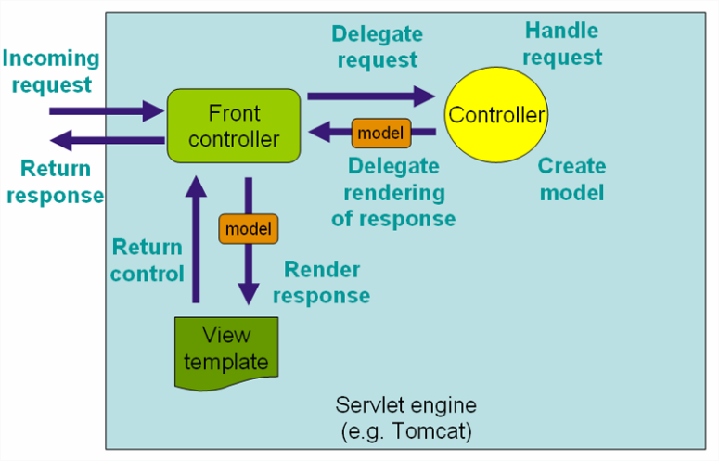Framework module Web MVC provides the Model-View-Controller architecture that powers the application.

Classes annotated with @Controller are automatically instantiated (since it implies the @Component annotation). Spring MVC looks for any method annotated with @RequestMapping (or @GetMapping, @PostMapping, ...) to locate which URL they manage. Each time that a request is received for a given verb/URL pair, the corresponding method is invoked. Its return value is used drive the process of creating a view that will eventually be returned to the invoking client.

## Showing HTML content

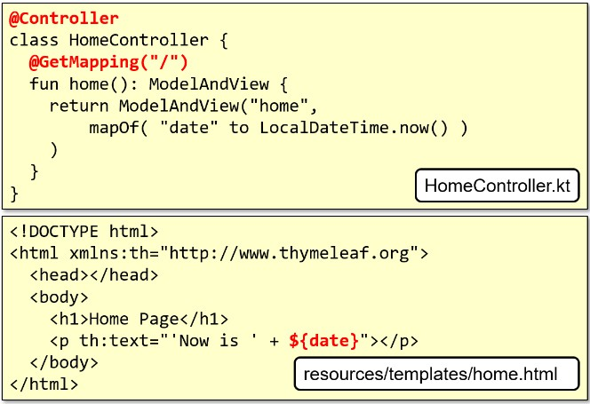The transformation of the value returned by a controller into a view is managed by a specific bean, named viewResolver. If the classpath contains the thymeleaf starter pack, this engine will be used to synthesize the view. Strings returned by controller methods are interpreted as template file names. These are searched in the project 'resources/templates/' folder (potentially adding ".html" as a suffix). TH

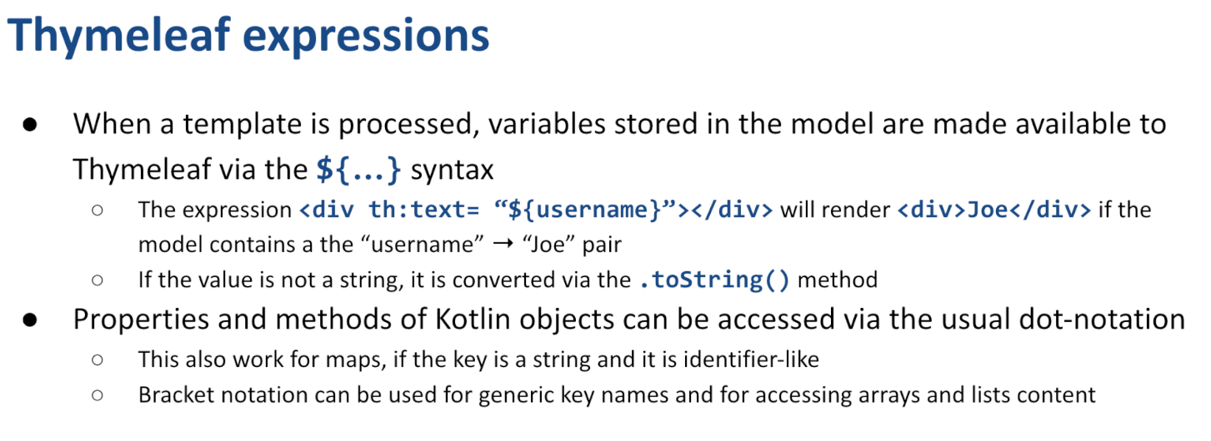

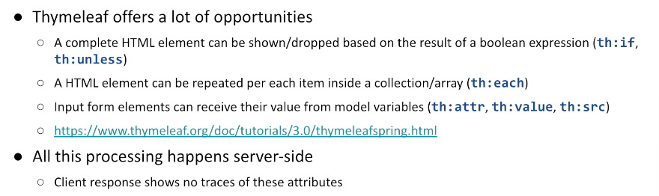

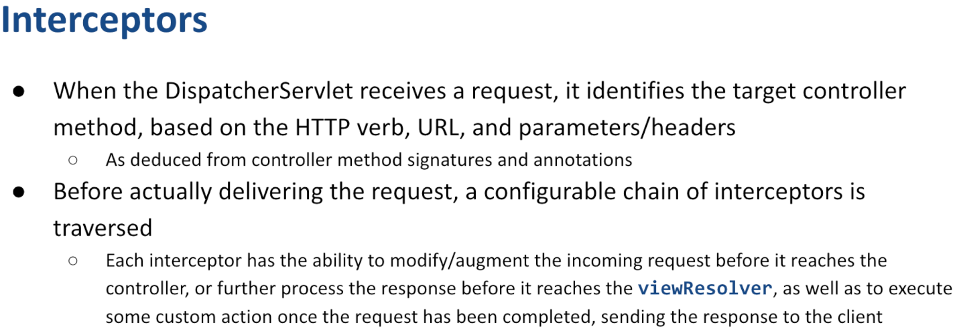Interceptors

Hanno la responsabilità di trasformare la richiesta in ingresso in qualcosa che sia adatto al metodo che deve essere invocato.

* Alcuni sono già configurati
* Altri possono essere customizzati

Effettuano process&forward fino al controller

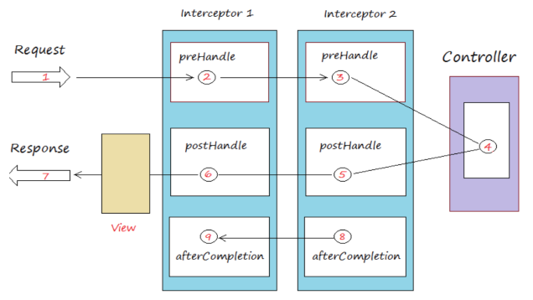  
  
  
pre-handle: invocato prima di inoltrare la richiesta al successivo (fino ad arrivare al controller)

controller ritorna

post-handle: invocato dopo la risposta del controller, fino all view

after completion: pulisce, dopo che la risposta è stata effettuata.

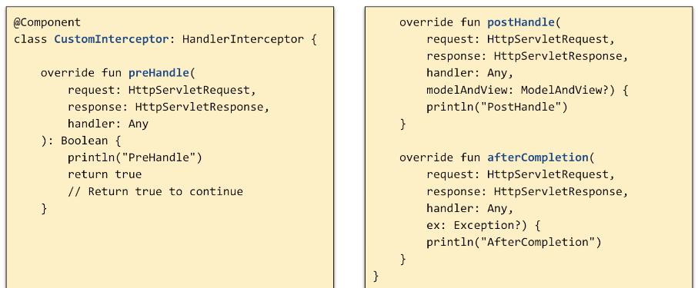  
  
  
  
  
  
  
  
  
  
  
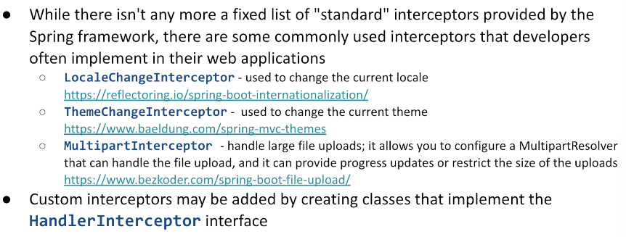definisco interceptors

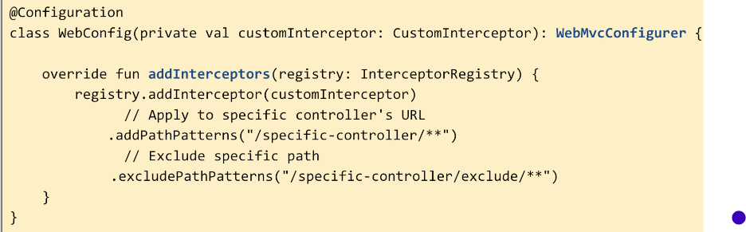configuro dove devono essere nella catena

## **Processing input data**

A controller can receive input data in three ways:

* Via URL text segments
* 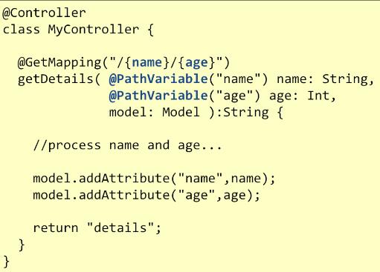Via query string parameters
* Via request body (when method is POST or PUT)

In the first case, a formal parameter per each URL segment must be added to the method signature

* It will be annotated with @PathVariable
* The method mapping URL will have the corresponding segment enclosed in braces

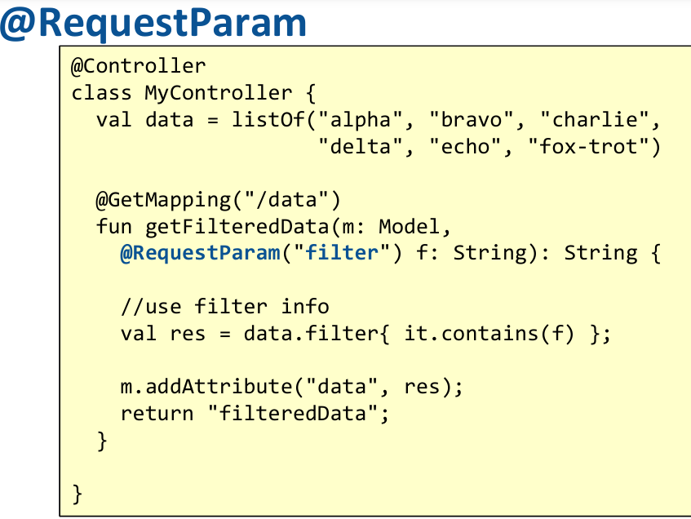Data sent in the query string can be accessed by declaring them as parameters of the controller method, as well. Each parameter will be labelled by *@RequestParam(<paramName>)*. They can be of type String or any other basic type: in this case it will be automatically converted, and an exception will be thrown if the conversion is not possible. Methods annotated with *@RequestParam* are not selected if the corresponding parameter is not contained in the request unless the annotation contains *required=false*.

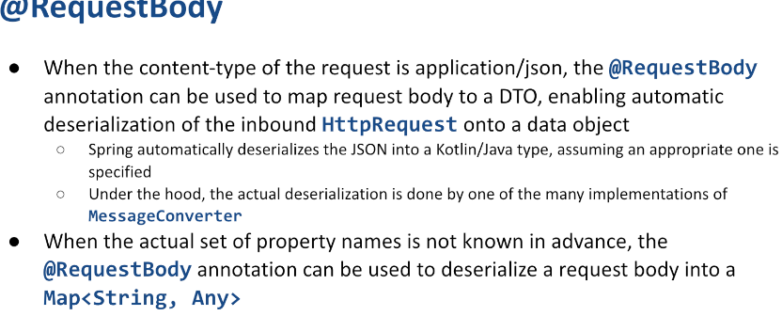

In most situations, input data must be checked against a set of **formal constraints**.   
While it is possible to make these controls inside the controller method, Spring offers – for many cases – a more general mechanism. DTO properties can be **labelled** with: *@NotNull, @Min(<val>), @Max(<val>), @Size(min=<val>, max=<val>), ...* If the DTO parameter is labelled with *@Valid* and an extra parameter of type *BindingResult* is added to the method signature, Spring will automatically enforce the constraints.   
Results will be stored in the *bindingResult* param. Dependency "*org.hibernate.validator:hibernate-validator*" need to be added.

## Immagine che contiene testo, schermata, Carattere Il contenuto generato dall'IA potrebbe non essere corretto.Processing form data

Data sent as part of an html form can be passed to the controller as an instance of a data class. Spring automatically instantiates and populate the given object, by matching the form input names with the corresponding class properties. Errors will be thrown if a conversion to a simple type is requested but it fails.

## Customizing error messages

Class *BindingResult* carries the result of the validation of the fields of the DTO object:

* Its hasErrors() methods returns true if any error is present
* Method getFieldErrors(<fieldName>) returns the list of all the errors related to a given field

Using the thymeleaf view engine, it is possible to decorate the view elements with their corresponding error message as well as localizing them according to the client or server locale. For each violated constraint, an error message is added to the model with the following key structure

*<violatedConstraint>.<DTOname>.<fieldName>*. File "resources/messages.properties" can be used to replace those keys with more specific error descriptions.

## Serving REST content

Instead of returning HTML content, a controller may directly return **structured data content**, in accordance with the REST architecture. The format of the returned resources can be negotiated from the client side using URL naming or via the "Accept" header. Annotation *@RestController* is used to label controller classes whose methods return values are used as the body of the response.   
Valid return types are *Unit*, *elementary types*, *POKOs* (*Plain Old Kotlin Objects*).

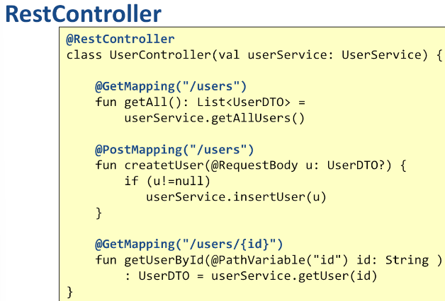

* The controller non inventa i tipi che vuole tornare, ma si basa su un servizio. Nel nostro caso dipende da userService. Quando viene creato il controller, Spring capisce cosa sta avvenendo e che, prima della creazione di esso, deve creare un’istanza userService.
* http method converter

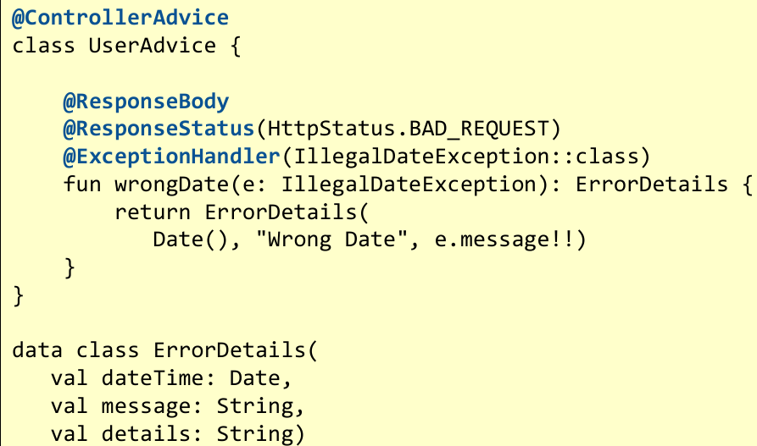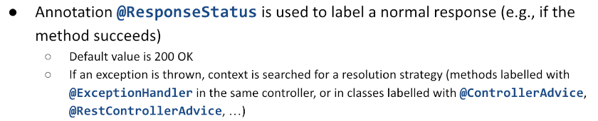Response status code:

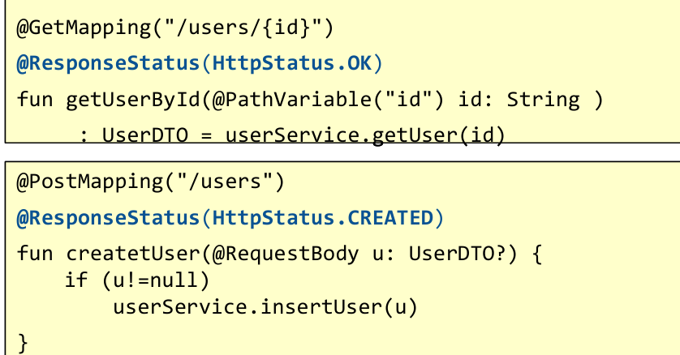

## THE problem details API

Creare classi customizzare per descrivere le condizioni di errore non è conveniente.

* Devo scrivere e testare più codice, sia client side che server side ☹

IETF RFC 7807 definisce un formato standard per i “problem detail” per portare i dettagli di erorre in una risposta http in modo machine readable.

* 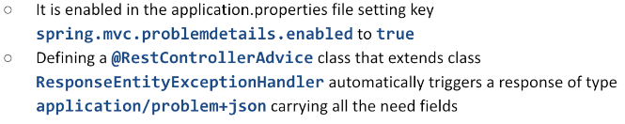Spring Boot3 supporta questo standard

## Come vedere se l’applicazione sta runnando e se sta funzionando

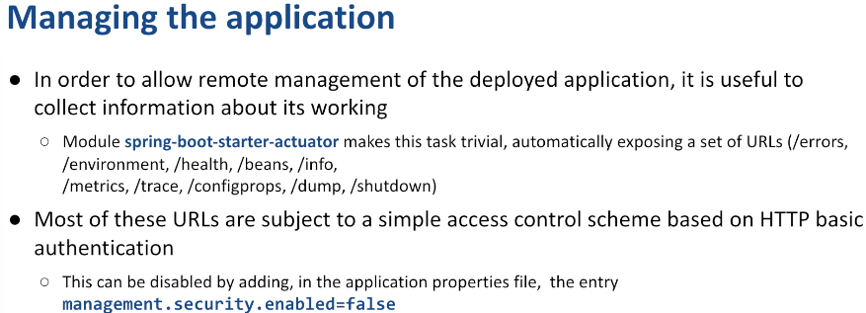Si aggiungono extra-endpoints per questo controllo.

Annotating the spring boot application -> @Operation & @ApiResponse

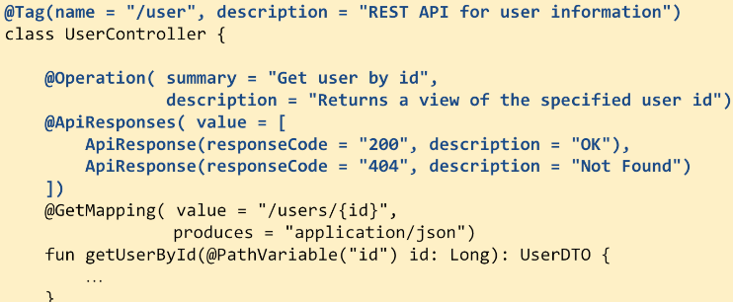

* Descrive operazione
* Descrive ritorno

# **OPENAPI documentation**

API documentation servono a fornire linee guida e esempi di interazione con un API.

* 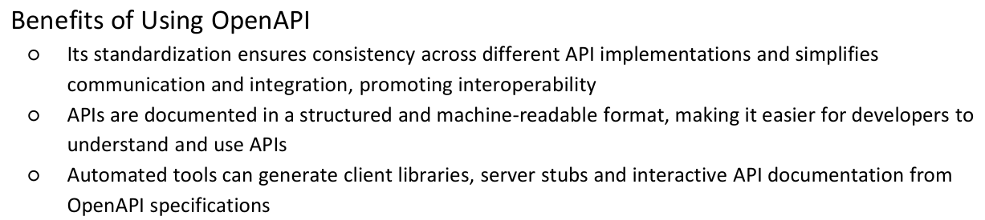Swagger/OpenAPI
* Springdoc-openapi
* Postman

Per Spring, si usa la libreria springdoc-openapi che integra le specifichedi OpenApi con le applicazioni SpringBoot.

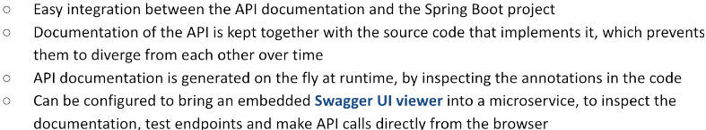

Configurazione:

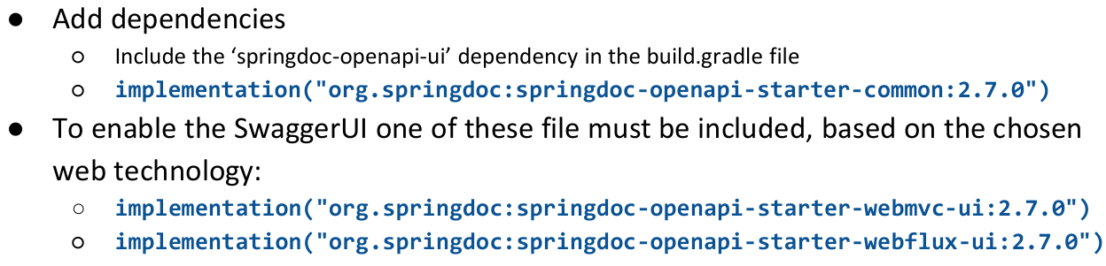

**Accessing the lower layers**

Controllers and handler function only manage the **presentation layer**. Although it is possible to directly access the data tier inside those components, it is not convenient to do so. By relying on Dependency Injection an Inversion of Control, it is possible to introduce **further components** Which are responsible of the lower layers and that will be auto wired where necessary.

## **The service layer**

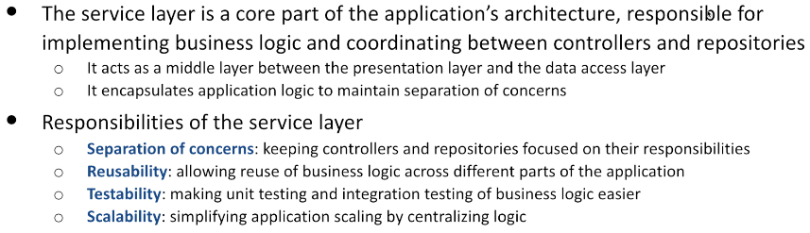Independently from the way in which a given view is created, an application is characterized by the functionalities it offers. From a programmatical point of view, functionalities take the form of a set of APIs. In object-oriented terms, APIs can be described as software interfaces, whose methods represent the logic of the application. Data that are received as parameters and/or returned as results represent the abstractions of the application domain.

The definition of the service layer represents the key aspect of server application design. It mainly **stems from the application requirements**, and it is largely independent of the overall application flavour (single page application + REST API or traditional web application).

Given the service layer definition, it is possible to create a set of tests, to verify the compliance of the implementation to the functional requirements but also a mock implementation that allows splitting server implementation among different developers, reducing temporal constraints.

The service layer is specified as an **interface** and its implementation is provided by a class labelled with *@****Service***. This makes it easy to wrap service implementation inside dynamic proxies in order to enforce security constraints, enable transaction management or simply logging request. All these cross-cutting concerns will be implemented via further annotations.

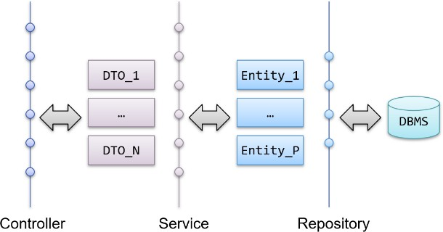The spring-test module offers a set of powerful functionalities to define tests and support their execution both at unit testing level and to integration testing level. Dependency injection and AOP are the main ingredients to support the implementation of these features.

## DTO – Data Transfer Object

Model information offered/consumed by the service:

* The **controller is responsible to translate incoming data into one or more DTOs** as requested by the service
* The controller may use DTOs received from the service to populate a view, or it can just return their serialization (as JSON objects or XML documents)
* The service is in charge of transforming DTOs into the data representation requested by the data

access layer (entities, documents, graphs, …)

They are often implemented as **Kotlin data classes** and they benefit from automatic generation of relevant member functions (*equals(…), hashCode(), copy(…)*). Mapping from DTOs to entities (and vice-versa) is usually provided via Kotlin extension function (i.e., *User.toUserDTO()*).

**Logging**

Effective error logging is crucial for debugging, monitoring, and maintaining a server-side application

* Indeed, it runs in background, continuously, and may break for a lot of different reasons
* Log messages are often the only source to understand application performances metrics and understand the causes of unexpected behaviours

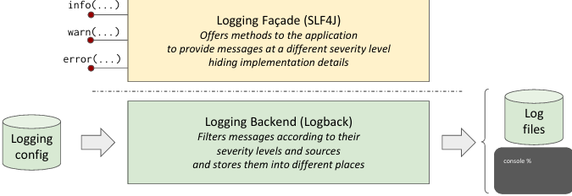Spring Boot provides a flexible and elegant architecture for logging messages, based on a front end (Accessibile al programatore - messaggi di log), that provides APIs to be invoked by user code, and a back end, responsible for propagating and storing messages (può decidere di tenerli, scartarli, mostarli in console)

* Library SLF4J (Simple Logging Façade for Java) acts as a unified logging abstraction (logged class), allowing the application to remain decoupled from specific logging frameworks (frontend del log)
* Library Logback is the default logging implementation bundled with Spring Boot (backend del log)

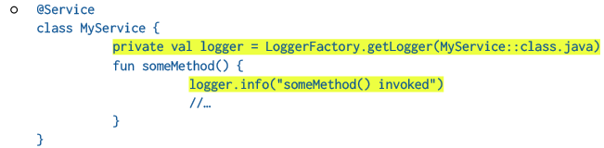Per accedere al log, uso

In order to distinguish the severity of log messages, several levels are introduced

* **TRACE** : Most detailed logs, usually for debugging during development
  + Risultato di questa operazione è X, di questa è y
* **DEBUG** : General debug information
  + Sto entrando nella funzione
* **INFO** : High-level events (e.g., startup) -> (ho preso il dato, ho mandato il dato, etc)
* **WARN**: Potential problems
* **ERROR** : Critical issues (ho provato a connettermi al db ma non sono riuscito)

Loggers provide corresponding methods that emit messages at the given level

* Messages can be built using placeholders ( {} ) that will be replaced by the corresponding arguments only if the current severity filter does not discard the message itself
* 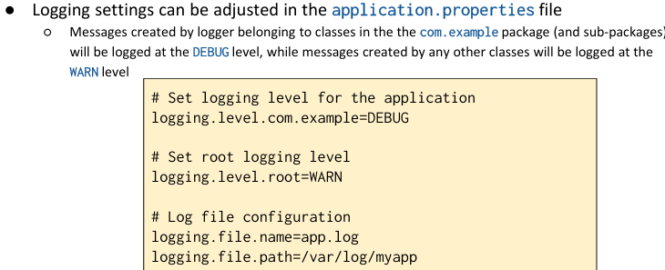This avoids consuming CPU cycles if the message is not actually emitted   
    
    
    
    
    
    
  -> se c’è com.example, almeno DEBUG  
  -> per tutto il resto, vai di WARN  
    
  -> voglio mettere le informazioni collezionate nel file app.log

Come i messaggi saranno formattati

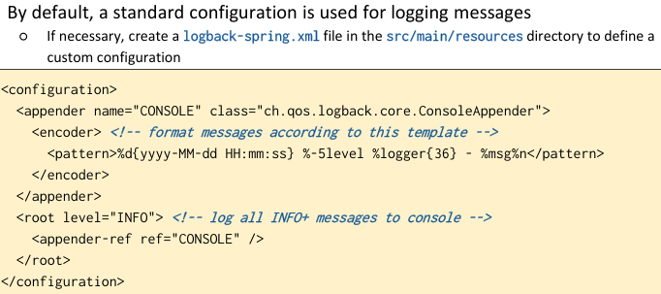

Logback configuration may include several appenders, outputting their content to different resources

* The console
* A file
* A remote server

**File appenders may have a rolling policy**

* When the file becomes larger than a given size or a given time elapses, the file is frozen and a new one is started

Apart the root logger, several other loggers may be defined, each one identified by a name, a severity level, and their additivity

* 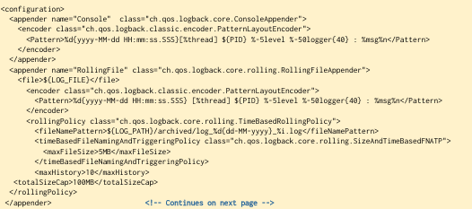This is a boolean value that defaults to true: it indicates whether the message should be propagated to higher level loggers (i.e., loggers having a shorter prefix) or no

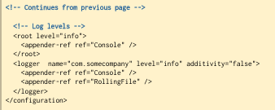

**Log asincrono:**

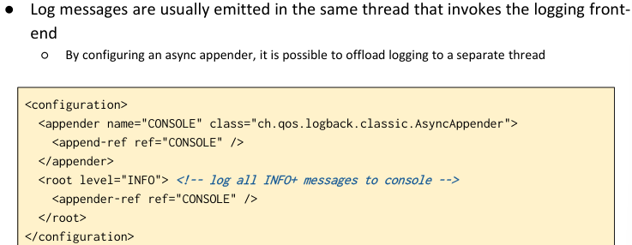In alcuni casi posso aver bisogno di avere una bassisima latenza e quindi avere un log asincrono, thread emette messaggi che vengono mandati ad un secondo thread che sarà responsabile di salvare questi dati

Best pactrices per logging:

* log at appropriate levels
  + Use DEBUG for development and INFO or higher for production
* Avoid sensitive data
  + Mask or exclude sensitive information (e.g., passwords, API keys)
* Correlate logs across services
  + Include identifiers like requestId in logs using MDC (Mapped Diagnostic Context)
* Log contextual information
  + Include request details (e.g., endpoint, parameters) when relevant
* Monitor log volume
  + Avoid excessive logging to reduce performance overhead
* Enable asynchronous logging for performance
  + Asynchronous logging improves performance by decoupling logging from application logic
* Centralise logs
  + Use tools like ELK (Elasticsearch, Logstash, Kibana), Splunk, or Graylog to aggregate logs for easier analysis
* Use structured logging
  + Log in JSON format for tools like ELK

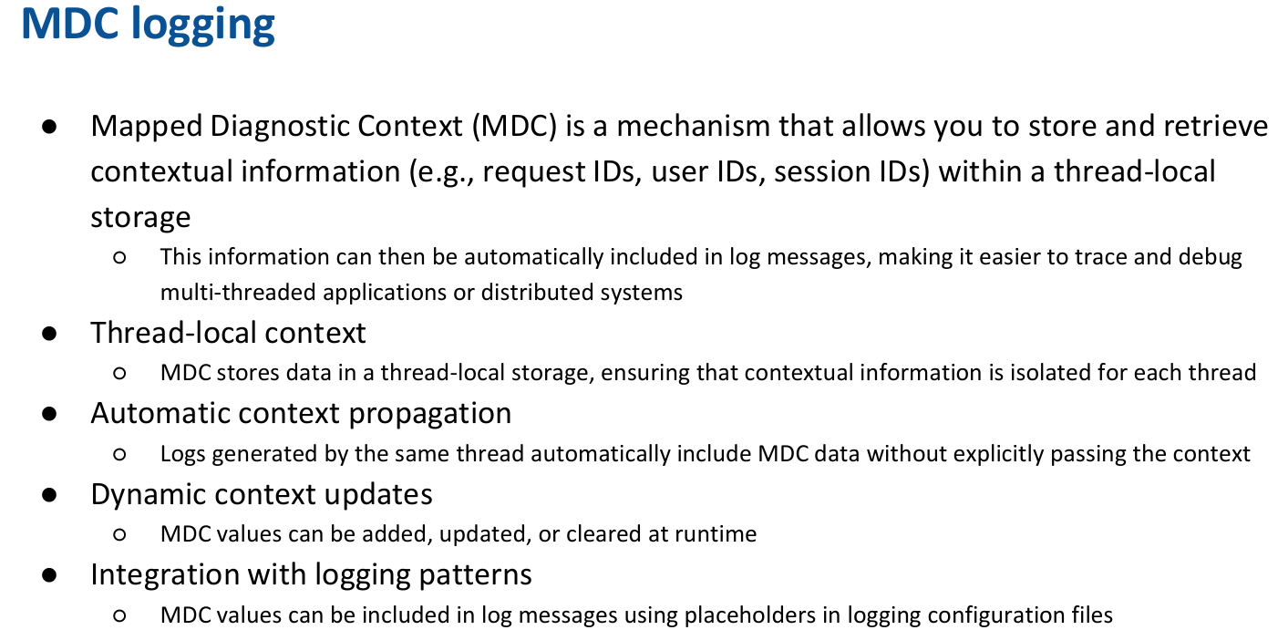

## **The data access layer**

Services delegate the task of persisting and retrieving domain objects to the **data access layer**. This may be implemented leveraging directly on **DBMS APIs** (most notably, the JDBC interface) or using some **higher-level** libraries. The former approach gives 100% fine-grained control over what is happening but leaves a lot of responsibilities on the programmer's shoulders (creation of entities from queries, navigation between entities, lazy loading, caching, …).

While data can be persisted in many different ways, the most common one relies on a Database Management System (DBMS)

* In particular, we will initially concentrate on Relational DBMSs (RDBMSs)

**Relational DBMSs** share a common conceptual model

* Data is organized in tables, with columns and rows
* Each column in a table stores one (elementary) type of data (a string, a number, a date, …)
* Each row represents a single instance or a real-world entity within the table's context
* Each row has a unique key that can be used as a reference to create relationships between different rows
* The SQL language (or a dialect derived from it) is used both to describe the structure (schema) of a database and to manipulate data within tables

**Accedere al DBMS:**

In order to programmatically execute SQL statements, each DBMS offers its own set of APIs

* The actual invocation of these APIs is usually hidden into driver libraries that offer easier bindings for different programming languages
* The driver takes care to actually contact the DBMS, handle authentication, serialize and deserialize data and commands, notify errors, …

In the Java world, the JDBC specification provides a common set of abstractions suitable for accessing relational DBMSs

* Providing programmatic abstractions like Connection, Statement, ResultSet, …

While it is possible to directly access these abstraction from the application code, this is usually avoided

* Since a large quantity of boiler-plate and error-prone code must be provided for even the simpler task

**Instead of taking care of the lower level details imposed by JDBC, a more declarative approach can be provided**

* This leverages on the (weak) correspondences between relational tables and classes

Since all records in a given table share a common structure (defined by the table column set), it is possible to represent rows of that table as instances of a class where class properties correspond to column names

* Such a mapping may be enforced decorating the class source code with metadata (annotations) ○
* This allow framework code to automatically instantiate the class when a record is read from the table, as well as to persist the content of an instance of the class into the table, providing efficiency, scalability, maintainability, …

***This declarative, fact-oriented approach falls under the term of Object Relational Mapping (ORM)***

## **ORM** – Basic principles

There are contrasts with typical OOP, where objects graphs are used to model domain abstractions. The main idea is that an object may roughly correspond to a database row while a class corresponds to a table. A semantic gap exists, however:

### Objects can be polymorphic and have subclasses, rows cannot

* DBMS data representation is **normalized**, objects may contain **duplicates** and/or complex data structures
* Rows have **stable keys,** objects are referenced by their **ephemeral memory address**
* DBMSs **use foreign keys in rows** to create relationships, which can be navigated in both ways, objects have **pointers** that are **uni-directional**

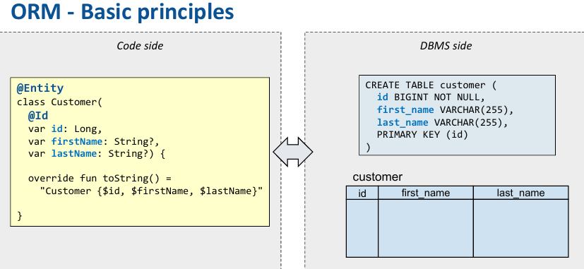

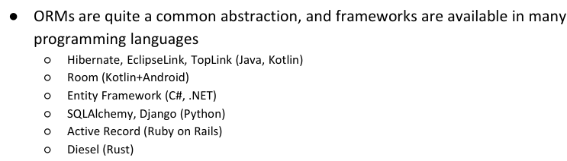  
  
  
Similar but not identical, they are related.

JPA - Jakarta (Java) Persistence API

* JPAis a specification that defines a standard for management of persistence and object to relational mapping in Java environments
  + It specifies a set of behaviours in terms of interfaces, that allows objects to be retrieved and persisted, hiding the details of how the process takes place

SpringBoot incorpora JPA e ha la sua versione -> SpingDataJPA

* In particular, it introduces the Repository abstraction, which reduces boilerplate code by allowing you to focus on defining interfaces rather than writing the implementation for common data access operations
* Permette di connettermi con diversi db

Parlando di db relazionali, la situazione è la seguente:

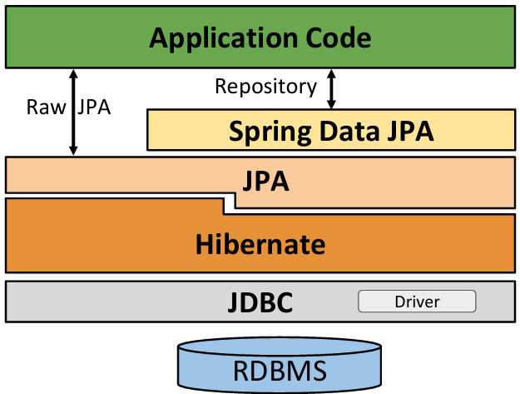  
  
  
  
-> entity manager  
  
-> nasconde le specifiche jdpc + session   
-> jdbc, attraverso lo specifico driver, contatta il db

Si può usare Raw JPA per accedere oppure aggiungere un altro strato: Spring Data JPA che ci fornisce un modo per operare con il dbms usando l’astrazione Repository.

# Spring Data JPA è una sotto-libreria di Spring Data.

# Spring Data

The Spring Data framework provides rich abstractions to access the data tier (indipendentemente dalla tecnologia di questo). It works with both relational and non-relational databases, sharing – wherever possible – a common logic for CRUD operation support and for transaction management. The main features are:

* Based on a **common set of abstractions** like Entity and Repository
* **Machine generated queries** derived from conventionally named interface methods

### Automatic auditing : può automaticamente aggiungere meta-informazioni come:

### Quando un record è stato aggiornato l’ultima volta, da chi

### Aggiungere ulteriori record per definire cosa sta succedendo

* 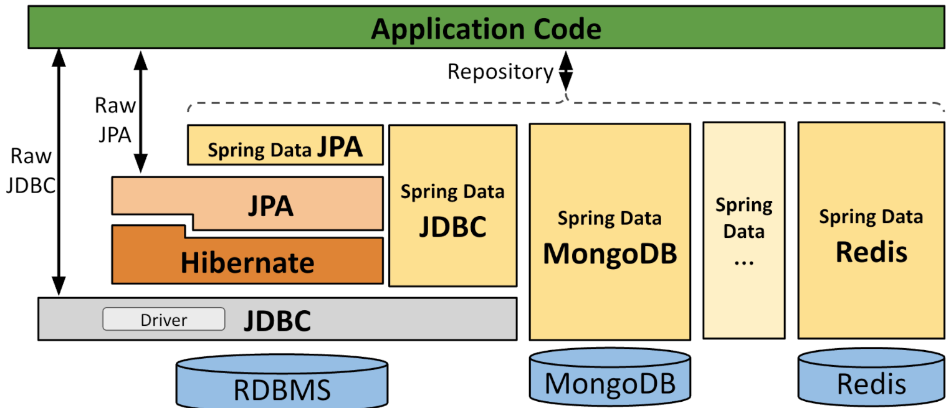Supporting many different DBMS via self-contained, autoconfigured starter library

Access to RDBMS is provided by two alternative (blocking) stacks

* Module **spring-boot-starter-data-jpa** relies on a JPA provider (Hibernate, by default) to implement a

**full-fledged ORM** (Object-to-Relational Mapping)

* 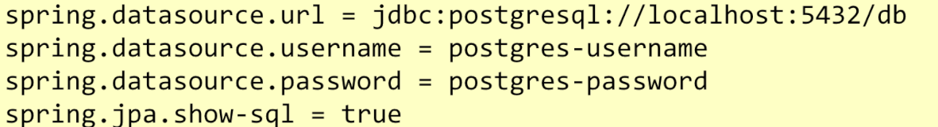Module **spring-boot-starter-data-jdbc** provides a basic ORM with less abstractions (and functionalities), but it may be simpler to use

When spring-data-starter-jpa is part of the classpath, several autoconfigured beans are injected in the context : They can be customized and replaced at programmers' will

* javax.persistence.EntityManagerFactory : A factory for creating instances of the persistence context
* javax.sql. DataSource : A factory for connections to the physical data source
* org.springframework.transaction.TransactionManager: The access point of Spring's transaction infrastructure

Software libraries offer a conceptual framework to model, queries, and process persisted data filling the gap between the object world and the relational one and by providing transparent conversions and getting rid of (most) boiler-plate code. It is **fact-oriented**:

* **Mapping** between classes and tables and relationships among tables are made **explicit** via meta-data (annotations)
* This allows the library to dynamically generate the necessary code, providing efficiency, scalability, maintainability

## **Entities** *(Nome come quello del db preferibile)*

Classes that map to DBMS rows are labelled with the ***@Entity***annotation. Each entity class maps to corresponding table and entity attributes map to table columns.

Annotations (@Table, @Column) can be used to prevent default name mapping.

* By default, they are matched to a table having a corresponding (lower-case) name
  + This may be changed, using annotation **@Table**(name="table_name")

The properties of the entities are mapped to table columns, based on their type and annotations

* Attribute **@Column(…)** can be used to provide custom details on the column mapping (by default, camelCase names property names are mapped to snake_case column names) as well as to express extra constraints, like nullability and uniqueness

Each entity class must have a ***@ID***labelled property. Its value represents the **DBMS primary key** for the corresponding record. Entities must have a public, no-args constructor. It can be added automatically, including the *org.jetbrains.kotlin.plugin.jpa* gradle plug-in.

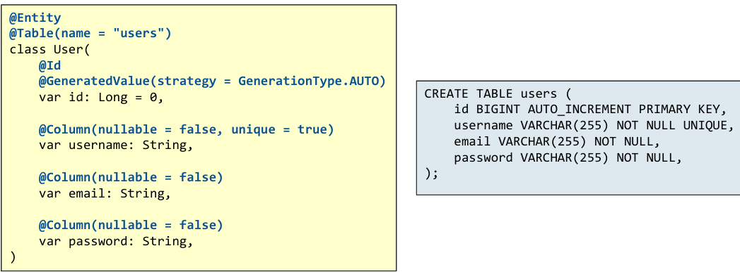

Vogio avere tabelle in plurale ma il nome dellla classe era in singolare, va bene lo stesso in questo modo

Nota su **id = 0 e auto-generated value** -> quando un oggetto come questo sarà aggiunto alla tabella

* Se il valore è ancora 0 -> oggetto non è ancoira stato salvato e deve ricevere id da db
* Se c’`e gia un valore diverso da 0, vuol dire che sto storando un valore aggiornato

Avere una classe entità va bene ma non garantisce che tutto sia safe, bisogna ottenere un’istanza dell’entity manager.

* Retrieve l’oggetto singleton EntityManagerFactory creato automaticamente dal createEntityManager -> mi da un modo per storare e ottenere dati
  + È incapsulato in REPOSITORY
* The EntityManager will keep entities in sync since its creation until it gets closed
  + In this timeframe, several DBMS transactions can be performed
* The current transaction is referred to by the transaction property of the EntityManager
  + It offers the begin(), commit() and rollback() methods to delimit the set of operations that must be executed with ACID properties

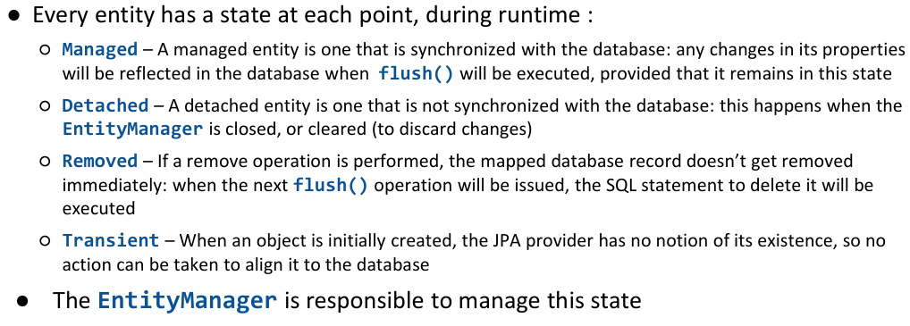

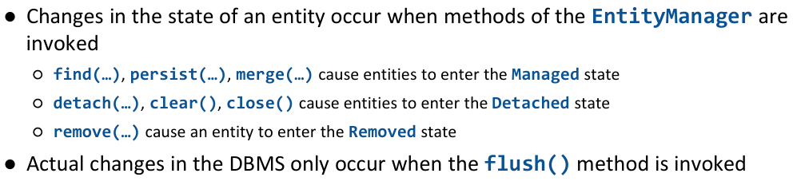

* **Find**: permette di fare domande al db fornendo una chiave primaria e chiedere di creare una managed entity che rappresenti esattamente questo record (se esiste)
  + Se chiedo 3 volte in contemporanea lo stesso id, ottengo 3 riferimenti identici a quell’oggetto
  + Se non c’è, torna null
* **Persist**: prende un’entità e garantisce che è connessa al db
  + Se entità ha una primary key settata e il db non contiene una entry con quella primary key, la inserisce -> insert
  + 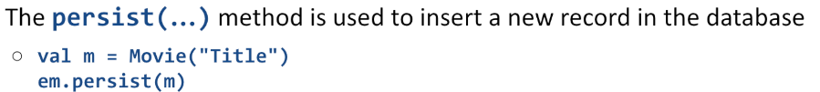Se c’è già, aggiorna -> upsert
  + Se entità non ha la primary key (e questa nella tabella è marcata come auto-genereted), inserisce
* 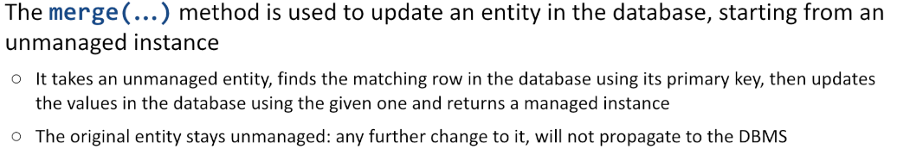**Merge**: trova l’oggetto con quella primary key nel db e re-fresha l’oggetto kotlin
* **Detach**: l’entity manager non si ricorderà più di questa entità
* Clear:
* Close:
* 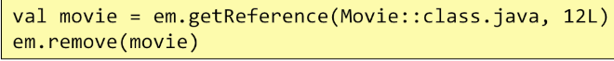**Remove**: marca un’entità come da rimuovere successivamente

Queste invocazioni fanno cambiare dei dati all’interno dell’entity manager ma per ora, niente cambia veramente nel db. Il **db verrà veramente cambiato solo quando il metodo FLUSH dell’entity manager** verrà chiamato

* Manualmente
* Automaticamente quando la transazione corrente committa

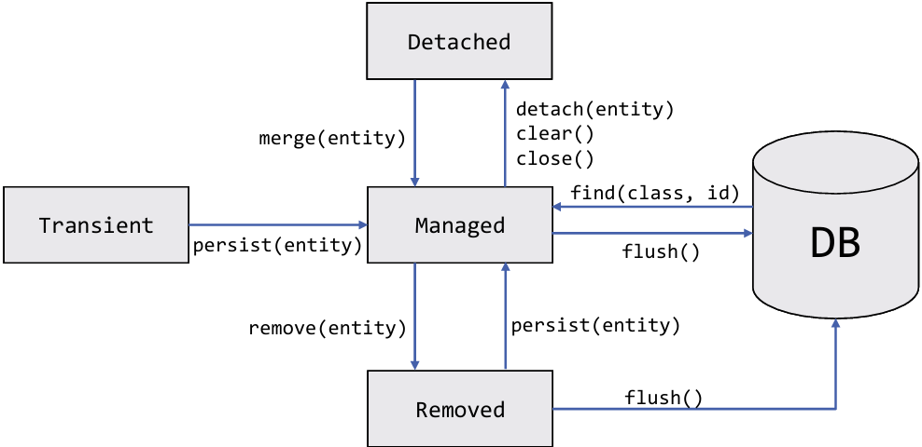

Altri metodi:

* getReference(): ritorna un oggetto che è una sottoclasse che implementa un comportamento lazy:
  + se trova qualcosa, ritorna un oggetto non vuoto, il cui contenuto verrà fetchato solo quando necessario (so a cosa fa riferimento nel db ma non ho tutto salvato in locale)
    - reference valida solo durante la transaction (se la transazione è finita, la reference non è più valida

## **Querying** entities

JPA permette di scrivere query usando JPQL (usato per effettuare query complesse su entity del database e effettuare operazioni di aggiornamento collettivo.

* Nota: nonostante sembri SQL, le espressioni fanno rfierimento alle proprietà dell’oggetto e non alle tabelle e ai nomi delle colonne.

Funzioni:

* 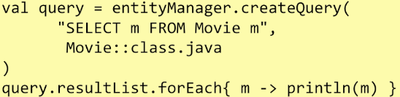createQuery: crea un oggetto Query

FROM CON JOIN

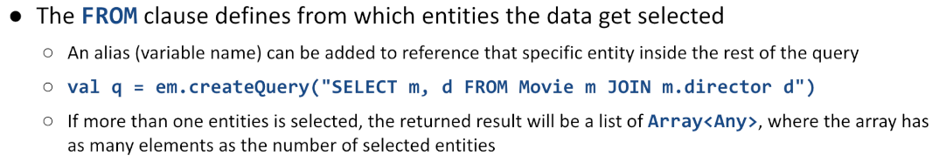

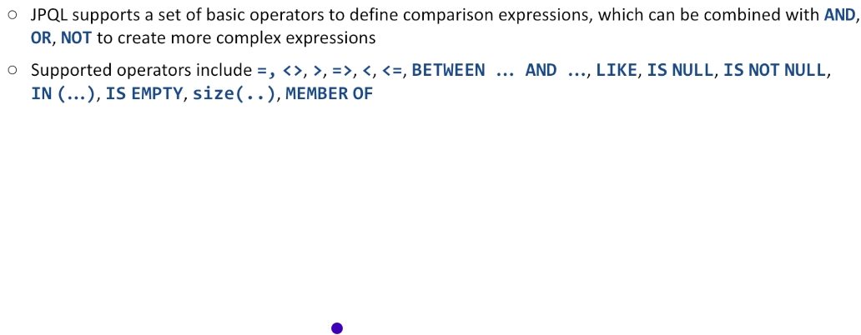WHERE CLAUSE

More on <https://thorben-janssen.com/jpql/>

Noi vogliamo usare SpringDataJPA che fornisce il Repository pattern:

* Repository in Spring Data è un’astrazione sul data access layer che permette di fare le operazioni CRUD sulle entità senza necessità di scrivere boilerplate data access code (è automaticamente generato all’avvio dell’applicazione)
  + Fornisce automaticamente la generazione delle query, la paginazione, gestione delle transazioni, rendere le interazioni con il db pulite, gestibile e facile da usare

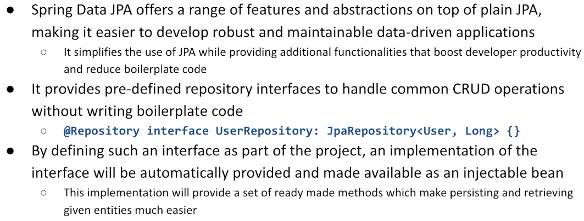

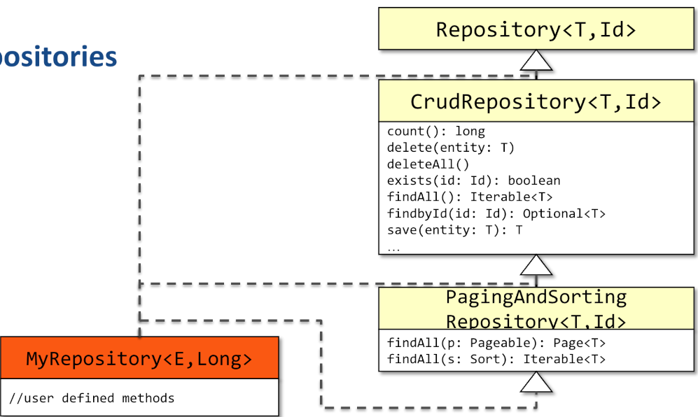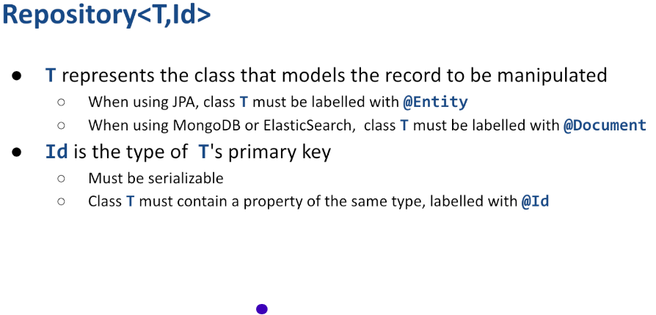  
  
  
  
  
  
  
  
  
  
  
  
  
  
  
  
  
  
  
  
-> findbyIdOrNull(id:id)   
  
  
-> da la possibilità di tornare solo alcune righe

per grosse operazioni

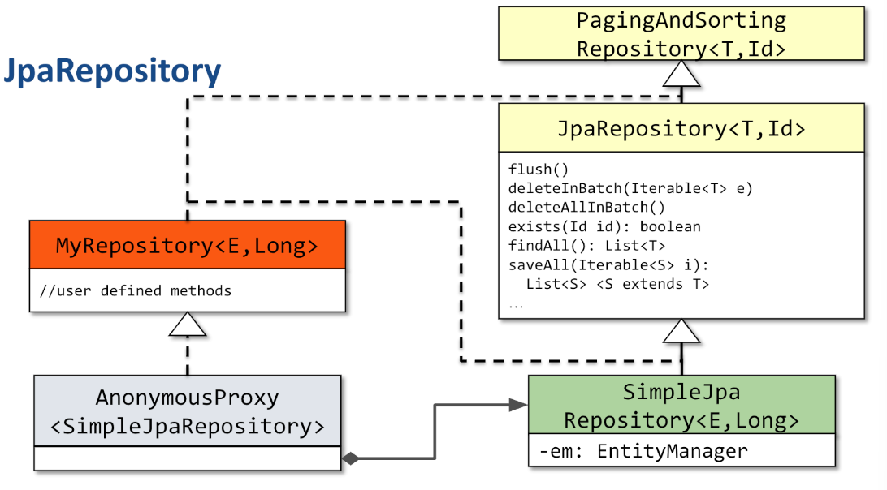

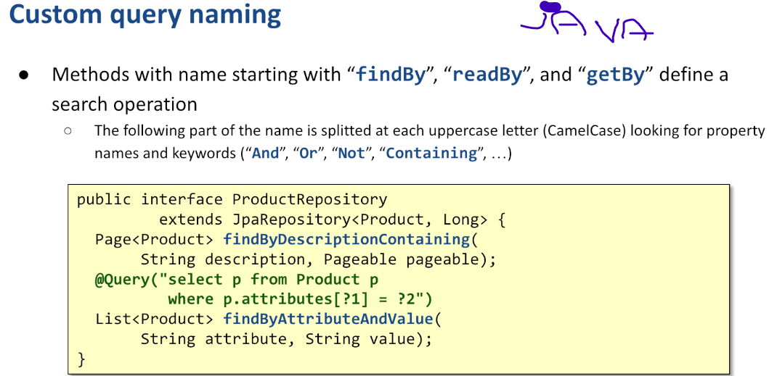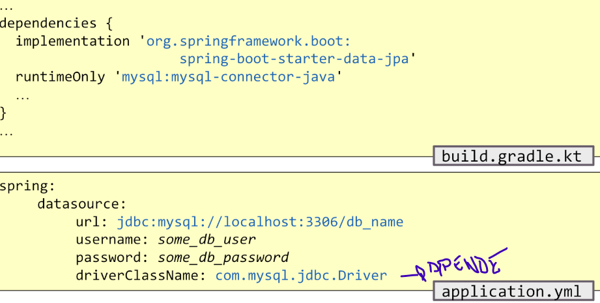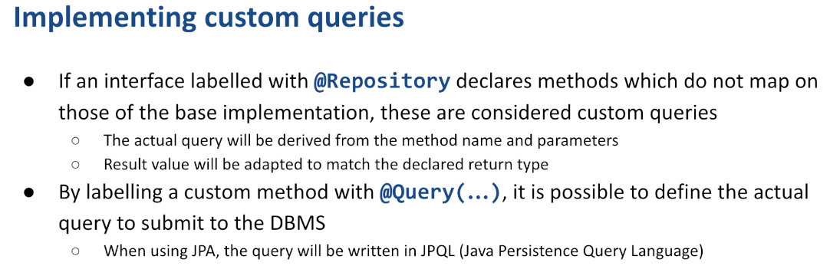

## Schema definition

Depending on how JPA is configured, DBMS schema can be either:

* **Validated** against the entities, throwing an exception in case of mismatch
* **Created** from the entity definitions, deleting any previous data
* **Updated**, according to the current entity definitions
* **Left untouched**, without pointing out nor solving potential conflicts

To set this behaviour property *spring.jpa.hibernate.ddl-auto* can be set. Since JPA is **not designed to work with immutable classes**, entities in Kotlin are based on **plain classes** and not data classes:

* Properties must be **mutable** (var)
* Equals implementation should rely on a "**natural key**"
* Because of some low-level interactions between Kotlin and Java, it is recommended to always use

### entities with generated IDs in Kotlin

Conversely, most other Spring Data flavours do support data classes with immutable properties and generated methods: Spring Data MongoDB, Spring Data JDBC, etc.

## Repositories

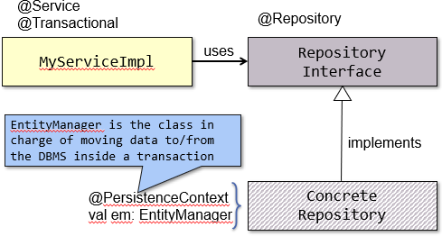Term used in Spring to define a class that **moves Entities to and from the DBMS**. A repository offers CRUD methods on a single table/collection of the underlying database. A repository is introduced in the project, defining an interface extending org.springsource.data.repository.Repository<T, Id> or one of the interfaces that derives from it. T represents the class that models the record to be manipulated

* When using JPA, class T must be labelled with @Entity
* When using MongoDB or ElasticSearch, class T must be labelled with @Document

while *Id* is the type of T's primary key that **must be serializable** and class T must contain a property of the

**same type**, labelled with @Id.

Spring Data **automatically generates an implementation** for any interface labelled with @Repository, marking it as a bean. When using JPA, the implementation class will delegate standard methods to an instance of class SimpleJpaRepository<T, Id>. The custom repository interface may contain user defined methods and they will be implemented according to a convention based on method name, parameters, return type, and annotations.

* **CrudRepository** offers all CRUD functionalities: if they are not needed, it can be more convenient to extend the Repository interface.
* **PagingAndSortingRepository** offers mechanisms to split larger result sets in pages transferring a given page inside a single connection to the DBMS. It is convenient when data sets are expected to be large.

If an interface labelled with *@Repository* declares methods which do not map on those of the base implementation, these are considered custom queries. The actual query will be derived from the method name and parameters. Result value will be adapted to match the declared return type. By labelling a custom method with *@Query(…)*, it is possible to define the actual query to submit to the DBMS. When using JPA, the query will be written in JPQL (Java Persistence Query Language).

# **SCHEMA MANAGEMENT**

# Una delle più grandi complessità di ORM è legata alla proprietà dello schema.

# The duality between classes and tables introduced by ORMs raises the problem of **which of the two sides has the authority to create, modify, and evolve these structures over time**

# And who, conversely, should follow the other party

# If the schema ownership is **not properly defined**, several risks are introduced

# **Schema drift**: misalignment between the database schema and application code, causing runtime errors

# **Production instability**: automated schema changes from ORMs in production can lead to unexpected behavior or downtime

# **Collaboration breakdown**: teams (e.g., developers vs. DBAs) might clash over who controls schema evolution, causing delays or inconsistent practices

# **Lack of rollback/testing**: ORM-generated changes often lack rollback mechanisms or proper testing in lower environments

# **Definizione dello schema:**

# In base a come è stato configurato JPA, DBMS può essere:

# validato against the entities, throwing an exception in case of mismatch

# le regole del database e classi vengono controllate per verificaree se matchano cone le definziioni della tabella

# Be created from the entity definitions, deleting any previous data

# Be updated, according to the current entity definitions

# Controllo db e classi -> se classe modificata, modifico db di conseguenza

# Remain untouched, without pointing out or solving potential conflicts

# **Noi vogliamo una soluzione migliore**. Dobbiamo essere consapevoli che il db evolve, che i requisiti evolvono, il mondo cambia e i dati devono seguire questi cambiamenti. Invece di propagare tuitto manualmente, vogliamo usare un toool di schema management

# **Supporta migrazioni di schema**: traccia cosa viene fatto e propaga

# Numero crescente + extra description

# Creare per ogni cambiamento, uno script che si possa applicare al databnase per aggiornarsi. Allo stesso modo, va creato un file per fare il processo opposto.

# Viene aggiunta una tabella extra che tiene traccia delle informazioni sullo schema

# Schema migration tools **automate the schema management process**

# At application startup, migrations are applied to the database in the correct order, ensuring that the database is always in sync with the application code

# Execution **environment consistency**

# Adopting these kind of tools allows developers to apply the same schema changes in development, testing, staging, and production environments without discrepancie

# **Rollback capability**

# also provide mechanisms to undo applied migrations, enabling recovery in case of errors

# Building a **baseline** for existing schemas

# Tools handle legacy (existing) databases by setting a baseline for the existing schema, in order to be able to track future changes

# **Validation**

# The current db schema is matched against the expected state defined by the migration scripts, preventing unauthorized or untracked changes

# Benefit dei tools:

# **Predictable changes :** Avoid surprises during deployment by ensuring all environments follow the same sequence of schema changes

# **Teamcollaboration: a**llows multiple developers to work on schema updates without conflicts

# Reproducibility : Makes it easy to reproduce schema changes for new environments or during disaster recovery

# Versioning : Keeps a historical record of every schema change, making debugging and auditing easier

# M.m.p

# MAJOR: cambiamento che rompe ciò che c’era prima

# MINOR: ho aggiunto qualcosa, cosa c’era prima continua a funzionare

# PATCH: piccola variazione del codice, senza cambiare API, niente di che

# Nota: le versioni client-side e server-side, possono essere totalmente scorrelate

# Potrei avere la versione 2.3 del client che funziona con la 1.1 del backend

# La regola è: se incremento db, incremento major number del mio server e frontend deve adattarsi

# Per semplificarew il processo, esistono diversi tools: Flyway, Liquibase, Alembic, Rails Migration, dbmate.

# Noi usiamo Flyway.

# **FLYWAY**

# Open-source database migration tool that helps **manage, automate, and version database** schema changes

# ensure database consistency across different environments (e.g., development, testing, staging, production)

# It works with most relational databases, including MySQL, PostgreSQL, Oracle, SQL Server, and SQLite

# It integrates easily with Java/Kotlin-based frameworks (e.g., Spring Boot), CI/CD pipelines, and containerized environments

# Flyway tracks migrations using a dedicated **flyway_schema_history table** inside the DB to record which migrations have been applied and their execution state

# It relies on the definition of a set of conventionally named ordered sql scripts that are kept as a part of the application resources (e.g.: V1__init.sql, V2__add_users_table.sql)

# Spring Boot has first-class support for Flyway:

# Dependency "org.flywaydb:flyway-core" is automatically detected causing migrations to be applied at startup

# Se si usa JPA, devo aggiungere anche:

# spring.jpa.hibernate.ddl-auto=none

# The src/main/resources/db/migration folder must contain migration scripts

# File naming convention: V<version>__<description>.sql (note the double underscore)

# Durante l’esecuzione, Flyway controlla per nuove migrazioni nella cartella

# Applica le migrazioni non applicate, assicurandosi che lo schema del database sia aggiornato in maniera incrementale

# Ogni migrazione è applicata solo per prevenire ridondante o aggiornando conflitti

# Flyway valida lo schema del database per assicurarsi che matcha lo stato definito dallo script di migrazione

# È possibile definire “undo script”:

# Deve essere nominato: U<version>__<description>.sql

# Questo file deve contenere un insieme di operazioni che revert la migrazione corrispondente

# Per evitare di dover scrivere tutto a mano, possiamo usare un plugin di intellij: JPABuddy

# Che semplifica lo siluppo di applicazioni usando JPA:

# Fornisce feature che funzioano con JPA entities, relazioni e gestione dello schema offrendo deisgn tools visivi, generazione di codice e integrazione con tool di database migration come Flyway

# Importa un db esistente e genera JPA entites e script di migrazione iniziale

# Analizza cambiamenti fatti alle entità JPA e genera script di migrazione per allineare lo schema del db con i cambiamenti

# Codice: demoflyway

# **Connessione al db**

# Per fetchare e salvare i dati da un RDBMS acceduto attraversi un JDBC driver, le istanze di Repository e EntityManager necessitano un’implementazione dell’interfacia java.sql.Connection (This is provided via a factory class conforming to javax.sql.DataSource interface)

# Spring offre 3 alternative:

# A **direct connection** to the DBMS driver

# A **connection pooling implementation** – produces a Connection object that will automatically participate in connection pooling (default)

# ci serve questo perché il db non può in automatico assegnare tante connessioni, se molte applicazioni si connettono allo stesso dbms, ognuna di esse allocherà 10/20 connessioni (bisogna controllare).

# Entity manager ha bisogno di contattare il db -> chiede al data source una istanza della connessione

# A **distributed transaction** implementation -- produces a Connection object that may be used for distributed transactions and almost always participates in connection pooling

# Difficile perchè potrebbe riguardare entità che vivono in diversi programmi, su diversi server, con diverse regole.

# Usiamo il 2-fase commit protocol.

# **Noi preferiamo HikariCP** come default connection pool implementation perché più performante (si può tranquillamente switchare ad altri)

# I dettagli di connessione vanno specificati nel file application.properties

Semplice dataSource via codice:

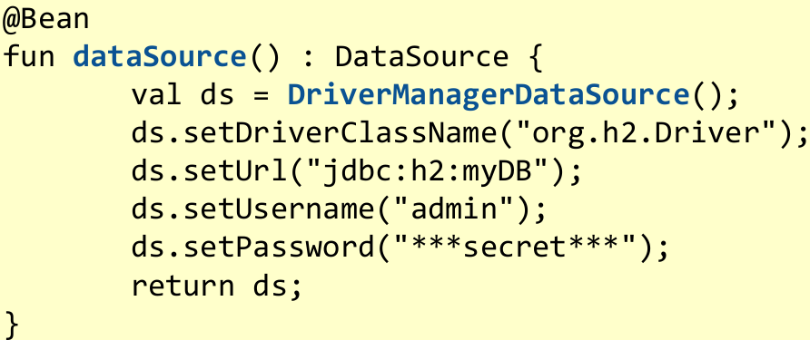

DataSource basata su una connection pool:

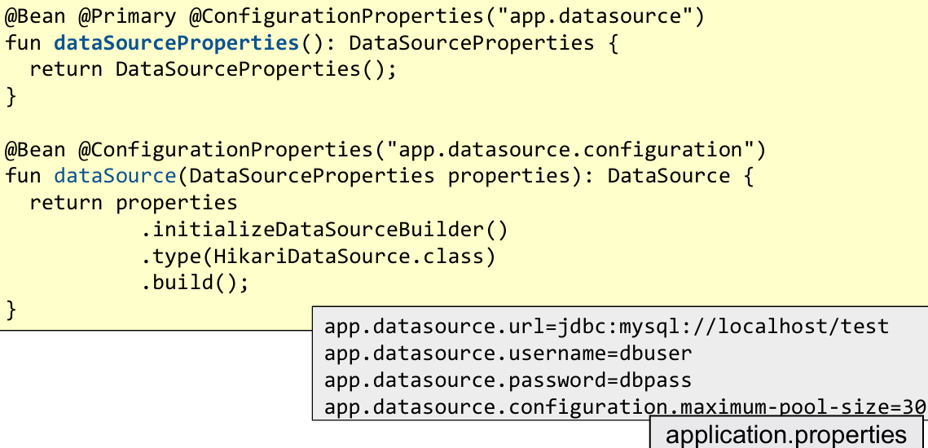

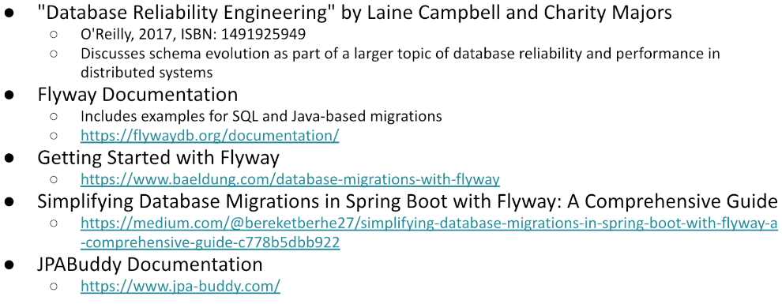

# **SPRING DATA JPA IN DEPTH**

# Constraint delle entity in JPA:

# An entity must be annotated with the **@Entity** annotation

# It must have a public or protected **no-arg constructor**

# Other constructors are allowed

# Both the class and its method/properties should be open

# Per questo **non posso usare data classes**

# It may extend a non-entity class

# If this is labelled with @MappedSuperclass, its properties become part of the current entity

# It must provide an **@Id**-labelled property

# It must provide working implementations for equals(…) and hashCode(…)

# Enitity constraint in JPA:

# Nel gradle file troviamo **2 plugin**:

# Jpa: se dimentico di usare no-arg-constructor per la nostra classe jpa, il plugin lo sintetizza in automatico a runtime

# Allopen: marca ogni metodo open

# **Perché tutto deve essere apero?** Sintetizzano una sottoclasse della nostra classe, con un insieme di tricks per migliorare la performance:

# **Lazy loading**: se car instance è legata in qualche modo al car model, potrei decidere che quando prendo i dettagli dell’auto, voglio anche ottenere i dati del veicolo generale oppure no. Solitamente, relationship:

# ManyToOne: **Eager** -> se prendo qualcosa, voglio ottenere anche le cose a cui è legato

# OneTo Many: **Lazy** -> se prendo qualcosa, non voglio tirar giù tutto il resto ma solo gli ID del resto

# Quando voglio prendere delle proprietà, si connette e fetcha informazioni

# Immagine che contiene testo, Carattere, schermata, linea Il contenuto generato dall'IA potrebbe non essere corretto.Volendo, se si vuole un comportamento particolare si può specificare nella classe

# Quando si ha un id generato, questo crea problemi. Alcune restirzioni:

# Tutte le proprietà devono essere mutabili

# Equals method: disponibile se creato client side (es: CodFiscale)

# Se generato da db -> problematico perché prima del salvataggio id=0, dopo assume un valore. Ne consegue che ci sono stati due oggetti identici con id diverso.

# Il comportamento di equal deve essere diverso se ho già ricevuto id o se non lo ho ancora ricevuto

# Id missing: mi baso su indirizzo di memoria

# Id presente: mi baso su classe + id

# Questo è complesso da fare perché devo farlo per ogni classe e devo anche implementare una hash code coerente con equal.

# Per evitare lo stesso codice per ogni classe, posso creare una soluzione generale:

# Nota: le tre proprietà maggiori sono: Reflexibity, Simmetry, Transitivness

## Mapping object properties

Per each property in the Entity class, the following items can be specified via the **@Column annotation**:

* The name of the DBMS column onto which the value will be mapped, via *@Column (default: the property name)*
* The SQL type to choose (via columnDefinition)
* Further constraints (insertable, updatable, nullable, unique, length, precision, scale) Property type is used to understand how the property will map onto the table:
* **Elementary** types (Boolean, Int and its derivatives, Float, Double, BigInteger, BigDecimal, String, Enums, Date, Time, Timestamp and derivatives) are directly mapped to their column and managed as value types (Date e time potrebbero avere ulteriori limitazioni)
* Types marked with the **@Embeddable** annotation are exploded in their elementary properties and added to the current table (es: person name potrebbe contenere nome e cognome e potrebbe essere splittato)
* Types marked with **@Entity** or that extend **Collection<T>** (where class T is marked with @Entity) denotes relationships: this must be marked with some special annotation to express their cardinality: **@OneToOne, @ManyToOne, @OneToMany, @ManyToMany**

## Date and time mapping

In a typical relational database, there are three basic data types for columns: date, time, timestamp. All of these three data types are represented as instances of *java.util.Date* object:

* **@Temporal** annotation is used to disambiguate it
* **TemporalType.DATE**: represents date-only values
* **TemporalType.TIME**: represents time-only values
* **TemporalType.TIMESTAMP**: represents date with time values

Internally, a Date only stores a long number, which is the number of milliseconds from the Epoch (1970-01- 01 00:0:00.000 UTC). *To represent it in local date and time, a time zone (****offset****) is needed: this must be stored in a different field.*

## **Relationships**

In a DBMS, relationships are implemented by referencing the primary key, via foreign keys. Given the schema and a record, it is possible to reach all other records related to it. Navigation from entity to entity may happen in three ways:

* By directly selecting the corresponding row, if the given record contains a foreign key (1-to-1, many- to-1)
* By selecting all rows of the target table that refer to the primary key of the given record (1-to-many)
* By performing a inner join on a secondary table, in order to select those rows that are related to the primary key of the given record (many-to-many)

In the application code, relationships are modelled via **pointers**: these are intrinsically unidirectional. **When the application logic requires navigating a relationship along both directions, it must be defined in both entities, possibly referring to an intermediate join table**. Whenever the relationship changes because of the application code execution, changes must be propagated on the opposite site (if this is mapped).

* **@OneToOne**: Each instance of the first entity is related to (exactly/at most) one instance of the second entity
* **@OneToMany**: Each instance refers to a collection of entities stored in a (Mutable)Set. Referenced entities must have a working implementation of equals and hashCode
* **@ManyToOne**: The current entity is related to (at most/exactly) one other entity. A join column is added to the table, whose name defaults to the <field_name>_<other_id_field>. This can be overridden via the @JoinColumn annotation
* **@ManyToMany**: these relationships require a join table where pairs of related keys are stored. Both sides may offer convenience functions to manipulate the relationship by owning side references to the table, the owned one refers to the other side via the **mappedBy** attribute.

## Immagine che contiene testo, schermata, Carattere Il contenuto generato dall'IA potrebbe non essere corretto.Immagine che contiene testo, schermata, Carattere Il contenuto generato dall'IA potrebbe non essere corretto.Immagine che contiene testo, schermata, Carattere Il contenuto generato dall'IA potrebbe non essere corretto.

## 

## Updating relationships

A special situation arises when one entity is created, updated, or destroyed. Depending on application logic, this might require creating/updating, destroying other entities as well. This is called "**cascading**" and can be controlled by the cascade attribute of the various relationship annotations. It expresses the transitivity constraints that the relationship enforces.

* CascadeType.PERSIST -> propaga l’operazione PERSIST all’altro lato della relazione
* CascadeType.MERGE -> propaga l’esecuzione di MERGE (copying the properties of the object onto the corresponding record with the same id) anche all’altra entità
* CascadeType.REMOVE -> rimuove I riferimenti all’entità quando questa è rimossa (es: rimuovo mario, rimuovo tutti i suoi corsi dal db)
* CascadeType.DETACH -> quando l’entità corrente è detachata dal persistence context, anche le entità collegate lod evono essere
* CascadeType.REFRESH -> quando l’oggetto viene ri letto dal db, vengono riletti anche gli altri
* CascadeType.ALL -> tutte le operazione sopra citate, vengono propagate

## Strategie per le relazioni

Although JPA allows mapping all kinds of relationships in the DB schema in terms of entity to entity direct reference, it is **not mandatory to do** so -> it is always possible to map the foreign keys as simple attributes and manually load related entities when needed.

**If the application logic does not require navigating a relationship bi-directionally**, it is much better to keep it unidirectional (i.e., map it in only one entity) -> This avoids the cost of keeping the two sides in sync, reducing the possibility of introducing errors

**Related entities** can be loaded using an **eager or lazy approach** -> Start with Lazy Fetching all child relationships from a given entity; convert to eager fetching only if the related entity is ALWAYS REQUIRED

**Cascading** should be applied only on "logically dependent" entities, not on independent ones

# Transactions

Di default, I metodi CRUD forniti sulle istanze della repository sono transacional.

* For read operations, the transaction configuration readOnly flag is set to true, thus informing the transactionManager that no change will take place

I metodi custom, possono essere marcati esplicitamente come @Transactional

* Possibilmente specificando the attribute readOnly=true, if it is a read operation

Se la transazione necessita di **spaziare su diversi metodi o repository**, un metodo **@Service** etichettato con **@Transactional** deve essere introdotto.

The SQL standard allows to relax the isolation level, in order to improve overall system performances

* This gives rise to the introduction of several potential anomalies when two or more transactions occur at the same time

SQL-92 introduced several isolation levels

* The database client may choose which one to apply in order to balance concurrency against data correctness

The standard defines **4 isolation levels**

* **Read uncommitted**→ Dirty-reads, non-repeatable-reads, and phantom-reads may occur
* **Read committed**→ non-repeatable-reads and phantom-reads may occur
* **Repeatable read** → phantom-reads may occur
* **Serializable** → none of the above occurs

Despite of this, other anomalies may occur

* Dirty-writes, read-skew, write-skew, and lost-update

## **Immagine che contiene testo, diagramma, Piano, linea Il contenuto generato dall'IA potrebbe non essere corretto.Locking**

If the application has concurrent writers to the same objects, then a locking strategy is critical in order to prevent data corruption. Locking assumes a co-operative approach to maintain data integrity and it may involve application-level changes and ensuring other applications accessing the database also do so correctly for the locking policy being used. Setting the transaction isolation strategy may not be enough for a typical web application.

JPA offers two locking strategy to manage concurrency: *optimistic locking* and *pessimistic locking*.

**Optimistic locking** relies on entities having a numerical or timestamp field labelled with *@Version*. Its value will be automatically managed by the repository implementation and when a read operation is performed, the field is populated from the database. When a write operation is performed, an extra check is added, in the transaction commit code, to verify if the version has changed. In case of mismatch, an *OptimisticLockException* will be thrown otherwise the transaction commits and increments the version.

In case of **pessimistic locking**, JPA creates a transaction that obtains a lock on the data until the transaction is completed. This prevents other transactions from making any updates to the entity until the lock is released but introduces potentially long delays in concurrent transactions, thus lowering the overall scalability of the system. If a lock cannot be obtained (because an other is in place), different exceptions can be thrown

* **PessimisticLockException** causes a transaction-level rollback
* **LockTimeoutException** causes a statement-level rollbackv
* 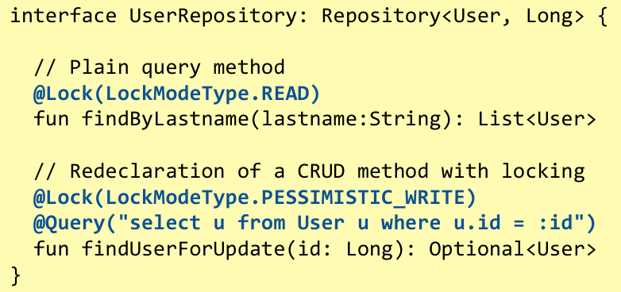**PersistanceException** causes a transaction-level rollback

Pessimistic locks will be automatically released when the transaction commits or roll-backs. To specify the lock mode to be used, the **@Lock(LockModeType) annotation** is added on repository query methods.

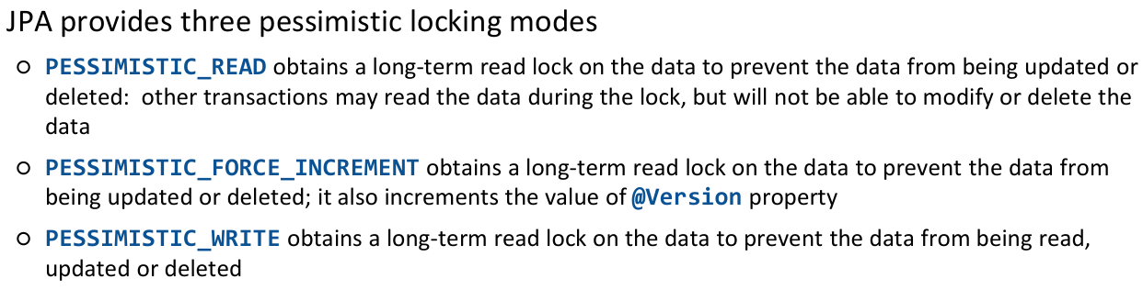

In order to deal with concurrency conflicts a proper compromise must be achieved between overall data- coherence and system usability. If optimistic locking is used, versions must be propagated to clients along with data so the client will send it back to the server that will check the version and commit the transaction. In case of OptimisticLockException, the conflict should be reported back to the user, who is the only one who can safely decide what to do.

Pessismistc lock solo se ci si blocca al server. Non possiamo usare pessimistic lock **se dobbiamo propagare l’informazione al client** in quanto altrimenti l’operazione terminerebbe in quanto la transazione finirebbe 🡪 dobbiamo usare optimistic lock con version number nel DTO.

## **Auditing**

JPA supports auditing by inserting extra properties and annotations on entities. If a temporal property is labelled with @CreatedDate or @LastModifiedDate, **its value will be automatically populated whenever the corresponding event takes place**. If the Spring Security infrastructure is in place and a security context storing the currently authenticated user is available, properties annotated with @CreatedBy and @LastModifiedBy will be populated with the corresponding data fetched from the Principal.

# **Execution Environment**

Ogni componente di una applicazione distribuita deve essere hostato da qualche parte per essere eseguito

* Il run-time environment deve provvedere l’accesso a tutte le risorse necessarie al componente (CPU, GPU, memory, storage, networking)
* Inoltre, ogni componente deve essere configurato in maniera appropriata in modo tale da essere capace di raggiungere altri componenti a cui è direttamente connesso
* Allo stesso modo deve essere raggiungibile da chi si basano su di lui in qualità di server

In base alla specifica fase di life-cycle in cui il progetto si trova, i requisiti sul run-time environment possono essere diversi.

* Non molto trasparente in quanto ogni execution-environment ha i propri requisiti
  + Bisogna definire questa cosa nelle fasi iniziali in quanto incide su come andranno fatte le cose

Durante il lifecycle, un sottosistema può essere sviluppato in diversi ececution environments, ognuno soddisfante un diverso scopo e basato su diversi tools:

* **Development**: write and test code locally (mio laptop)
* **Integration**: combine and validate with other modules
  + Moduli interoperano tra loro
* **Testing**: perform thorough testing under various scenarios
  + Sia test automatici che test pratici
* **Staging**: simulate production for final validation
  + Configurato come final production ma limitato ai test di accettazione
* **Production**: serve live users
  + Con veri dati
* **Disaster recovery**: standby for emergencies
  + Se appplicazione molto importante, potrebbe esserci una copia del production environment, pronta a partire nel caso in cui l’applicazione principale si rompa

## **Development environment**

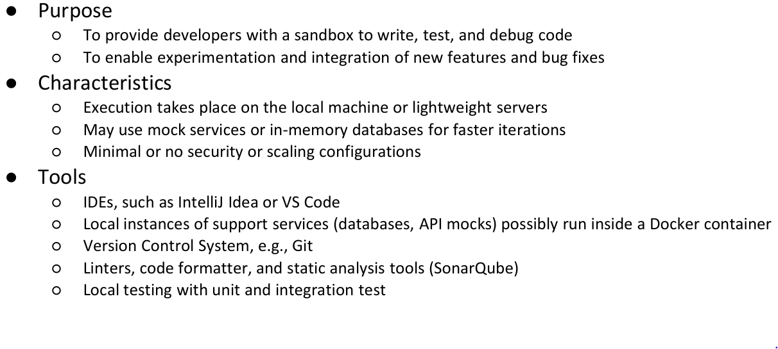

Docker mi piace perché così posso sperimentare già come funzionerà una volta impachettato

* Se voglio contattare db in lcoale, uso localhost; con docker non funziona perché ogni container ha il proprio localhost

SpringBoot da la possibilità di fornire alcune **informazioni di configurazione** (application.properties) in diversi posti e vede prima fuori dall’applicazione e poi dentro.

* Abbiamo database url (springData.databaseURL) nelle application properties, ma se io creo ua variabile d’ambiente con lo stesso nome ma con altro URL, spingBoot prende questa come vera invece di quella scritta nel file.
  + Posso dire che, quando sto sviluppando app, uso localhost… Quando poi muovo la mia applicazione in un diverso environment, devo solo settareuna variabile d’ambiente che fornisce il valore aggiornato e senza ricompilare nulla, ottengo la versione aggiornata.

Tipicamente non si contattano i veri servizi ma mocks, in quanto si vuole solo comprendere il funzionamento.

*Quando il mio modulo è pronto e un altro componente sta sviluppando un altro modulo, c’è bisogno di passare a integration environemnt.*

## **Integration environment**

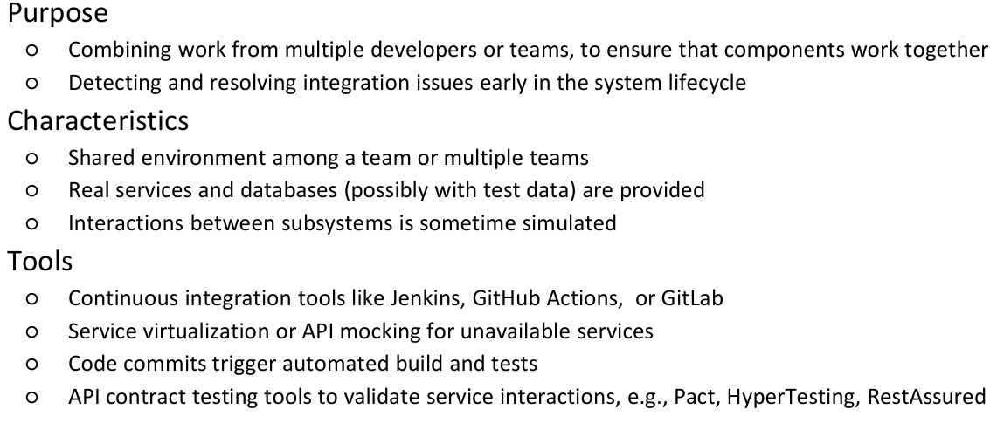

Environment condiviso, dove più persone hanno accesso e possono deployare diverse parti.

## **Testing Environment**

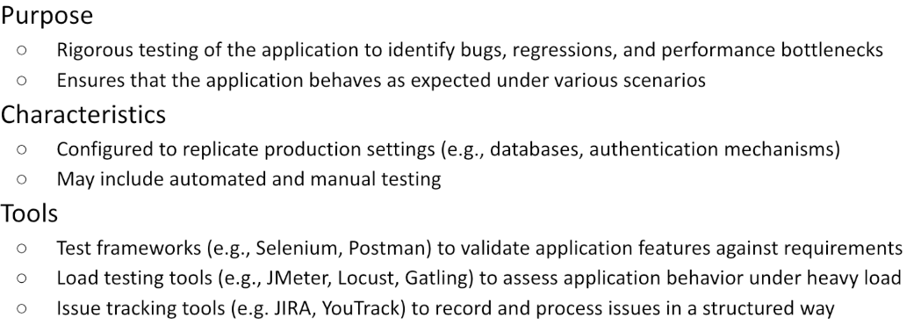

Quando l’applicazione è pronta, si passa allo staging environment

## **Staging environment**

## Immagine che contiene testo, schermata, Carattere, algebra Il contenuto generato dall'IA potrebbe non essere corretto.dati simili ai reali ma non i reali

## Production environment

## **CHALLENGES**

Per garantire con comportamento consistente tra i vari environments, l’esecuzione attuale dovrebbe essere **protetta il più possibile dalle loro pecularità**

* Ridurre a zero l’intervento manuale necessario per aggiustare la configurazione

Allo stesso tempo, il **costo deve essere tenuto sotto controllo**, usando environment leggeri ovunque possibile.

**La privacy dei dati** deve essere considerata anonimizzando o mascherando i dati sensibile in ogni fase diversa dalla produzione.

Per far caso a queste challenges, bisogna far attenzione nell’impostare i vari execution environments, possibilmente **usando procedure automatiche** per fornirli.

Oltre ad essere dei buoni developers, bisogna essere dei buoni DEVOPS: ognuno in una compagnia, indipendentemente da ruolo e titolo, è parte della compagnia e deve collaborare nel far raggiungere alla compagnia l’obbiettivo.

**Componenti di un execution environments**

**Risorse computazionali ->** quante CPU posso accedere

* Pc in cui ranno app
* Server che hostano una serie di virtual machine, enviroment virtualizzato in cui posso eseguire alcuni task
* Docker container in una virtual machine in un vero server
* Application subsystems may run inside these machines hosted by the operating system or inside a container

**Networking**

* Consentire alle risorse informatiche di comunicare tra loro e con il mondo esterno
* Le risorse di calcolo possono far parte di una Virtual Private Network, possono appartenere a diverse sottoreti e può essere protetto da uno o più firewall

**Storage**

* Storage esterno necessario
* Può consistere in dischi condivisi, object storage o DMBSs as a service

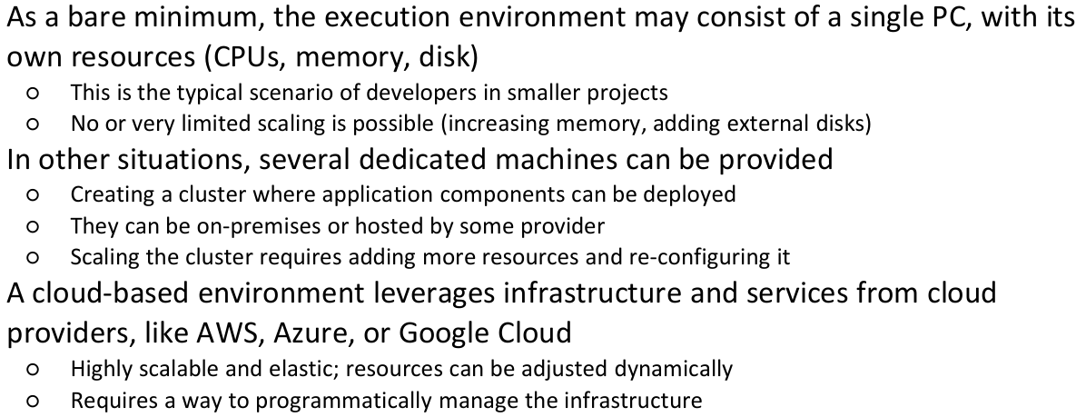

**Configurazioni di execution environments**

## **Comparazione tra costi**

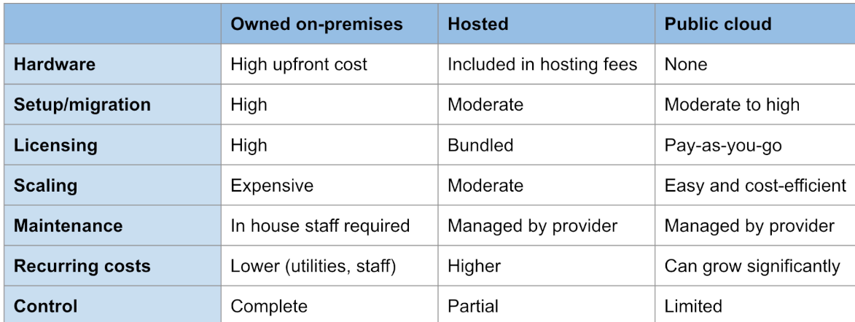

**Owned on premises** -> sono proprietario dei pc, posso farci ciò che voglio

**Hosted** -> ho una serie di macchine che affitto per un determinato lasso di tempo, ho accesso remoto attraverso ssh

**Public cloud** -> non ho il controllo della macchina ma solo del carico di lavoro

## **Infrastracture as Code**

Ci sono tools che danno la possibilità di descrivere l’infrastruttura necessaria attraverso scripts che saranno applicati dal provider in modo tale da riconfigurare il loro hardware in modo tale da fittare ciò che richiedevamo.

Configuration code can be:

* **Declarative** code specifies the desired state of the infrastructure, and IaC tools ensures that the actual state matches it (e.g., Terraform, AWS CloudFormation, Azure Resource Manager)
* **Imperative** code specifies how to achieve the desired state, detailing the steps to create or modify the infrastructure (e.g., Ansible, Chef, Puppet)

Le configurazioni delle infrastrutture sono salvate in un version control system (GIT), abilitando tracciamento di cambiamenti, revisioni e rolled back.

* Running the IaC configuration multiple times produces the same result, avoiding unintended changes

Principali tasks:

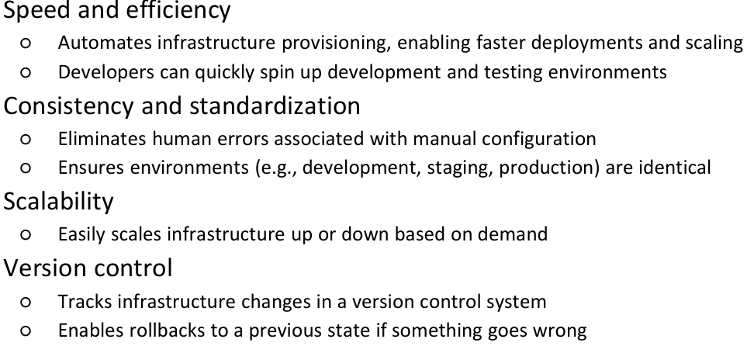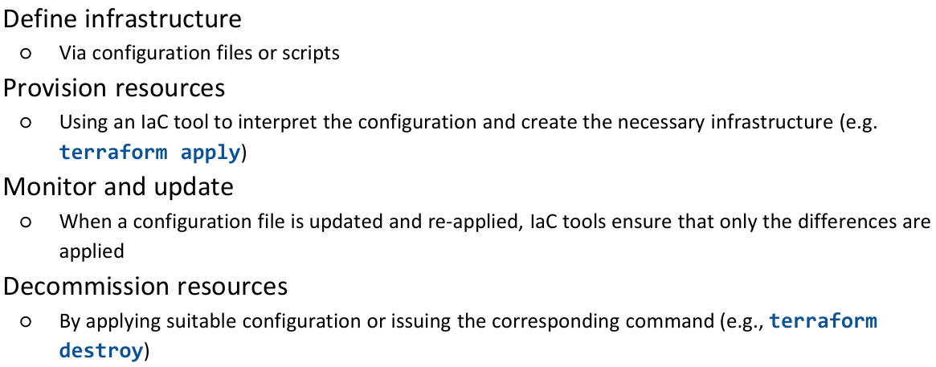Benefits:

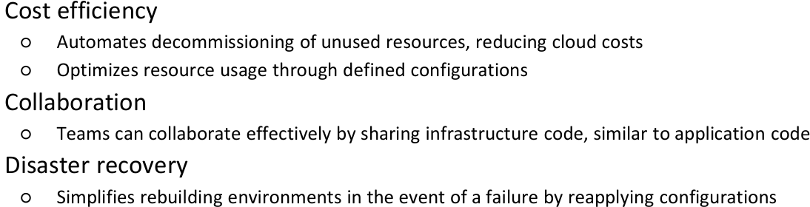

# **Esecuzione del processo**

Data la disponibilità di una o più risorse di calcolo all'interno di un ambiente di esecuzione, i vari sottosistemi di un'applicazione distribuita devono essere allocati  
a tali risorse per essere eseguito

* Allocazione deve occuparsi dei requisiti computazionali
* Networking deve essere propriamente configurato per permettere visibilità tra i nodi che cooperano
* 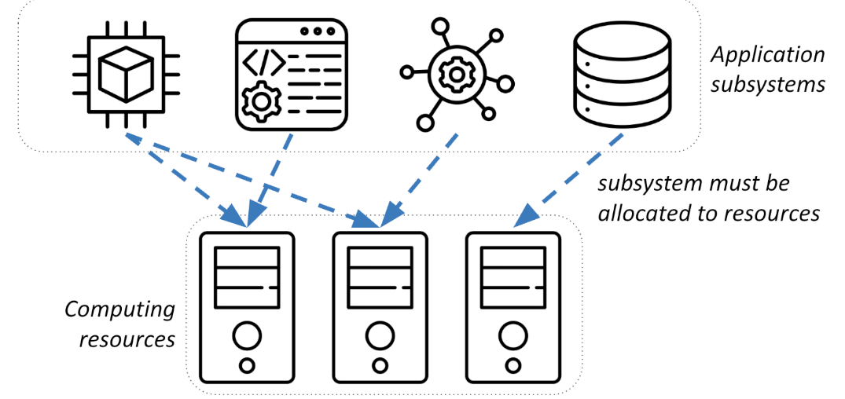Storage deve essere fornito per rendere persistenti i dati

L’esecuzione può avvenire in diversi contesti:

* Localmente, dentro un sistema operativo di un singolo noto
* Dentro un Docker container, runnando dentro un nodo
* Dentro un cluster Kubernetis, estendosi su diversi nodi

## ***Local processes***

Quando la macchina fisica è solo una. Soluzione più semplice, facilmente tracciabile e debuggabile.

* Applicazione sta però condividendo le risorse con il resto delle app sul pc (es: intellij toglie molte risorse)
* Se due o più applicazioni con i loro processi, questi condividono lo stesso disco.
  + Se provano a scrivere un file con lo stesso nome, potrebbe crashare tutto.
  + Condividono lo stesso stack di rete, se vogliono entrambi sentire la porta 8080, uno dei due fallirà
  + Librerie condivise potrebbero essere un problema a causa delle varie versioni
* Magari un’app vuole dei determinati permessi utente mentre l’altra altri.

Ne consegue che local processes, vengono usati per piccoli test

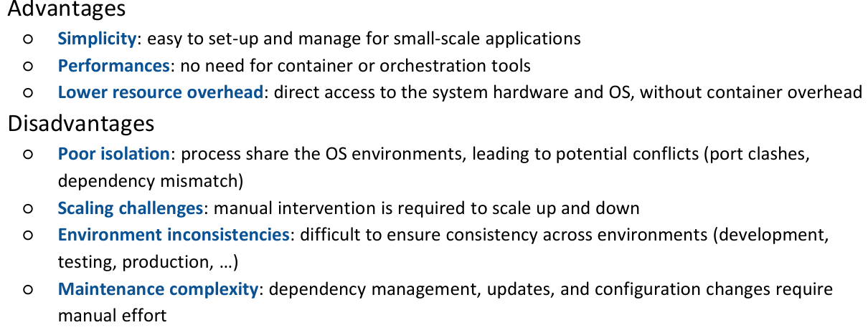

## ***Containers – r23***

Unità di software leggere standalone che possono essere impachettate insieme a dipendenze, pacchetti e quant’altro, in un format che può runnare indipendentemente dal sistema operativo. Loro si basano sulla virtualizzazione del sistema operativo. Ogni container ha il proprio stack di rete, il proprio indirizzo IP, la propria copia del filesystem e loro forniscono un’interfaccia comune per esere deployati e tracciati durante la loro vita. Imapcchetto come container e muovo nei vari execution environments.

Sono stateless -> they can be stopped, destroyed, or replaced without affecting the overall system

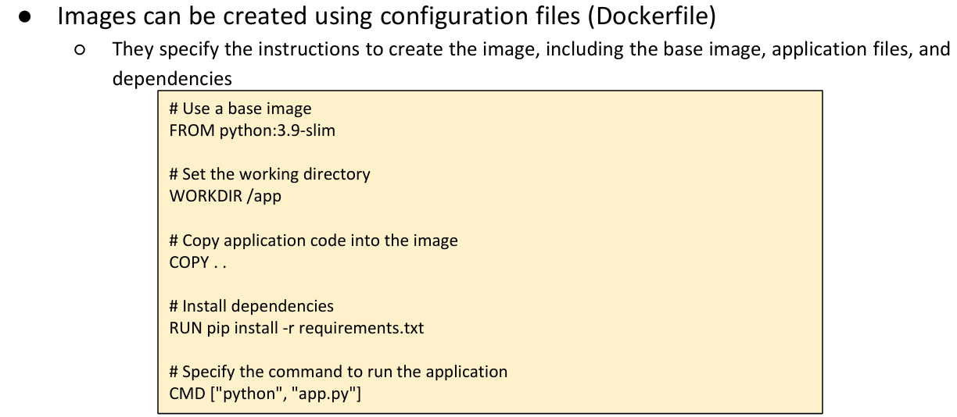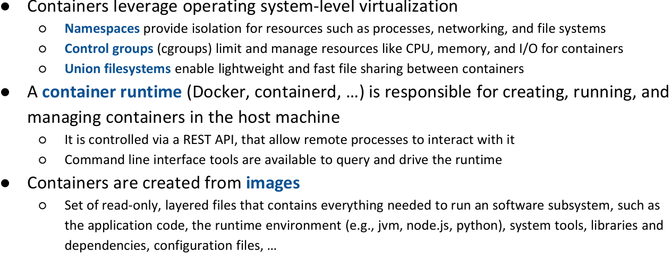  
  
  
  
  
  
  
docker ps -> lista di docker in esecuzione  
  
  
  
  
  
  
  
  
voglio partire da python enviroment

su questo, voglio aggiornare il contenuto della cartella /app, creo questa nuova entry e con il prossimo comando di dirò cosa voglio fare.

Dentro l’immagine che sto creando, copia ogni file che è anche nella directory corrente dell’host (lancio questo comando dalla cartella contente il mio main.py e copia ogni file, che è nella local folder, dentro l’immagine)

Installo i vari requisiti in modo tale che la nostra immagine li contenga

Quando runna

Per runnare il tutto, possiamo invocare da command line “docker build” che crea un’immagine che può essere slavate localmente oppure in un repository facendo “docker push” che prenderà una copia e la pubblicherà da qualche parte.

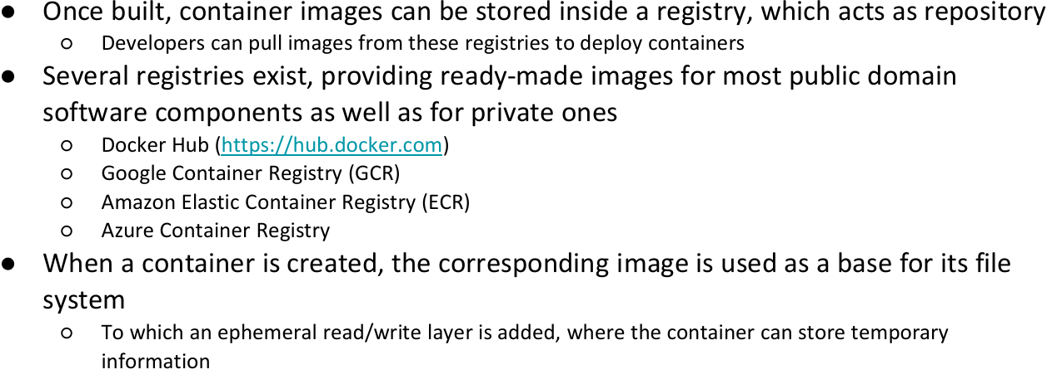

Chiunque ha accesso ai registri, può effettuare una copia dell’immagine e creare il proprio container

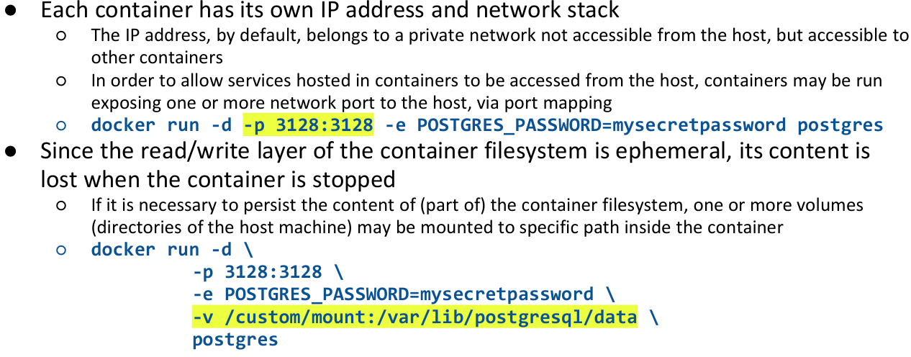

-d -> in background  
-p -> port mapping   
-e -> setta variabili d’ambiente

-v -> *processo postgres deve storare cosa pensa sia un file a quel path, se prova a scrivere in quel file deve scrivere nel mio custom. In questo modo, se stoppo container e lo rilancio, si parte da quei dati.*

In alcune situazioni, abbiamo bisogno di avere diversi container in esecuzione allo stesso tempo. Un modo per stabilire cosa questi diversi container devono fare e quali sono, è usare **un docker compose file**.

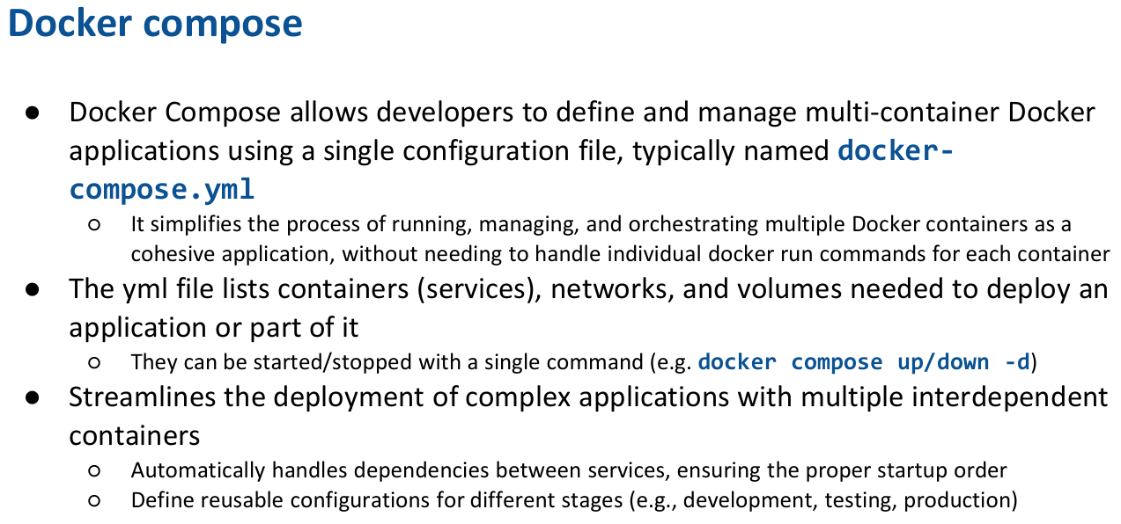

-> runna/chiude tutti i processi

**Services**: insieme di container che vogliamo eseguire

* Postgres: deriva da immagine standard
* Backend: contiene la keyword build, trova la cartella backend e dentro trovi Dockerfile, quando runni il servizio, viene buildata la nuova immagine e si eseguono tutte le immagini lì contenute.
  + Le variabili d’ambiente settate qui, fanno override su quelle dell’application.properties
  + Depends_on: mi dice che prima di runnare questo servizio, deve prima esser partito postgres

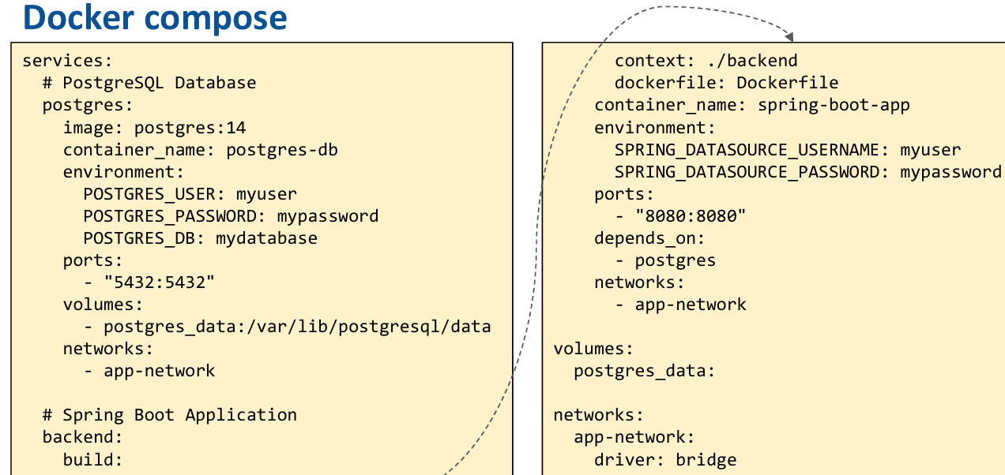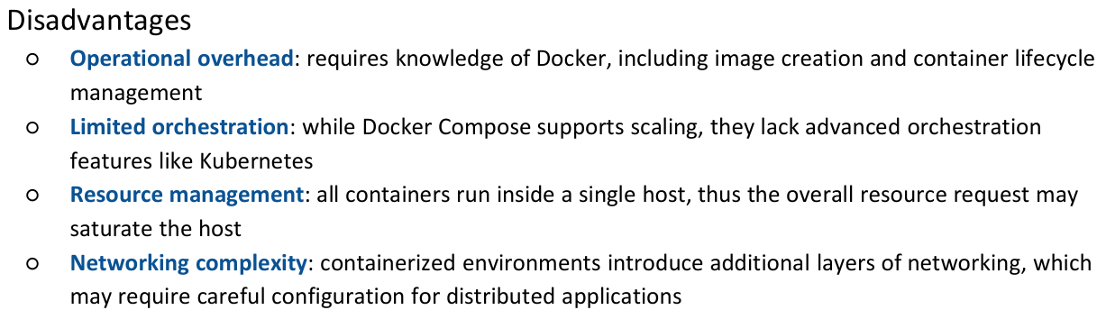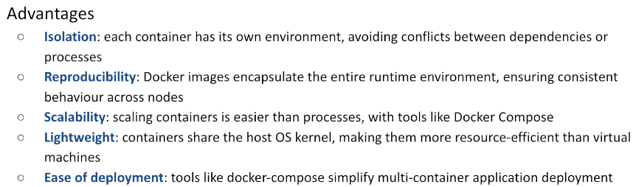

Persone hanno iniziato ad introdurre nuove cose -> orchestrator come Kubernetis.

## **Container Orchestration**

L’idea è: ho un insieme di macchine, voglio vederle come una serie di lavoratori e voglio distribuire il carico di lavoro tra loro. Per fare questo devo creare un modo per permettere ad ognuna di loro di vedere l’altra.

**Kubernetis** allows any number of machines to be clustered into a larger execution environment and taking care to allocate workloads to specific nodes, according to their requirements and to the current cluster state.

Esegue automaticamente una serie di task:

* Properly deployed on available resources
* Scaled up or down based on load
* Monitored for health and restarted if they fail
* Networked securely for communication between services
* Integrated with other infrastructure components (e.g., storage, load balancers)

**Kubernetes clusters**

Open-source container orchestration platform.

I nodi all’interno di un cluster kubernetis possono giocare diversi ruoli:

* **Master nodes**: implementre il control plan
  + *managing the entire cluster; they oversee the scheduling of workloads across worker nodes, maintain the current state and handle cluster-level operations*
  + *max 5 solitamente*
* **Worker nodes**: eseguire il workload
  + where application workloads (pods) run; each worker node communicates with the master node(s) to receive instructions and report status
  + pods: unità di esecuzione dentro uno dei worker nodes, può consistere in uno o più container
    - ci sono situazioni in cui conviene eseguire un pod come una coppia di container
      * uno contenente il principale scopo dell’applicazione
      * l’altro si comporta come side car, fornisce alcune funzionalità

Nota: per creare un cluster, abbiamo bisogno di almeno un pc.

* 1 solo pc: alcuni processi si comporteranno come master, altri come worker
* Solitamente, quando si crea un vero cluster, il cluster è fatto di diverse macchine suddivise in due gruppi
  + Max 5 master nodes
  + Restanti worker nodes

Es: se siamo in 4, possiamo dividere in

* + 1 master e 3 slaves
  + 3 master, 4 slaves (in modo tale che, se 1 muore, ne stanno altre 2 che possono continuare)
    - Nota, se muore la seconda anche, il cluster non funzionerà più. SERVE LA MAGGIORANZA

**PODS**

Container nello stesso pod usano lo stesso spazio di rete, dunque indirizzo di rete.

* Ogni volta che un pod viene eseguito, ottiene un ip address randomico. Ne consegue che non possiamo saperlo in partenza
  + Ci costringe a non comunicare direttamente con lui
* Kubernetis è a conoscenza di quando viene creato un Pod e conosce l’indirizzo IP che ha.
  + Ci fornisce una serie di astrazioni di alto livello per comunicare con il Pod
    - Services
    - Deployment
    - Stateful sets
    - Resource maps
    - Deaemon sets
    - …

**The kubernetes zoo**

* **Deployment**: Kubernetes resource that manages the lifecycle of pods and ensures the desired state is maintained
  + Garantisce che almeno una istanza di quel pod sia attiva e in esecuzione dentro il nostro cluster
    - Se muore per qualche ragione, deployment starterà una nuova copia e switcha a questa
  + Non ha un IP address conosciuto
* **Service**: kubernetes resource that provides a stable network endpoint to access a set of pods, even if they are created, destroyed, or replaced
  + IP address fisso
  + Il mondo esterno può contattare il service che inoltrerà la richiesta all’istanza corrente del pod.

Esistono 4 tipi di servizio:

* + **ClusterIP** -> espone il servizio dentro il cluster
  + **NodePort** -> espone il servizio su una porta statica su ogni worker nodo del cluster
    - Se contatto una porta, i pacchetti vengono direttamente inviati al servizio che espone quella porta
    - Rende disponibile uno specifico deployment in una specifica porta che è disponibile in tutti
  + **LoadBalancer** -> Si integra con i fornitori di cloud per esporre il servizio tramite un load-balancer esterno
    - Conosce come mappare un dato indirizzo DNS all’interno insieme di porte esposte -> lo rende così disponibile via le connessioni fisiche degli host
    - Tipicamente si può anche comportare insieme ad un ingress (componente speciale per ottenere connessioni http e https dentro il nostro cluster)
  + **ExternalName** -> mappa un servizio su un nome DNS esterno
* **StatefulSet** -> risorsa speciale che può essere istanziata in molte copie, al massimo 1 per ogni nodo
  + Contiene uno specifico modo assegnato in un modo prevedibile e deterministico
    - Importante perché può essere connesso ad uno specifico pezzo di filesystem
    - Richiede un volume speciale
  + Mi permette di runnare db dentro un cluster kubernetes
  + Molto importante in quanto:
    - Pods sono effemeral (possono essere creati o eliminati in ogni momento)
      * Se Kubernetes trova che uno dei nodi sta soffrendo per qualche motivo, può decidere di uccidere tutti i pods dentro esso e ristartarli in un altro worker.
      * Pods quindi non possono basarsi sul loro filesystem interno per storare delle informazioni in quanto sono effemeral
        + Non possiamo usarli per gestire una stateful application
* **ResourceMap** -> piccolo read-only database contenente keys-values
  + Utile per garantire che alcune porte condividono un insieme di informazioni
    - In quanto alcune volte, alcune porte richiedono pezzi di configurazione (es: nel container, possiamo necessitare mapping volume)
* **DaemonSet** -> responsabile per avere uno specifico pod in esecuzione su ogni worker node
  + **Fornire alcune funzionalità necessarie (es**: logging, networing, monitoring)
* **Secret** -> utili per tenere alcune informazioni sicure dentro il cluster

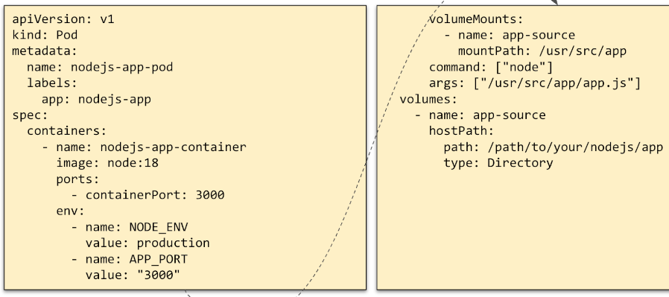

Docker compose.yaml che a sua volta chiede a kubernetis di runnare un’istanza di unápp in un dato modo

cosa fa:

* Creare un Pod -> nodejs-app-pod
* Label utile per gestire meta-data
* Specifiche per costruire pod
  + Single container chiamato nodejs-app-container
  + A partire da immagine node-18
  + Porte che voglio esporre
  + Variabili d’ambiente
  + Volumi

Per lanciarlo, devo usare un utily-command -> kube-ctl

* Legge yaml file
* Invia al cluster

Possiamo vedere il kubernetes cluster come un grande mare dove vari pods vivono:

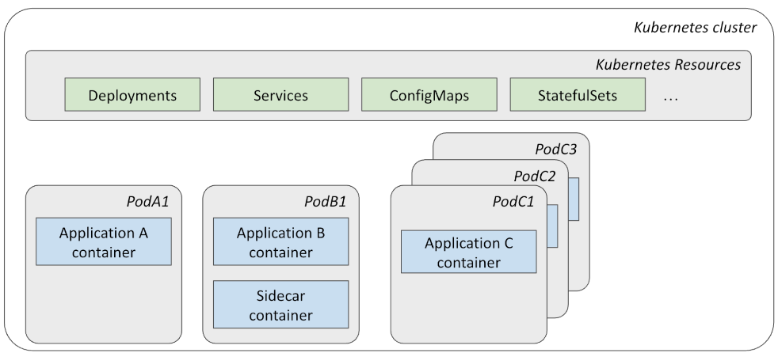

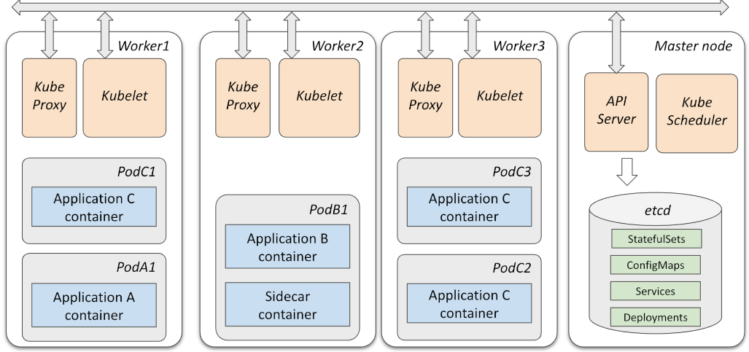Dal punto di vista fisico, il cluster è fatto da un insieme di diverse macchine fisiche divise in Worker e Master.

Sul master node, ci sono una serie di cose comuni: database (conosce esattamente cosa runnerà nel worker) e molte operazioni che il master node esegue, sono continuamente controllate dal worker per verificare che si riflettano a cosa c’è nel db. Quando eseguiamo un comando, kube-ctl aggiorna il db, il nuovo db non riflette più lo stato del cluser, per questo motivo Kubernetes sceglierà che comando runnare sul cluseter per riallineare.

Per fare questo ci sono

* Kube proxy: responsable per la parte di networking, permette di vedere tutte queste macchine come una parte di una grande rete sovrastante
* Kubelet: responsabile per prendere comandi dalle APIserver e di trasformare il comando ricevuto in azioni sull’insieme di pods

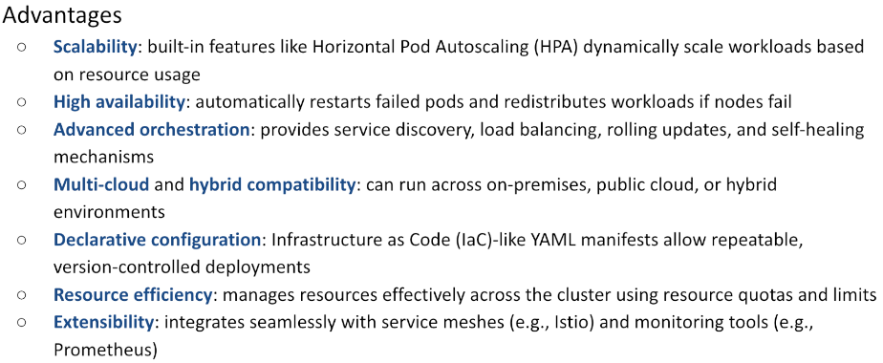

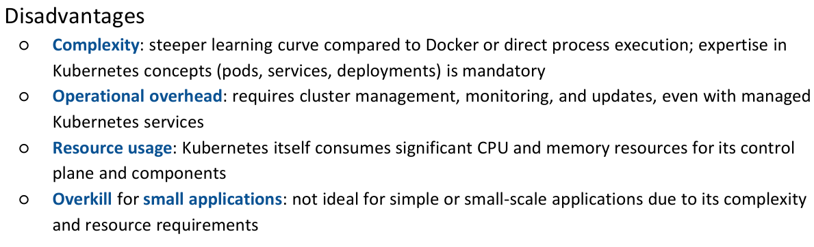

# INTEGRATION TESTING – r24

Prima di parlare degli integration, si deve parlare degli unit.

#### Unit testing

* Unit testing is concerned with the behavior of a **single element** (a function, a class, a module, …)
  + 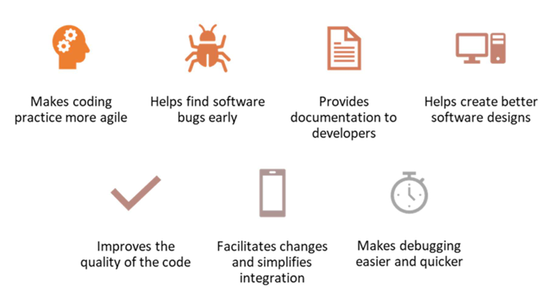Isolato da cosa è intorno
* Focused on **functional correctness**, uses white-box approach and test doubles
* Code base includes dedicated test functions following **AAA-pattern**
  + Arrange: Setup test objects and dependencies
    - Porto il sistema allo stato desiderato
    - Posso mockare dati e funzioni
  + Act: Execute method under test
  + Assert: Verify results
    - Se qualcosa non va -> throw exception

In alcune situazioni, testing è usato come modo per fornire specifiche.

Un test deve essere:

* Facile da scrivere
* Facile da leggere
* Realiable -> deve fornire al volo una prova che il tuo codice sia corretto o meno
* Fast and efficient

Ci sono **testing frameworks** che ci rendono la vita più facile: junit-jupiter (spring-boot-starter-test dependency)

* Classi labelled con @test diventano runnable e vengono usate per test

Per kotlin, conviene usare la libreria mockk:

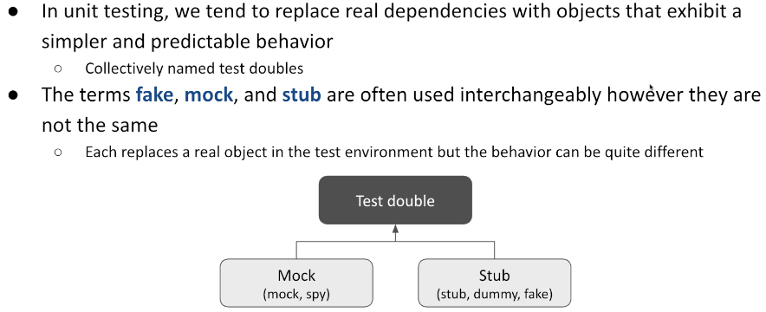

**Mocks**: aiutano ad emulare e esaminare le interazioni in uscita

**Stubs**: aiutano ad emulare le interazioni in ingresso, forniscono dati al nostro sistema sotto test

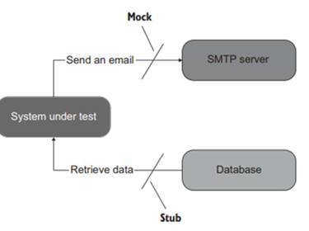

I mocks si dividono in:

* **Mocks**: oggetti con aspettative preprogrammate per i metodi che dovrebbero o non dovrebbero essere chiamati e quante volte
  + **Es**: deve ricevere 2 chiamate di quel metodo e i dati ricevuti devono essere quelli definiti
* **Spies**: accetta ogni chiamata e la salva. Durante l’assertion verifica.

Gli stubs si dividono in:

* **Stubs**: forniscono una risposta predefinita per una data domanda
* **Fakes**: forniscono un’implementazione funzionante, con una logica approssimata
* **Dummies**: oggetti passati ma mai usati

#### Integration Testing

Test che copre più unità, livelli o intero path attraverso l’applicazione.

Solitamente, per eseguire dei test utili, bisogna considerare almeno il db.

Per fare questo ci soo diverse opzioni:

* Di default, quando si crea un progetto, vengono generati dei test example
  + La classe etichettata con @DataJpaTest può essere usata per testare il comportamento del nostro database
    - Istanza di un H2 database, mantiene informazione solo per il tempo del test
      * Non con il mio vero db postgress
* **TestContainer: libreria per costruire un docker container con lo stesso db usato in produzione**
  + Ci piace perché testiamo proprio con quello che useremo
    - Ci fornisce istanze di database, redis, elasticSearch, kafka, selenium wb e tutto ciò che può girare su docker
  + Test container riconfigura SpringBoot in modo tale che, durante l’esecuzione dei test, le richieste vengano redirette al container effimero e non a quello principale
  + L’insieme di operazioni che rende più semplici sono:
    - Fare accesso a tutti gli integration test del data layer
      * Data access layer integration tests: test will be executed using a freshly-created container running the same database used in production code, always starting from a known state
        + Popolare db con dati forniti per runnare test
    - Integration test per intera app (invio della mail)
      * Application integration tests: for running your application in a short-lived test mode with dependencies, such as databases, message queues or web servers
      * Test come http server
    - UI/acceptance tests
      * Usando containerized web browser, compatibile con Selenium, per condurre test UI automatici.

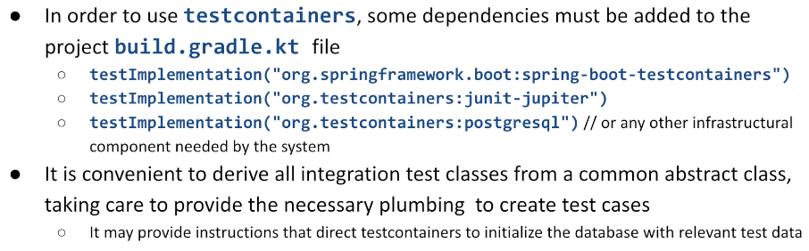

# In modo tale da inserire le azioni da fare prima e dopo ogni test, in una sola parte

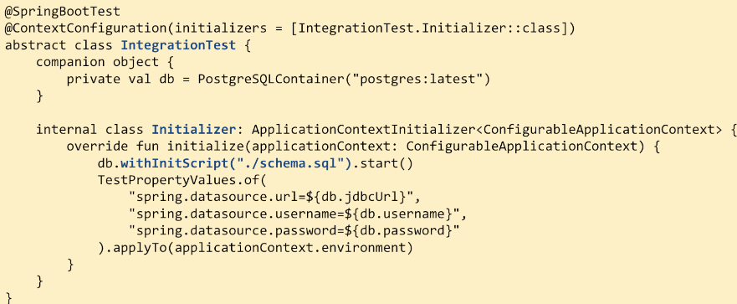 @SpringBootTest: mi permette di processare autoWired dependencies.

@ContextConfiguration mi permette di inizializzare il testContainer, quando l’applicazione runna, per prima cosa runna lo script sql che mi popola il db con un insieme di tabelle e dati. In questo modo i test troveranno cosa cercano.

Inoltre, questo mi garantisce che il db appena creato, sarà propriamente usato per ripopolare la configurazione del nsotro test environment.

Inoltre, possiamo derivare delle sottoclassi contenenti ulteriori test con metodi con @Test per renderli riconoscibili da JunitJupiter per essere eseguiti.

* All’interno di queste sotto-classi, si possono creare delle proprietà di tipo lateinit var che avranno **@AutoWired** 
  + Quando il test sarà istanziato, queste saranno popolate con un’istanza del servizio
  + DB
* In alcune situazioni, oltre al comportamento del servizio, si vuole essere sicuri che contattando un URL, si ottenga il risultato aspettato
  + Si può invocare il controller, mockando con un **MOCKmvc** istance
    - Accetta url e body da sottomettere
    - Si comporta come se application abbia ricevuto una connessione di quel tipo, fornisce accesso diretto al controller
    - Mi permette di controllare che controller invochi service che invochi db che dia una determinata risposta
  + CONTROLLER-SERVICE-DB
* Se voglio che funzioni l’intera catena TomCat, controller, etc
  + Devo usare **TestRestTemplate e WebTestclient**
    - Effettuano una Full Network Request
      * Contattano, come se fossero oggetti esterni, il mio endpoint e controllano la risposta che torna
  + TOMCAT-securitylayer-controller-service-database

**Che tipo di test fare:**

- tanti test direttamente su services

- un po' di test usando MockMVC per controllare le situazioni in cui il controller effettua qualche task più elaborato

- pochi, pochissimi full test su tutta la rete (particolarmente per security)

**Test direttamente su services: TANTIII**

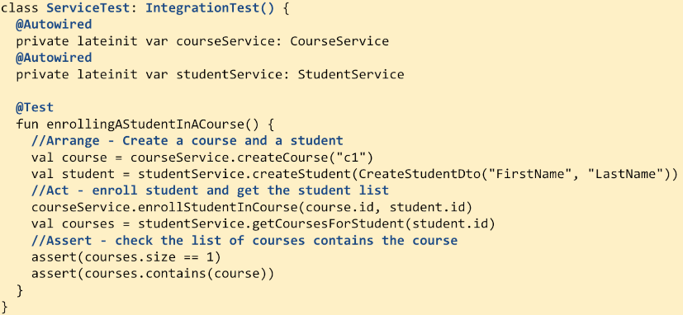

Test più complessi, voglio controllare che il controller si comporti come voglio in risposta ad una get. POCHIIII

* 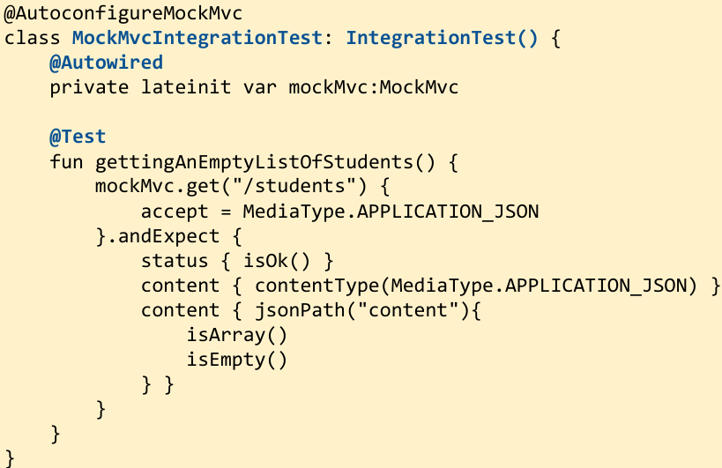inject **MockMVC** object

Questo mi da un object che accetta richieste come get, put, post, etc

Test attraverso tutta la rete con TestRestTemplate. GIUSTO QUALCUNO, soprattutto quando ci sarà security

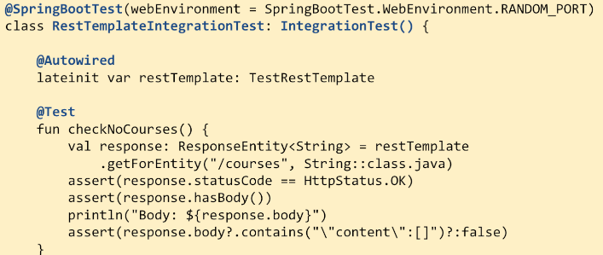

Volendo, posso inserire prima di ogni test @Sql(..) che esegue prima di fare il test quelle chiamate sql

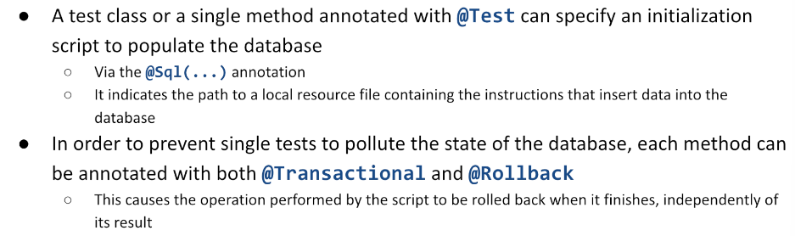

# **MESSAGE BROKERS**

Quando bisogna interagire con più servizi, mantenere transazionalità garantendo che le informazioni ricevute su un canale restino, siano tracciate e possano essere consumate da altri, serve introdurre alcuni componenti infrastrutturali in più.

## Event driven architectures

Quando qualcosa accade, devo essere in grado dinotificare agl altri che quel determinato fatto è accaduto. L’altro può reagire come ritiene opportuno.

* Ignorarlo
* Usarlo come preferisce

Ci saranno 2+ server che interagiranno tra loro.

*The HTTP protocol mostly assumes* ***synchronous interaction:***

* *The request sender (client) expects a response to be generated by the server in the short time*
* *This creates a strong (temporal) coupling between the two roles*

*Choosing an asynchronous web framework* ***does not mutate this paradigm****. The fact that the client and/or the server is based on a reactive implementation is just a detail and still requires that a response is to be produced.*

Diversamentre, Event **driven architectures** are based on systems that interact by **producing** and **consuming events**, stored in a **channel** operated by a broker. This **removes the temporal dependency**, allowing one system to be temporarily down and yet be able to later process received events notifications and react accordingly.

## Events

Events are **facts that happen** in the system: an incoming request, a state change, an amount of time that has elapsed, and so on. They are represented by **data structures** which may be **transferred** from one sub-system into another one. These data representations are named **messages.** A sub-system may operate as a **message producer** or a **message consumer** (oftentimes, it operates in **both ways**).

* A **producer** is a component detecting an event and sending the corresponding notification
  + Descivono cosa è accaduto in un oggetto e lo pubblicano
* A **consumer** reacts to the notification, triggering further processing o ignorando

Inotre, gli eventi possono essere broadcastati, posso ripetere una sequenza di eventi avvenuti nel passato in modo tale da riallineare sistemi ad esempio (sistema si era disconnesso, ora che si è connesso voglio che abbia più conoscenza).

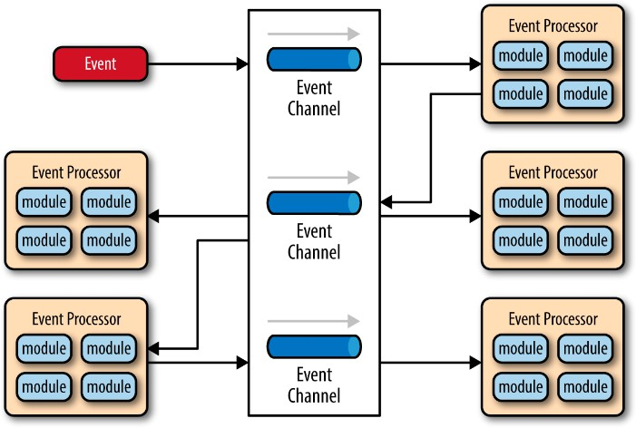Avendo un modo per mantenere l’informazione, posso far funzionare il tutto anche se client e server non sono attivi allo stesso momento. Posso così anche avere sistemi ch evanno a velcoità diversa.

**Event channel**: posto in cui la comunicazione tra produttore e consumatore di un messaggio avviene. Ci possono essere più event channel.

Un evento accade, viene pubblicato sul canale e viene osservato da un **Processor** che è formato da più moduli. Se uno dei **moduli** è interessato all’evento, reagirà a questo evento. Nel nostro esempio, l’event processor, propaga l’evento verso altri 3 event processor attravcerso un altro event channel.

## Events vs commands

A message is the **unit of communication** for event-driven architectures. However, special attention must be paid not to confuse events with commands. While both can be represented with messages, their semantics is different.

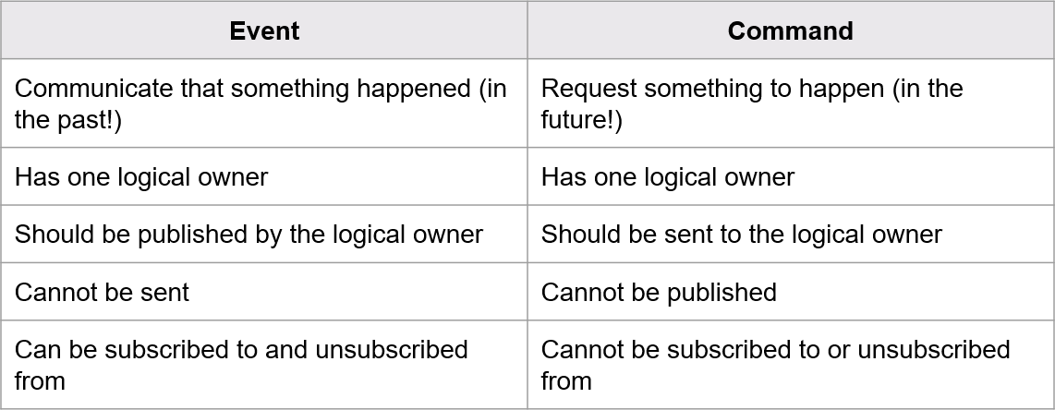

Source  
Target

## **Message brokers r25**

A message broker is an **infrastructural component** responsible of **validating**, **transforming**, and **routing messages** among applications. Applications interact with a broker sending and receiving messages to/from **message queues**. The broker is responsible to **store the messages** and **deliver them** to connected consumers. If no consumer is currently available, messages are **retained and delivered upon connection** of a consumer.

Brokers may support **two approaches** to message delivery

* **Publish/Subscribe**: messages are sent to a specific channel by the producer; many consumers may subscribe to the channels, and they all get a copy of the incoming messages, which are then discarded: events cannot be replayed after having been received and novel subscribers will not get past events.
* **Event Streaming**: messages are appended to a log, in strict time order; consumers can read from any part of the stream, thus they may replay past events.

Brokers can operate with a **push- or pull-strategy:**

* **Push-based** brokers actively forwards incoming messages to subscribers, forwarding them as fast as possible (*RabbitMQ*)
* **Pull-based** ones let subscribers pull for new messages and fetch them at their own rate (*Apache Kafka*)

## Consuming strategies

Brokers offers two types of **consumer policies:**

* **cooperating** – each message is delivered to all connected consumers, thus allowing collaboration among subscribers letting them share a common view of the world
* **point-to-point** – each message is delivered to only one subscriber, even if more than one is connected, thus favoring competition among consumers

## Commands and events in message brokers

A **command** will have exactly **one consumer**: it is responsible of executing the requested action. In order to deal with command messages, a message broker must be **instructed** to send them to only one consumer.

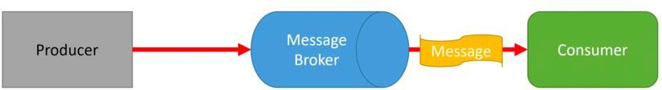

An event will have **zero or more consumers:** when a producer publishes an event to a message broker, it will deliver it to all subscribed consumers. The publisher is unaware of the number and identity of the currently subscribed consumers.

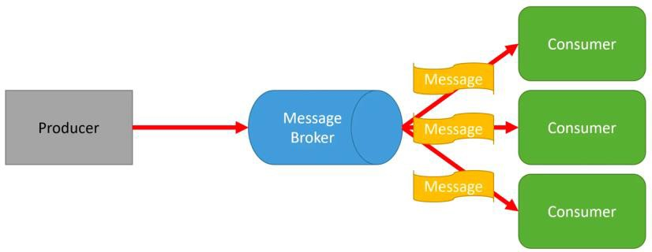

## RabbitMQ

Popular open-source message broker based on the **Advanced Message Queuing Protocol** (AMQP). It can also support other protocols like STOMP, MQTT and WebSockets. Internally it is based on **exchanges** and **queues:**

* Producers send messages to an exchange, possibly adding a routing key
* The exchange applies routing rules and determines which queue should receive a copy of the incoming messages
* Messages may contain metadata (headers) that the broker can use to direct the routing algorithm

When a message is delivered to a consumer, this can **acknowledge** its reception and the broker will then

**drop** the message.

Several types of **exchanges** are supported:

* 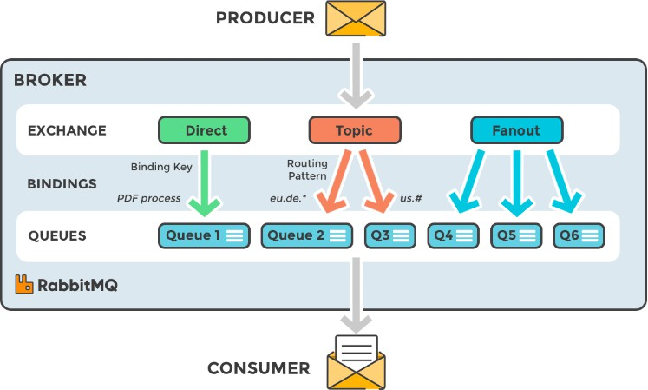**Direct exchange** - it forwards messages to the queues whose binding keys exactly matches the routing key of the message
* **Fanout exchange** - it broadcasts the message to all the matching queues
* **Topic exchange** - this exchange is connected to a set of queues via binding keys that must be a list of dot-delimited words: two special wild-chars are allowed ('*' and '#'), matching,

respectively, a single word or a sequence of zero or more words

* **Header’s exchange** - it bases its routing decisions on message headers rather than routing key

## Using RabbitMQ in Spring Boot

Spring Boot fully supports RabbitMQ via the Spring AMQP project. It facilitates the management of AMQP resources providing the AmqpTemplate bean as a high-level abstraction for sending and receiving messages. Moreover, it supports several annotations to decorate components with extra configuration information.

Posso creare un metodo in una classe ed etichettarlo come RabbitMQListener così che questo metodo sarà invocato ogni volta che un messaggio sarà pubblicato su quella coda. Inoltre ci viene fornito un RabbitMQTemplate per creare messaggi.

By default, it tries to connect to a broker running on localhost:5672. Default connection parameters are guest/guest. A **CachingConnectionFactory** bean can be defined to customize this behaviour.

Queues may be defined declaring beans of class org.springframework.amqp.core.Queue. The constructor accepts up to 4 parameters:

* **name** - a string defining the name of the queue (mandatory)
* **durable** - a Boolean stating whether the queue must survive server restarts
* **exclusive** - a Boolean stating whether the queue is for exclusive use of the current connection
* **autoDelete** - a Boolean stating whether the broker should delete the queue when it is no longer in use

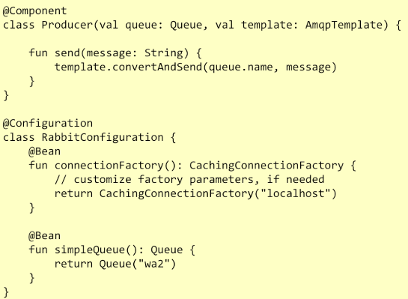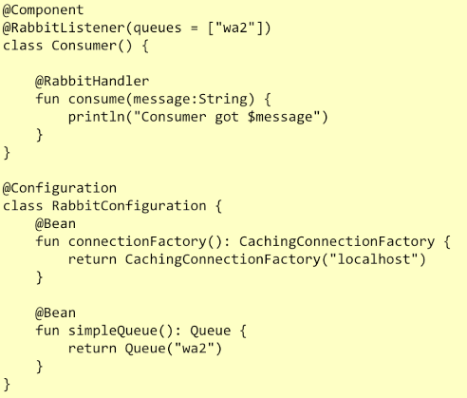Interface AmqpTemplate describes basic operations for interacting with the broker. It provides synchronous send and receive methods

Per comprendere meglio perché questo è interessante, bisogna notare come posso scalare orrizzontalmente con la mia applicazione SpringBoot.

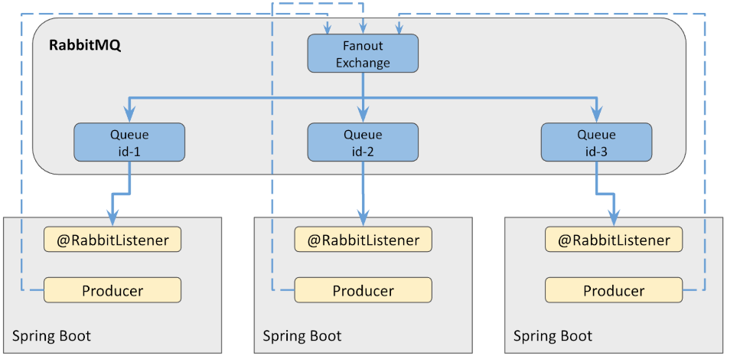

Rende facile la comuncazione:

* **producer** per mandare informazioni fuori
* **listener**: per ricevere informazioni

Fanout Exchange: automaticamente manda i messaggi ricevuti ad ogni coda

* Ogni copia della nostra applicazione SpringBoot si avvia e crea dinamicamente la propria copia della coda
  + Per fare questo ogni copia deve identificarsi in qualche modo

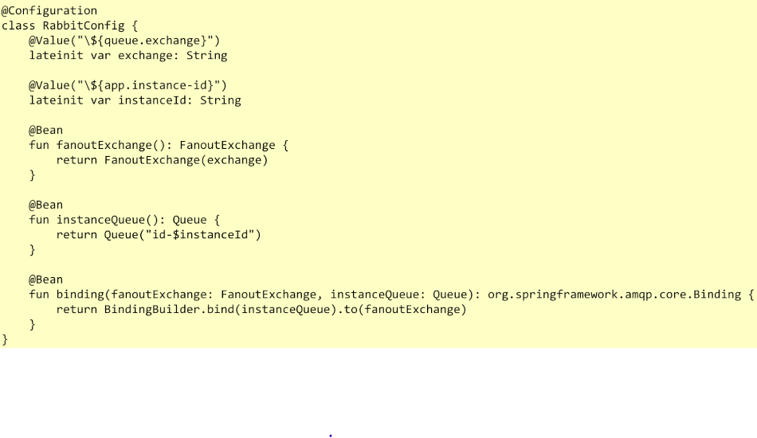

Fanout exchange, necessario per iniettare messaggi. In questo modo, creo un oggetto di tipo FanoutExchange con quel nome. Creando un oggetto di questo tipo, SpringBoot capisce automaticamente che ogni volta che vede un oggetto di questo tipo, deve connettersi ad un’istanza Rabbit e chiedere se c’è già un FanoutExchange con quel nome. Nel caso in cui ci sia, ottiene i dettagli di quello eisstente; in caso contrario, lo crea e prende i dettagli.

Stesso meccanismo avviene per Queue.

L’ultimo blocco è invece un binding object, ci serve per collegare instanceQueue a FanoutEchange: dico a rabbit di inviare tutto ciò che arriva al fanout exhange, alla coda.

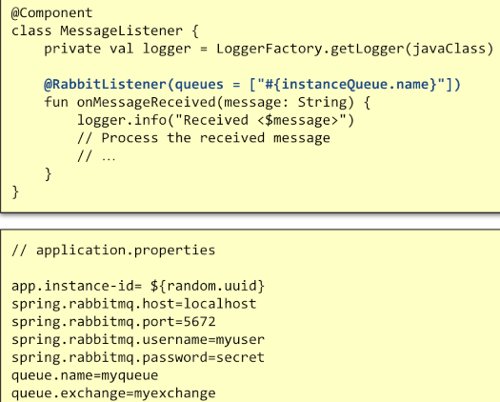

Per processare messaggi in arrivo su quella coda.

* Informazioni su connessione

Se devo inviare qualcosa, devo usare il RabbitMqTemplate con il comando ConvertAndSend con id del mio exchangePoint. Tutte le istanze saranno capaci di notificare le peer application di tutto ciò che è rilevante e può interessare. Se una di questa applicazione si disconnette, la corrispondente coda viene eliminata; Se si connette una nuova applicazione, viene aggiunta una coda per questa. Il messaggio viene ricevuto da coloro che sono attualmente connessi, niente di più.

## Apache Kafka

A highly **scalable and fault tolerant event streaming** platform based on a cluster of servers. It is designed to support mission critical applications and capable to be run on bare-metal hardware, VMs, containers, both on-premises and in a cloud. It logically **manages a set of topics**, which organize and durably **store events** sent by applications. Each topic can have **zero or more producers** writing events to it, and **zero or more consumers** that subscribe to these events. Events are appended to a **topic** and can be read **as often as needed**. Event publication occurs inside a transaction.

Fisicamente, il nostro sistema kafka è composto da 1+ server dedicati, ma **dal punto di vista del programmatore, si può considerare kafka come un singolo server che espone un insieme di API**.

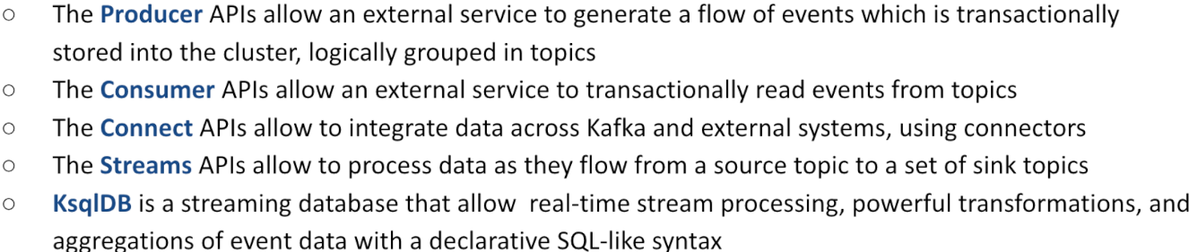

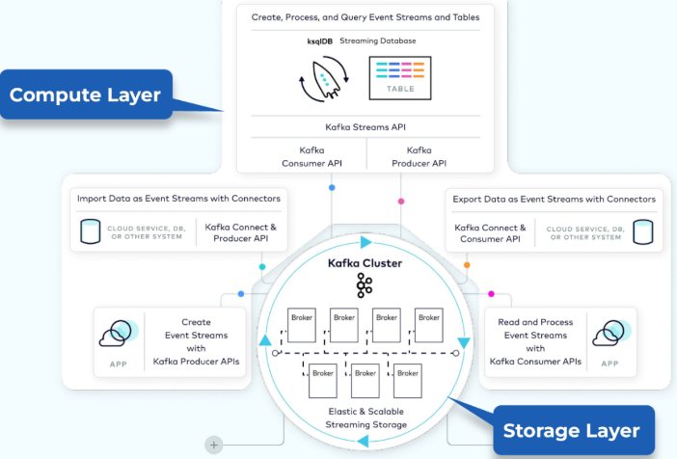

## **Organizzazione di kafka:**

Al minimo, il sistema kafka, è un insieme di macchine che comunicano tra di loro in modo tale da condividere i loro load e gestire le informazioni che nesessitano. Internamente, le singole machine sono nominate **broker**, possono essere aggiunte o rimosse in ogni momento. Ognuna di esse, espone l’insieme completo di API che sono presenti. Quindi i client possono connettersi ad ognuna di queste macchine.

Tutto ciò che è fuori dal circolo, è l’insieme di client supportati da kafka.

Tipicamente **un’applicazione può essere un client del sistema kafka:**

* Come producer: contatta host del cluster con una richiesta per produrre messaggi. Il cluster reagisce iniettando i dati e garantendo in modo transazionale che i dati iniettati siano mantenuti in modo sicuro per essere processati successivamente
* Come consumer: chiede di legegre il contenuto di un dato topic.

Kafka mi permette di gestire grandi quantità di dati in poco tempo (a differenza di quanto succederebbe provado ad inserirli direttamente su postgres).

PRODUCER: applicazione che genera dati

CONSUMER: applicazioni che legge dati

Un topic in kafka, prende dati da 0+ producer e fornisce dati a 0+ consumer. Un consumer, non sa da quale producer arrivano i dati, sa solo che questi arrivano. Tipicamente il sistema kafka, mantiene l’offset dell’ultimo messaggio consumato, quindi il consumer può semplicmente leggere chiedendo il seguente oppure può settare una determinata posizione da cui vuole leggere.

## **Topics**

A Topic is a **category/feed name** to which messages are **stored** and **published.** It is organized as a **log file**, making the consumers responsible for tracking their position in the log.

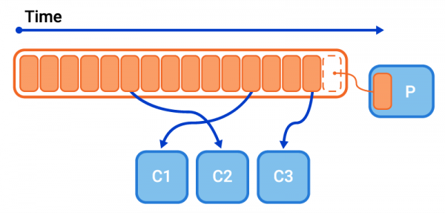Il server è responsabile di salvare e conservare i messaggi, i messaggi sono storati in più repliche in modo tale da resistere ad eventuali fallimennti.

L’informazione dentro i topic viene mantenuta basandosi sul fatto che i messaggi contengono una chiave, payload, [headers].

* **Key , value (payloads) e headers** sono trattati come normali byte;
  + Messages with the same key are stored in the same partition, keeping the arrival order.
* Diversamente, i message boundaries vengono riconosciuti da kafka

I messaggi sono immutabili, questo vuol dire che, una volta salvati all’interno di un broker, non cambieranno. Ogni messaggio contiene un **timestamp** che rappresenta quando sono arrivati.

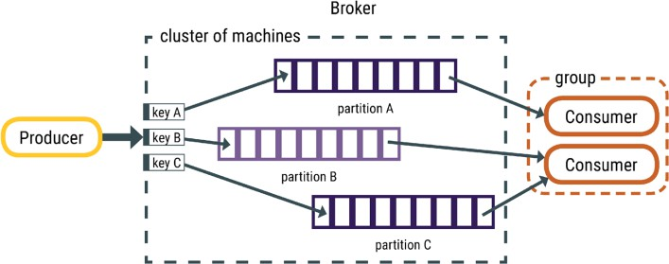Topics are divided into a number of **partitions** (numero fisso che non viene cambiato per l’intera vita del topic). When a message is sent to a topic, it is stored in **exactly one partition**. **Messages** are the elementary objects stored in a topic.

Kafka calcola l’hash value della chiave e in base a questo determina la partiione che si occuperà di quel messaggio.

I messaggi dentro la transizione sono ordinati e il consumer leggerà i messaggi esattamento nell’ordine in cui questi sono mantenuti nella partizione.

Posso avere più di una partizione se:

* Non è utile mantenere un ordine completo delle informazioni, aumento il parrallelismo
* Se è facile dividere i messaggi in gruppi indipendenti a livello applicazione

La partizione è utile per:

* Inserire dati più velocemente
* Parallelismo nel processare i dati

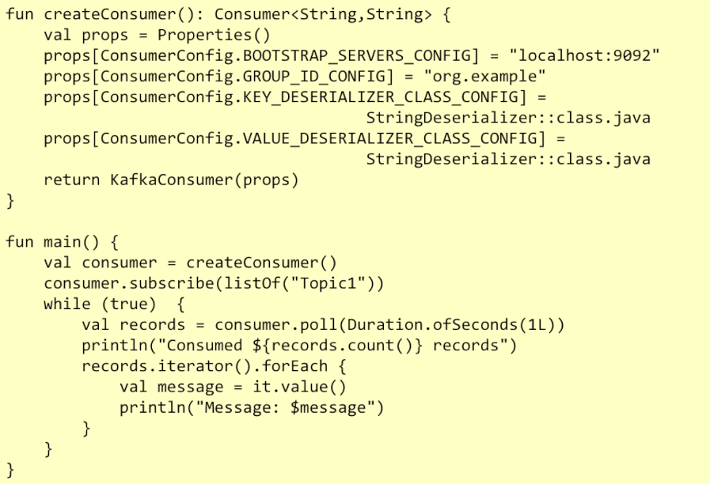

Insieme di host separati da virgola

Nome del gruppo che può connettersi

Deserializzatore della chiave in modo che questa abbia un senso e non sia solo un insieme di byte.

* Oggetto per trovare

Consumer sarà interessato a topic1

* Sono pronto a leggere
* Posso riposizionare l’offset per leggere in un determinato punto
* Poll: operazione in cui si chiede se c’è qualcosa di nuovo dopo quell’offset
* 1L seconds vuol dire: se non c’è nulla di disponibile, attendi 1 secondo; se niente sarà ancora disponibile ritornami un insieme vuoto.

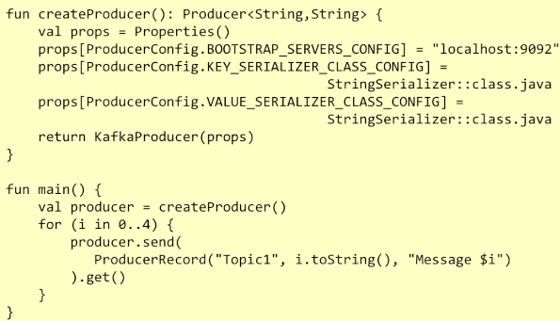

Send-> causa operazione asincrona. Send ritorna immediatamente ma l’operazione viene svolta in modo asincronol; Se ho bisogno di vedere che ogni singolo messaggio venga letto prima di ritornare, devo usare la get.

Kafka viene instaziato come un insieme di broker connessi.

Internamente mantiene comunicazione tra le parti e accordi su chi svolge quale ruolo.

## **Using Kafka in Spring Boot**

Spring Boot supports Kafka integration, applying core Spring concepts to the development of a Kafka-based messaging solution.

* Class **KafkaTemplate** provides a high-level abstraction for sending messages.
* The *@KafkaListener* annotation can be used to label **message-driven components** that act as receivers of messages published to a given topic.

**Custom message content** is supported, by serializing it to JSON format.

* Custom KafkaTemplate instances must be created in order to support serialization to a given data class.

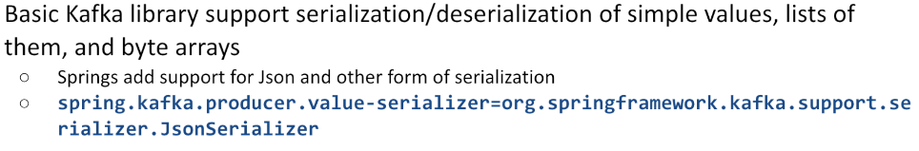

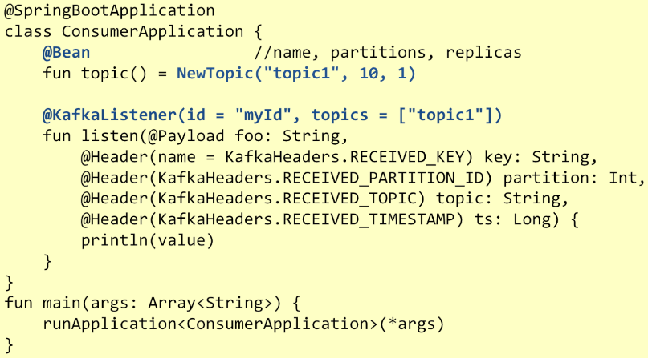

* 10 partizioni e 1 sola replica

Metodo listener, ogni volta che ottengo un nuovo messaggio, questo metodo sarà attivato.   
Questo metodo vuole leggere Key, Partition, Nome del topic da cui ricevo (in quanto potrei essere iscritto a più topic), quando ho ricevuto.

Nota: se un topic con quel nome esiste già, non verrà modificato ma ci sarà dato quel topic come è…

* Se non eisste, viene creato con i parametri che specifichiamo

**Per poter runnare il programma**, bisogna fornire un insieme di file di configurazione:

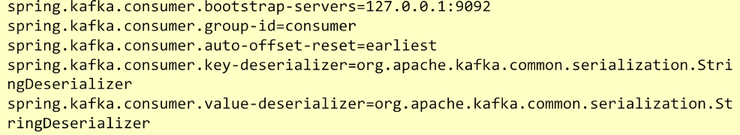

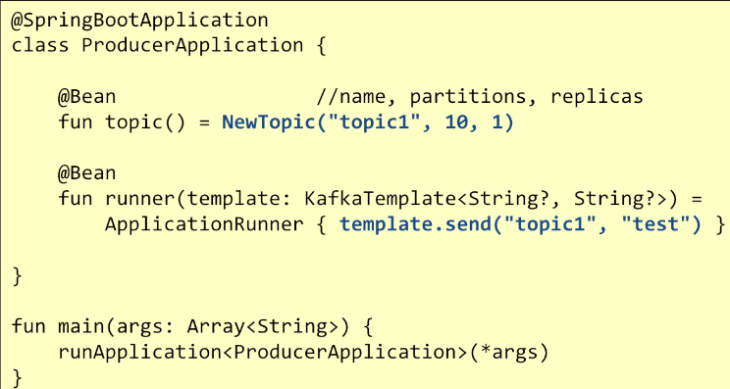

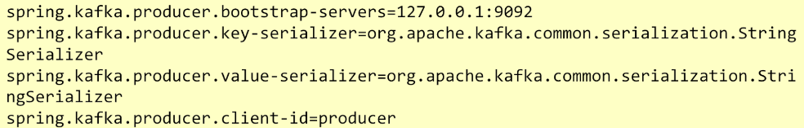

Codice per farlo funzionare con docker.

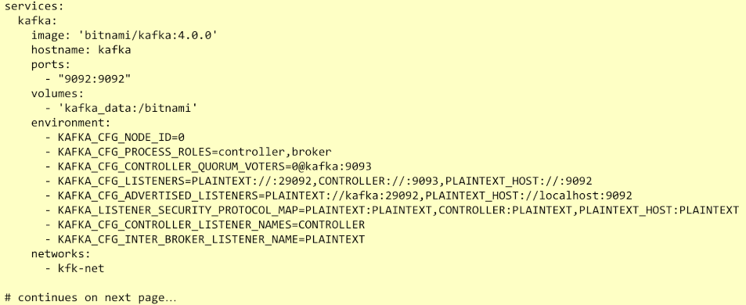

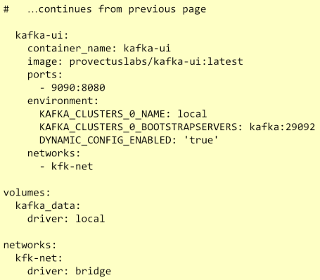

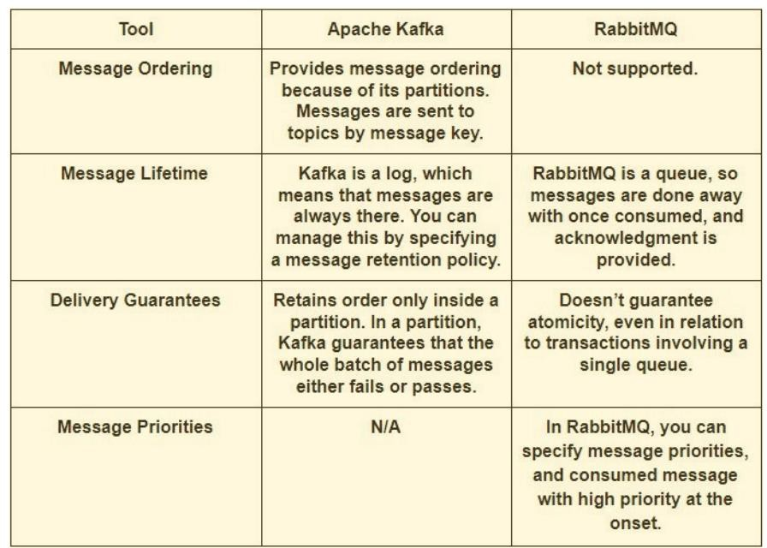Message brokers comparison

## **Kafka Connect**

Tool che si basa sulla capacità transazionale di kafka che è esplicitamente pensato per muovere dati da alcune sorgenti ad alcune destinazioni, usando uno step intermedio (kafka topic).

Kafka connect consiste in due pezzi diversi che possono essere usati insieme o sepratamente:

* Lafka connect sources: processo che tipicamente può assorbire o inserire dati da database, cloud, remote API e pullarli dentro un kafka topic
* Kafka connect sink: leggono data da un topic e li pullano in un target system
* CONFLUENT.IO/HUB :sito con sources e sink già fatti

Uno dei connectors esistenti è “The Basium” che si occupa di osservare cambiamenti che occorrono al mio databse e propagare i cambiamenti, il Delta.

* C: creation
* U: update (before and after)
* D: delete
* Tungstone: messaggio che non contiene dati ma solo una chiave “dopo l’operazione di delete questo è sparito”

Quando setuppo kafka connect, definisco docker compose description dove definisco brokers che forniscano la possibilità di storare topic, voglio avere anche kafka ui e voglio aggiungere servizio per kafka connect.

Questo servizio di default sarà silenzioso, Deve essere configurato con l’indirizzo del kafka broker e deve essere configurato anche con la descrizione del lavoro che deve compiere (source: connettiti al db e fetcha dati; sink: leggi da un kafka topic e produci l’output)

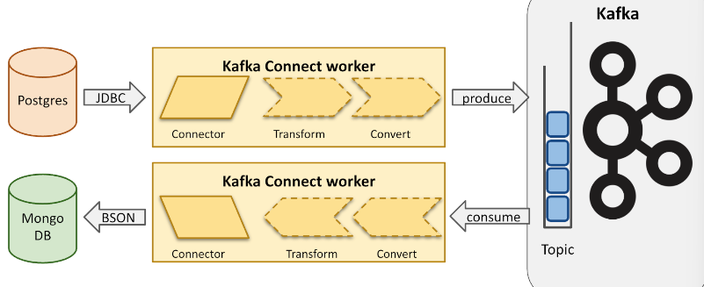

Vantaggi:

* Scalability
  + Gestisce grandi quantità di dati in maniera efficiente
  + Streamma dati in diverse partizione del topic in modo tale da dividere il lavoro su diverse macchine
* Reliability
  + Assicura consistenza e fault tollerance
  + Transazionale , implementa ExactlyOne
* Resuability
  + Connectors possono essere usati su più implementazioni
* Configurability
  + Il comportamento viene descritto da un file di configurazione json

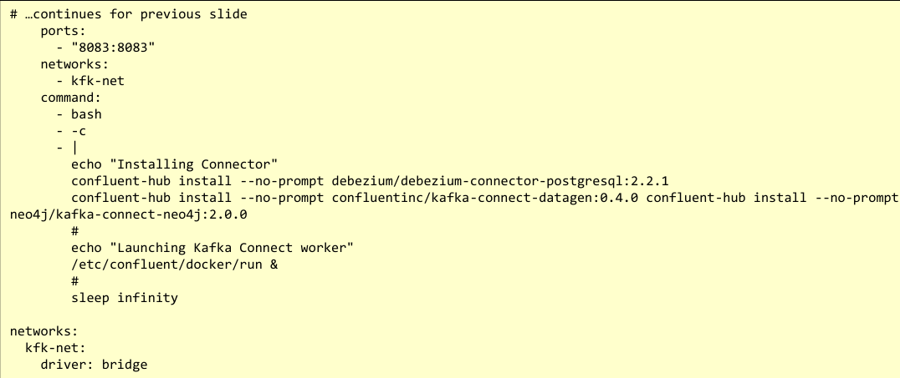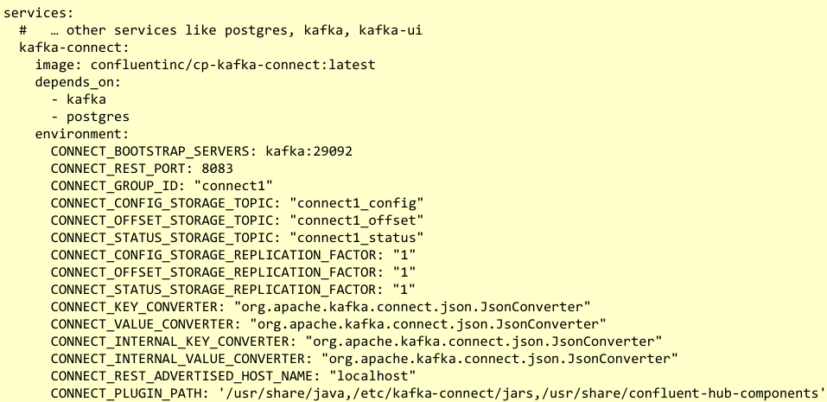noi 1 perché il nostro pc è quello che è, in produzione almeno 3

Impostare versione attuale, questa vecchia

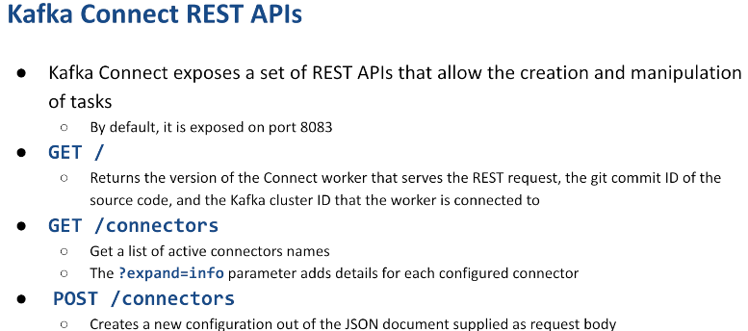utile per debug

Es di Post:

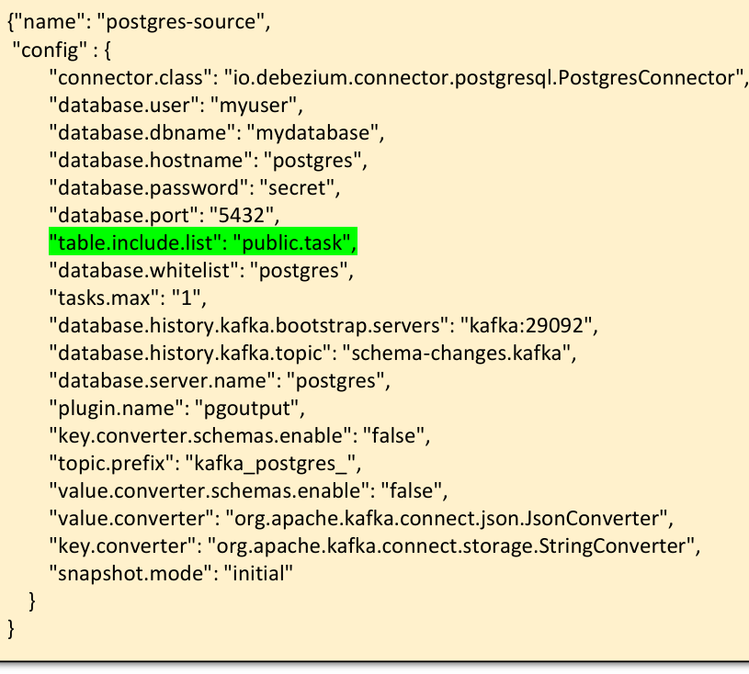

In alcune situazioni, voglio prendere molteplici input da un singolo output o creare molteplici output da un singolo input o N records da input per produrre M records in output (records che ptorebbero non essere consecutivi)… In questi casi abbiamo bisogno di kafka stream.

**Kafka Stream**

Kafka Stream è una streaming computing platform per processare e analizzare i dati salavti in kafka e riscrivere i dati risultanti in Kafka o inviare l'output finale a un sistema esterno

* Per realtime
* Si basa su topic partitioning per scalabilità orrizzontale

I principali usi sono per analisi realtime, sistemi per monitorare e allarme, applicazioni event-driven

**Stream**

Sequenza di dati immutabili ordinata, processabile più volte e fault-tollerant.

* Non cambio cosa vedo -> sono eventi accaduti nel passato
  + Questi eventi producono dei dati

Gli stream sono composti da 3 parti:

* Key
* Value
* Timestamp: può far riferimento a diverse cose
  + Quando il fatto è accaduto
  + Quando il fatto è stato preso da kafka (utile ad esempio nel caso in cui i mittenti abbiano tempi diversi)

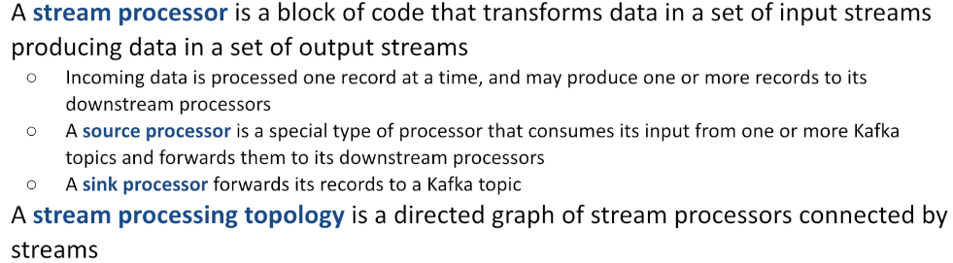

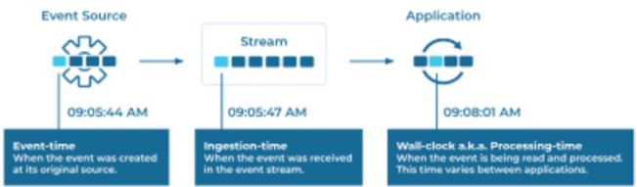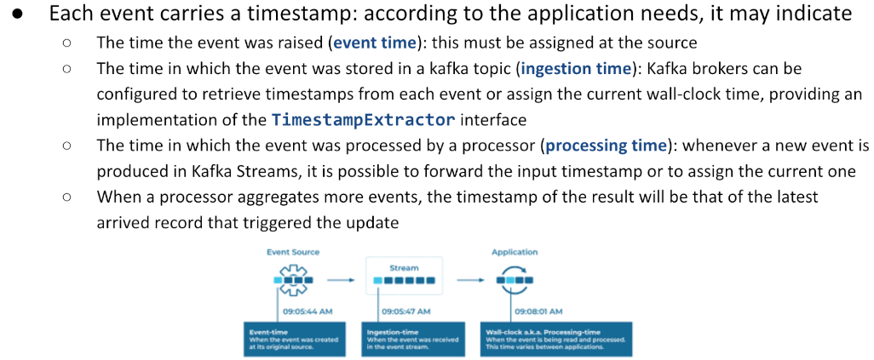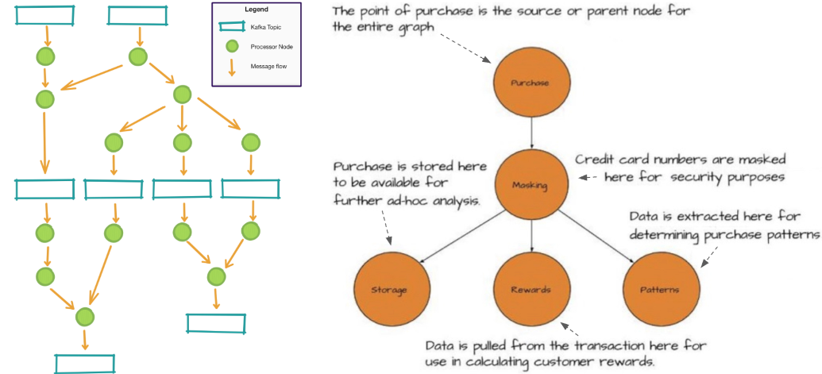

**Gestire lo stato degli eventi**

In alcune situazione si può consumare il messaggio in arrivo e produrre immmediatamente un messaggio di uscita. In altre situazioni non si può, ad esempio:

* **Debouncing system**: ottengo informazione, mantengo, gestisco eventuali update, update e infine il metodo settato.
  + Se il rercord originale viene modificato tante volte, mi conmviene non salvarlo immediatamente ma aspettare qualche minuto: se non avvengono cambiamenti lo carico, altrimenti lo sostituisco con quello nuovo e poi lo carico quando definitivo
  + Questo vuol dire che sto leggendo un record ma non lo sto processando immediatamente, mantengo da parte finchè non ho abbastanzza informazioni o non sia passato abbastanza tempo
  + Leggo tantissime informazioni
* Kafka streams fornisce una’architettura sicuro per gestire il tutto. Mantiene in modo sicuro queste informazioni
  + Nel caso in cui il sistema viene fermato e riparte successivamente, ricrea lo stato in cui il sistema era precedentemente.

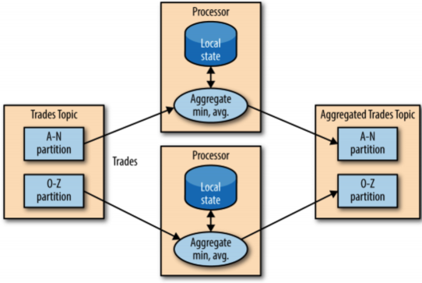Inoltre la scalabiità è fornita dal fatto che il topic può essere instanziato molte volte, una per ogni partition del topic.

* Posso avere diverse partizioni, ognuna su una parte dei dati in input

SpringBoot supporta kafka streams>

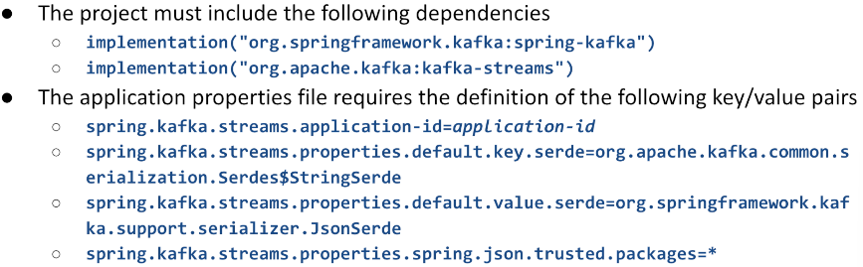

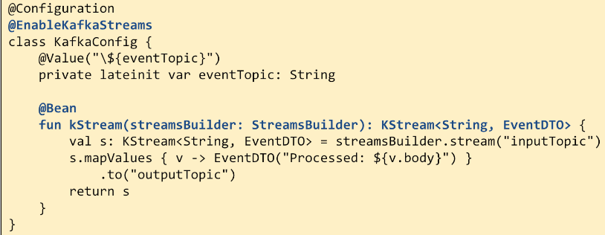

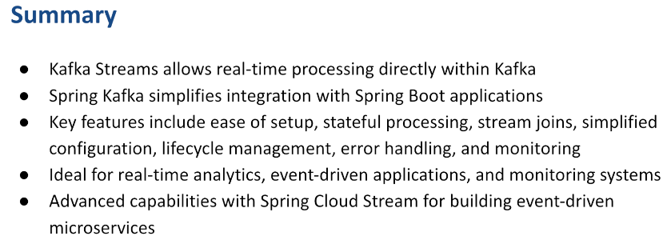

# **Authentication and Authorization – r28**

Quando un’applicazione ha bisogno di accedere ad una risorsa remota, bisogna considerare due aspetti principali:

* Autenticazione: chi/cosa sta accedendo
* Autorizzazione: controllare se può accedere o no ad una specifica risorsa

Nota: serve una pagina di registrazione e una pagina per accedere.

* Può registrarti un admin del sistema (e come fare con pw??)
* Puoi registrarti tu e chi dimostra che sei tu veramente??
* Si può fare con metodo misto…

A questo punto serve una pagina per fare il login, e una pagina per il recovery della password… Ma questo deve essere molto sicuro, non deve essere troppo facile… Inoltre la password deve avere delle caratteristiche speciali e magari una data di scadenza.

Inoltre, potresti dimostrare la tua identità attraverso una terza parte (mail) ma bisogna anche vedere i diritti d’accesso.

Per questi motivi, si è pensato ad un altro metodo per fornire tokens che permettano un insieme di operazioni. Due protocolli a riguardo:

* OAUTH
* OATC

Sono stati definiti dei tools, per gestire questo problema: IAM (Identity Access Manager) che si occupano di gestire un insieme di utenti e le interazioni con la tua applicazione

* Multi-factor authentication
* SingleSignOn (si basa su identità confermate su altri provider: gitHub, google…)
* RoleBasedAccessControl
* AttributeBasedAccessControl

Inoltre questi tool permettono di restare compliant con GDPR.

Nel nostro corso utilizziamo **KEYCLOAK**: user federation, strong authentication, user management, fine-grained authorization.

Ne esistono altri come Okta, Auth0 (VEDI MEGLIO SLIDE 4 PER TUA INFO)

Le Responsabilità sono:

* **Autenticazione**
  + This process can involve various methods such as usernames and passwords, multi-factor authentication (MFA), biometric data, one-time passwords (OTP), and more. Effective authentication is crucial in preventing unauthorized access.
    - Chi accede è davvero chi dice di essere?
* **Autorizzazione**
  + This is achieved through settings that define **permissions and role**s assigned to users, ensuring that they have only the necessary permissions to perform their jobs
    - Quali sono i poteri dell’utente?
* **User management**
  + IAM tools support creating new user accounts, updating profiles, managing roles and permissions, and deactivating or deleting accounts when necessary
* **Access Control Policies**
  + IAM tools enforce access control policies that dictate how resources are accessed and used
  + These policies can be based on attributes (such as department, role, or location), ensuring that they comply with organizational security policies and regulations
* **Single Sign On**
  + It allows users to log in once and gain access to multiple related but independent software systems without having to authenticate again
  + SSO improves user experience while reducing the chance of password fatigue, lowering the risk of phishing attacks
* **Federated Identity Management**
  + This feature enables users to access systems across different organizations using their home organization’s credential
    - Es: posso accedere a youtube con accesso di google
* **Audit and Compliance Reporting**
  + IAM tools generate logs and reports that can be used for auditing and compliance purposes
  + These reports help organizations verify that their security policies are being followed and assist in forensic investigations if breaches occur

Questo accade perché IAMs sono tipicamente sistemi standAlone che fornisco interfacce (ad esempio per loggarsi) e una volta loggato, ti restituiscono un token: Token è un pezzo di dato crittografico che puoi prendere nella tua applicazione e la tua applicazione può usare per validare, per vedere chi sei e per controllare i permessi che hai. Attualmente IAM fornisce 3 tipi di token:

* **Access Tokens**: gestiti dall’applicazione, contengono i permessi per fare/non fare qualcosa
  + Non serve per identificare la singola persona ma cosa può fare
  + Solitamente hanno una breve validità nel tempo, scadono subito
* **Refresh tokens**: per ottenere un nuovo access token quando quello corrente scade
  + Per avere accesso più lungo, una persona deve rubarmi access token e refresh token
* **ID tokens**: contiene in modo specifico la mia identità
  + Encoded nello standard JWT

Il protocollo attuale è OAuth2.0 che prevede che il nostro sistema server, si comporti come client di Oauth2.

* Definito client perché chiede al IAM di validare l’utente.
* Il client, quando riceve l’access token, permetterà all’utente id ottenere le informazioni
* In alcuni casi, il client deve avere la possibilità di contattare un altro server di terze parti dove l’utente ha delle informazioni
  + Es: ha la carta di identità salvata su google drive e vuole prenderla da lì però non vuole fornirti le credenziali di google drive. Ti vuole solo fornire il permesso di accedere a google drive per leggere quel file.
    - Google drive si sta comportando come resource server.
      * Mia applicazione contatta google
      * Google ti autentica
      * Io posso accedere a quel file

**Codice r28**

Oltre ad installare l’IAM, bisogna **registrare la nostra applicazion**e per lavorare con esso. Questo è possibile perché nell’IAM abbiamo creato un client con il nome e il secret corrispondente e, in questo modo, la comunicazione tra client e IAM può prendere luogo ed essere sicura e loro possono capirsi a vicenda.

Nel momento della registrazione, possiamo specificare che tipo di tokens vogliamo fornire all’applicazione attraverso la variabile di configurazione “scope”.

* Nel nostro caso abbiamo visto OADC (access + id + refresh)
* Ne esistono di altri, customizzabili in base a quello che vogliamo fare con specifiche richeste e permessi.

La comunicazione che avviene tra client e IAM possono accadere su diversi **scenari chiamati FLOWS**. Tra questi abbiamo:

* Password credential flow (deprecato): non era sicuro
* 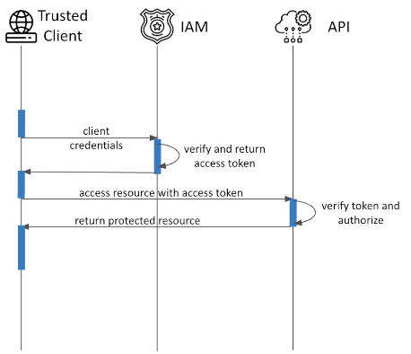OAuth 2.0 **client credentials flow**: un client deve autenticare se stesso con lo IAM per ottenere un token (per l’app) per poter interagire con API di terze parti.
* OAuh 2.0 **device flow**: per tutte quelle volte in cui vglio loggarmi in un dispositivo che abbia almeno la possibilità di mostrare qualcosa
  + Es: WaWeb autentica l’utente sul web basandosi sul device flow
  + 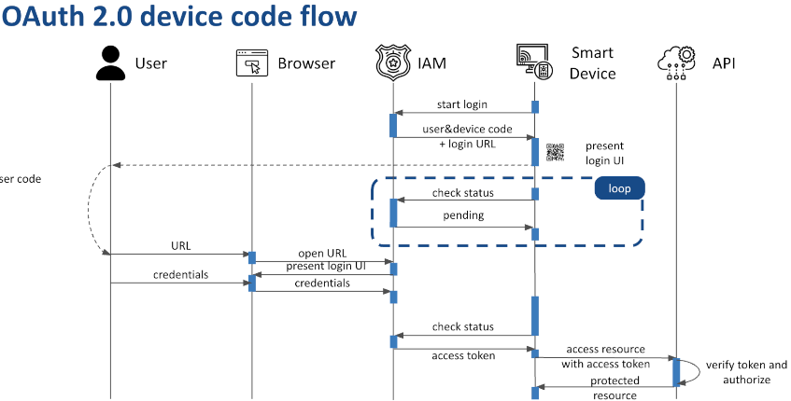Es: Netflix da tv con qr code
* Oauth 2.0 **authorization code flow**: USIAMO QUESTO
  + Funziona solo se c’è un full browser
    - Si basa sul fatto che il browser ricarica un’intera web page, non si può falsificare
  + Inizia quando l’utente scrive l’URL del mio sito
    - Rispondo con 302, mandadoti su IAM che ti mostrerà la pagina di login
  + Tante magie nell’IAM che mi risponde poi con 302 e mi rimanda sulla mia applicazione dove ci sarà un endpoint speciale che a partire dal codice, contatta l’IAM fornendogli client id, client secret e authorization code ricevuto.
    - IAM controlla se tutto ok
    - Se sì, fornisce token all’applicazione
  + Ora l’applicazione spring può usare il token
    - Contattare Api remote
    - Decodificare il token per comprendere info su utente

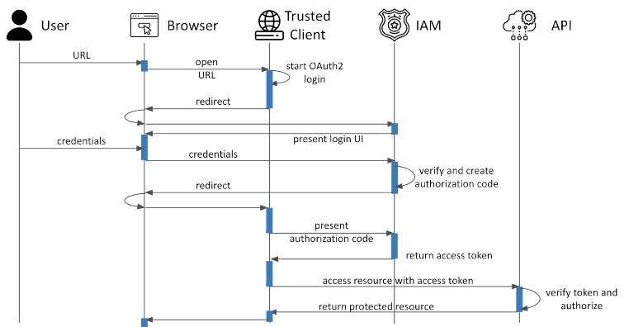

Tutto questo deriva dallo standard Oauth. OpenID Connect fornisce una descrizione su come Oauth token deve essere codificato -> JWT.

JSON Web Token:

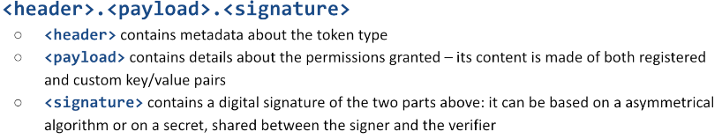

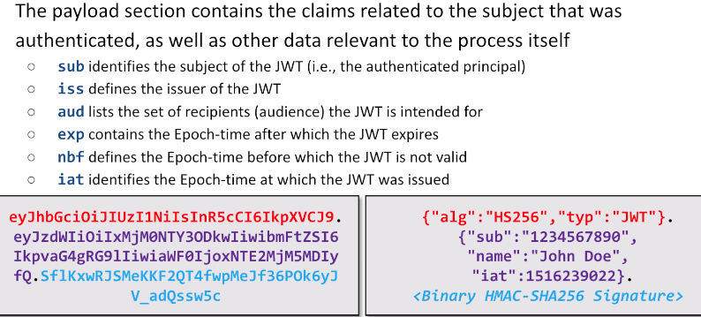

Tipicamente JWT sono self-contained: chiunque li ha, può operare come l’utente. Per questo motivo sono validi solo per un tempo limitato e vengono trasferiti solo sotto connessione https.

* Se rubi un JWT puoi impersonificare un utente

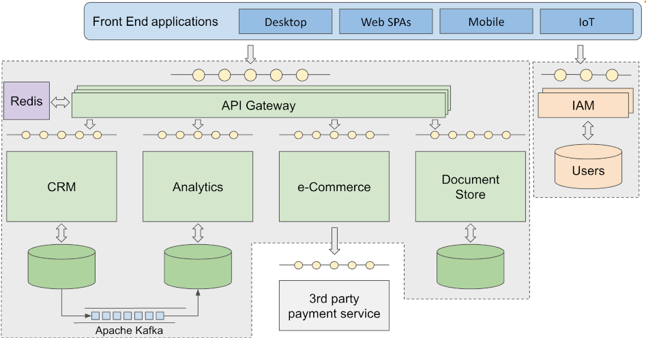JWT viene propagato usando un header http.

API gateway: riesce a parlare con IAM, ottenere e rinnovare toke.

* Esposto all’intero pubblico e si prende la responsabilità di inoltrare le richieste che riceve aò di sotto dove ci possono essere più applicazioni che lavorano.

# Spring Security – r30

Bisogna fare in modo di fornire risposte effettive e reliable ai seguenti problemi: **Autenticazione**, **Autorizzazione**, **Data privacy e integrity** (provide guarantees that the data exchanged with the application cannot be eavesdropped or replaced by third party, both when in transit and when at rest) e **Accountability** (a way for holding users responsible of their actions, by collecting audit trails and other logging and monitoring data to enforce compliance with the security policies).

Per proteggere la nostra applicazione dobbiamo considerare **l’attack surface**: ci sono cose visibili e non visibili.

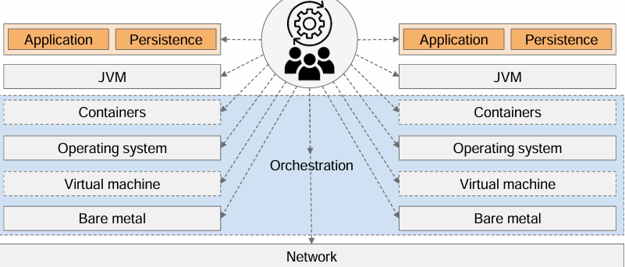

La JVM può essere fonte di atacco:

* non bisogna esporre la porta di debug, altrimenti possono avere accesso ai dati
* container
* operating system: può runnare su macchina fisica o su una virtual machine. Nel caso in cui runna su una virtual machine, devo proteggerla.
* Bare metal: può essere oggetto di attacco (es: chiavetta usb)
* Sopra ogni cosa, ci sono le persone… Le persone sono soggette agli attacchi, posso usare social engineer tecniche per convincere le persone a fare qualcosa

Nota: anche cose che sembrano irrilevanti, possono essere importanti da proteggere in quanto possono essere usato come trampolio di lancio per causare altre problematiche.

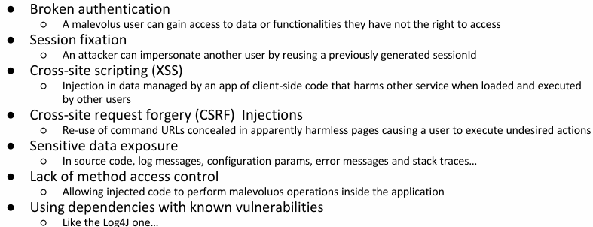

-

- Session: salvati nei cookies, se mando una richiesta al server con quel cookieID, ottengo determinate informazioni su quell’utente

-XSS: code injected nel browser, viene scaricato da utente per sbaglio e può provocare qualche disastro

- CSRF: inserimento automatico di dati dal rowser su sito sbagliato. NON ABILITARE GET SIDE EFFECT.

**CSRF**:

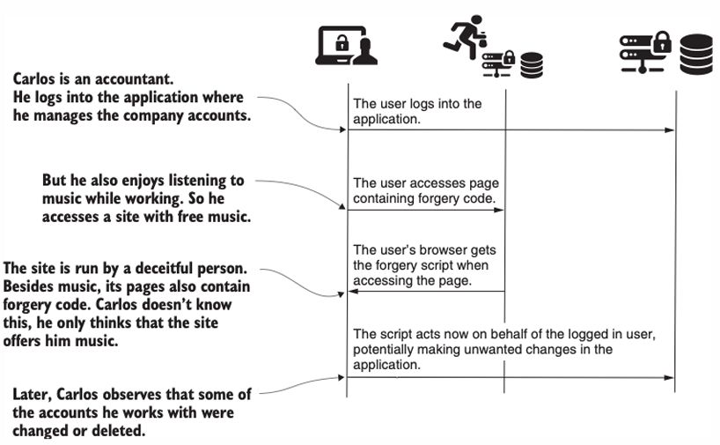

Sente musica mentre accede a robe di lavoro, i cookies sono gli stessi. Il codice javascript dentro l’app musicale, inizia a fare delle operazioni sul sito di lavoro.

Per evitare questo devo fare attvità di prevenzione server side e client side.

**CORS**: Cross origin Resource sharing

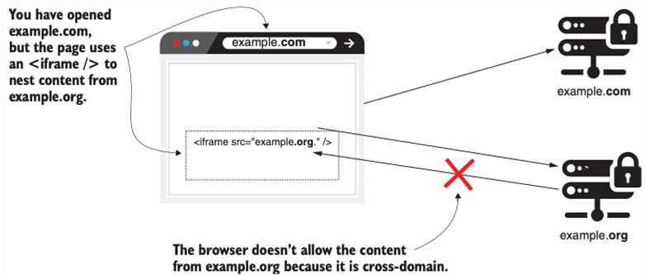Pagina che voglio aprire, prova a fare accesso ad altra pagina.

* Il browser solitamente stoppa
* Se fai da command line, nessuno blocca.

In alcune situazioni può essere utile fare CORS però va fatto in una maniera controllata.

* Si possono fare delle option request con cui si chiede di poter efefttuare alcune operazioni CORS.

*Although it is possible to set security constraints at application level, it is not a good idea doing that*.

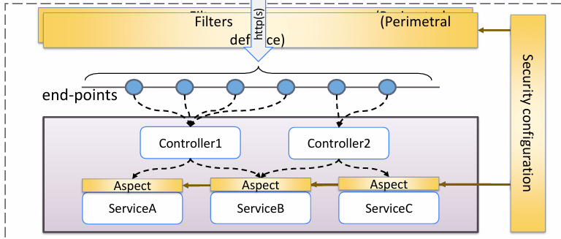  
Application security must be implemented in a **declarative way**, leaving to **the execution environment** the task of **translat**ing those constraints into concrete implementations, in all places that can be affected.   
**Project Spring Security** implements **web application security** in a **declarative way** by using "**filters**" for the HTTP protocol and by using dynamic "**aspects**" around internal methods, in order to grant proper access only to those who are entailed to do so.

Si usa quindi un mix tra difesa periferica e difesa interna, noi non sappiamo chi può attaccare e quando. Noi vogliamo che le librerie trasformino queste descrizioni dichiarative in codice.

## Spring Security

Spring Security is a framework that lets you build application-level security by **declaratively introducing components**, which can be configured as beans, via annotations and the Spring Expression Language (SpEL) in order to implement predefined functionalities and avoid writing boilerplate code. However, it is up to the developer to understand and use it properly. **By itself, it does not secure an application or sensitive data at rest or in flight**. In a layered system, every layer and all their communication is at risk and must be properly hardened.

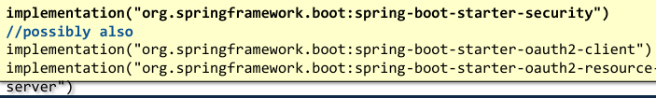

Uno tra i due non in grassetto.

## Terminology

* **Principal** – Any user, device, or system that need to interact with the web application
* **Authentication** – the process by which the application verifies that the principal really is the one who it pretends to be
  + Authentication is also the name of an interface carrying relevant information about the current user
* **Credentials** – Information provided by principal as an evidence of its own identity
* **Authorization** – Procedure that checks whether a given principal can access a specific service / information inside the application
* **Secured resource** – Part of the application the access to which requires the principal to have successfully completed both the authentication and the authorization
* **GrantedAuthority** – Spring interface that describes a fine-grained access right owned by a principal when accessing the secured resource
* **SecurityContext** – Spring interface that keeps the details of the authentication of a principal

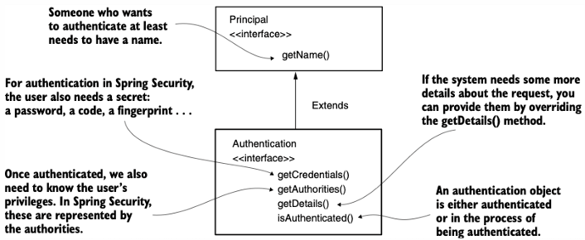

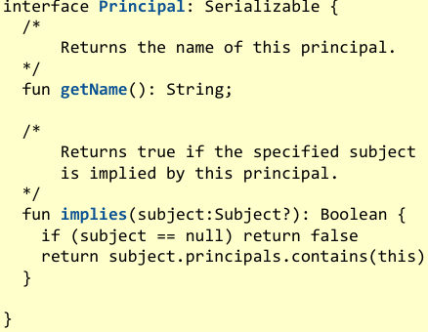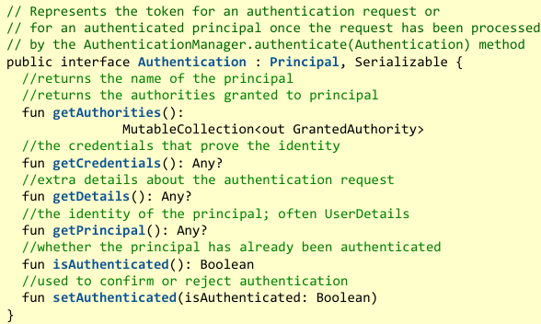

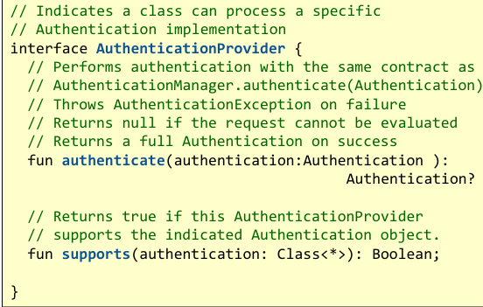

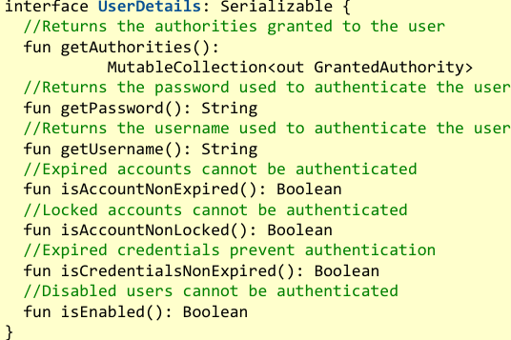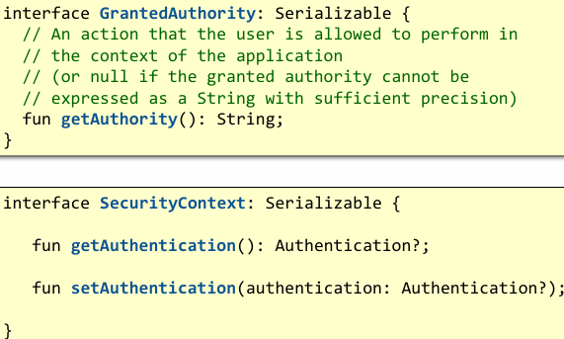

Bisogna configurare Spring security e authentication strategy e il file di configurazione SecurityConfig labelled con Configuration.

Nel file dobbiamo definire alcune @Beans come

* Authentication manager
* Authorization Chain

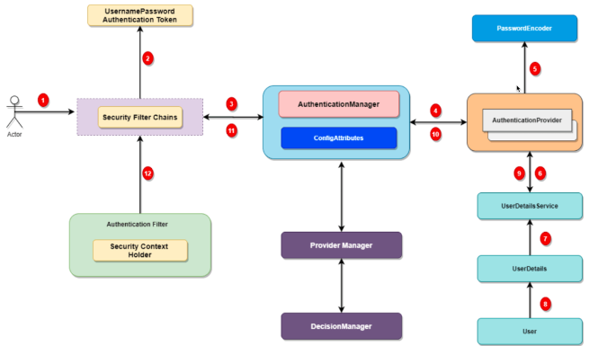**Authentication Flow:**

* **Security filter chain**: verifica se la richiesta contiene un token per identificare utente
  + **Si** -> ok
  + **No** -> mando la richiesta all’authentication manager
* **Authentication Manager**: può andare presso vari provider per verificare il contenuto della richiesta
* **Authentication Provider**: si basa su un proprio db per verificare utente

Noi ci basiamo su terze parti…

**SECURITY CONFIG**:

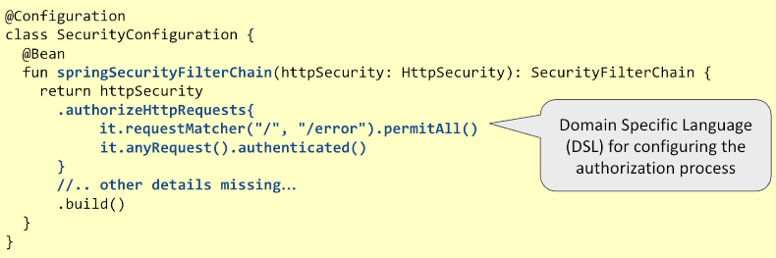

* Se ricevi richiesta con / o /error, va bene per tutti
* Per le restanti, devi essere autenticato

Ci son altre regole applicabili.

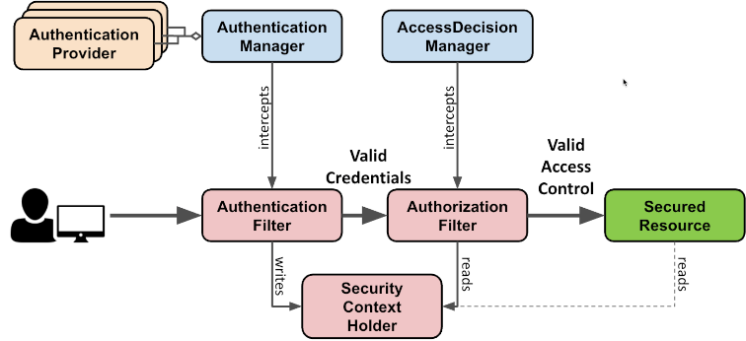

Esistono diversi tipi diAuthenticationProvider:

* **JwtAuthenticationProvider**: responsabile per la decodifica e la verifica del access token codificato in JWC
  + Usato nel caso di OAuth 2.0 Client
* **OidcAuthenticationProvider**: è responsabile della convalida di un codice di autorizzazione e dello scambio con i token di accesso e ID
  + Usato nel caso di OAuth 2.0 Client
* **DaoAuthenticationProvider**: possibile in alcuni casi in cui si voglia gestire l’utente a livello locale**. Non fare.**

## **THE OIDC AUTHORIZATION CODE FLOW**

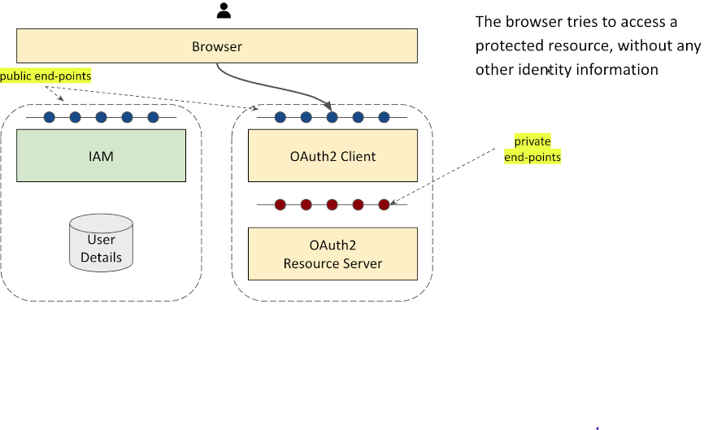All’inizio, l’utente inserisce l’indirizzo di una risorsa (url) fornita da Oauth2 Resorse Server che si trova dietro l’Oauth2 client che opera come Gateway.

Gli endpoint dell’Oauth2 Server sono inaccessibili dall’esterno.

Quando dal browser arriva una richiesta, Oauth2 client non sa da chi arriva la richiesta, quindi, risponde con 302 (moved temporaly - redirection) -> dice al browser di andara da IAM che ci porta alla pagina di login for the given realm.  
The IAM, in turn, presents the authentication page, asking for user credentials

The user provides the required credentials to the IAM, that validates them If the validation succeeds, a redirect (302) to the pre registered client endpoint is sent to the browser, together with an authorization code (che viene ritornato nella risposta).

The browser follows the redirect link, waiting for a response

The client directly contacts the IAM, exchanging the authorization code (ricevuto prima) for the user token, which is stored in the client session object. IAM validerà il client e se tutto è ok, ritorna il token.

Meanwhile, the browser is still waiting for a response from the previous redirection request

The client stores in a cookie the reference to the current session and returns a response to the browser, indicating a successful authentication.

The browser tries again to access the protected resource, implicitly providing the session cookie

The client maps the cookie to the user token and forwards the request to the resource server

The resource server validates the token (possibly checking the IAM for its public key) and provides the response to the client that forwards it to the browser

* Codice r30

# **Immagine che contiene testo, schermata, Carattere, linea Il contenuto generato dall'IA potrebbe non essere corretto.R31**

Bisogna configurare il resource server:

* Deve basarsi su credenziali verificabili JWT
* Deve conoscere in partenza il JWT issuer uri, in modo tale da poter fetchare la chiave pubblica necessaria per validare il token

Configurazione di un resource server:

* In questo caso si voleva autenticare tutto

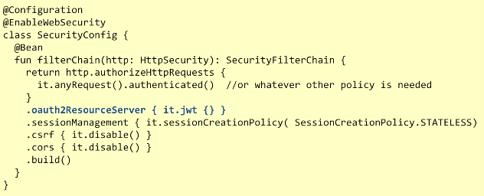

Per inoltrare le richieste, nel client aggiungiamo la dipendenza da

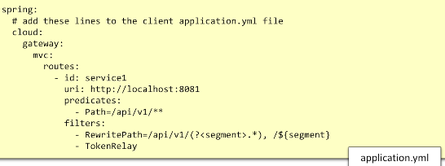

NEL CLIENT otteniamo informazioni riguardo il principal in termini di OADC user (da id token).

NEL SERVER invece otteniamo le informazioni da Access token.

Sono simili ma non la stessa cosa…

L’informazione è mantenuta nel client come un mapping che salva la sessione che ci permette di tarsformare il cookie che contiene il session ID nel token necessario per loggarci.

* Access token, ID token, Refresh token.
* NOTA: se chiedi per offline access, viene fornito il refresh token per rinfrescare l’access token; altrimenti no e dopo un po’ scade e vieni scollegato.

Si possono definire url accessibili da chiunque, altri per autenticati, altri per utenti con determinato luogo.

Oltre a questa prima barriera di sicurezza, noi vogliamo anche una seconda barriera di sicurezza -> METHOD SECURITY.

Per abilitarla, dobbiamo attivare MethodSecuriti e usare le annotations.

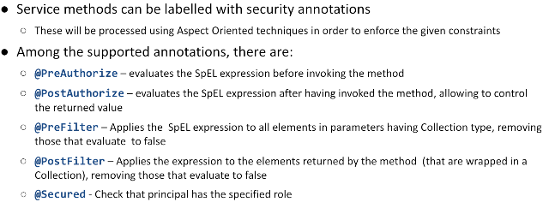

# **Spring WebFlux --**

When processing incoming requests, some operations may block the execution for an unknown amount of time

* Anything concerning I/O and networking
* Delay functions
* Synchronizations

*Keeping a thread blocked while waiting for their outcome, makes the code easier to be written**and maintained. Since it is possible to adopt an imperative coding approach, based on the fact that the current computation remains "stable" (i.e., variables keeps their values, the history of function invocation does not change, …) while waiting takes place.* Una connessione per thread, per quanto sia bello a livello di codice, non è sostenibile. Devi pagare una macchina più grossa o anche se vai sul cloud devi pagare per l’allocazione della memoria.

In order to support many concurrent requests, **many threads need to be pre-allocated**. Whenever a new request arrives, a thread is selected to deal with it. If the thread blocks, other incoming requests will not be affected, since they will be managed by a different thread. Once the request is done, the thread returns to the pool, and can be selected for managing **other requests**. Unfortunately, this approach requires a lot of **resources**. Each thread need to be pre-allocated together with its execution stack.

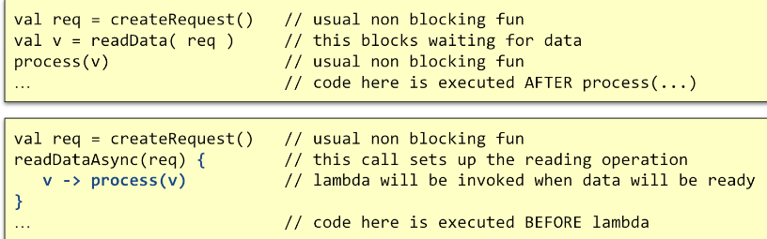It is possible to evolve such paradigm, if the underlying system provides **asynchronous API**. These are typically built using call-backs. Computation is broken in two parts:

* what that happens before the blocking call
* what happens after.

Apparently, it is an easy solution, but which thread is responsible to invoke the call- back?

**Nel caso di un web server:**

* ricevo network request -> inizio a fare qualcosa finchè non vengo bloccato
  + vado da service
  + service va da db
  + – quitto dicendo che il thread può fare altro mentre apsetto di ottenere i dati dal db

**Nota**: se abbiamo una coda dei messaggi, facile processare messaggi in questo modo ma non beneficiamo del tutto dei tanti core.

Se non abbiamo la coda:

* dobbiamo conoscere su quale thread la callback viene schedulata
* Cosa succede se dentro la callback voglio eseguire un’altra funzione async
* Cosa succede se viene scatenata un’eccezione
* Cosa succede se voglio cancelare l’esecuzione di un’operazione già schedulata

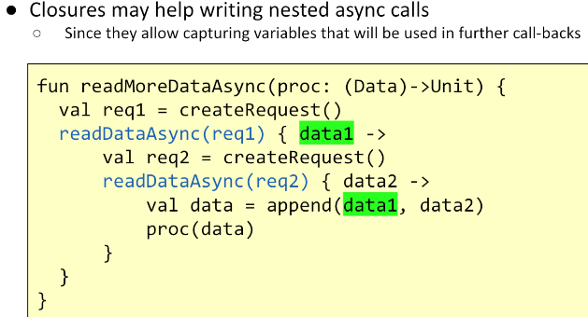

* Attende il dato e poi esegue

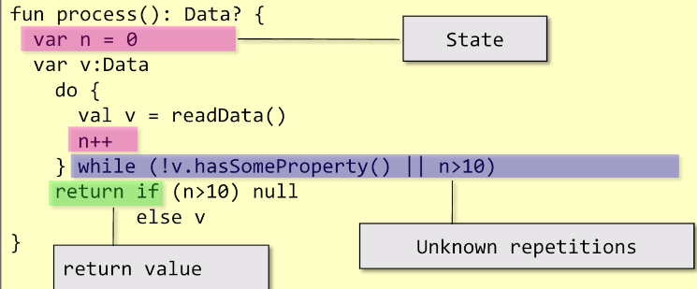non tutto è facile da rendere asincrono: questo è problematico perché va mantenuto uno stato, devo mantenere l’informazione di quanti loop sonos tati fatit.

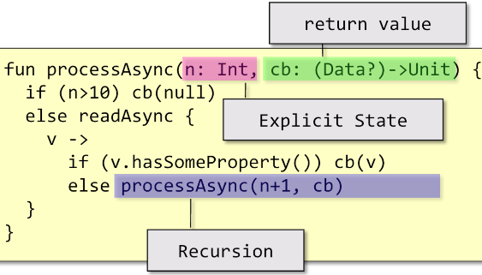

Return  
  
value  
  
mi viene  
  
passato  
  
callback

## A reactive stack

By adopting a non-blocking approach to computation, a significant number of threads (and thus of computational resources) can be **dismissed** while gaining improved performances. Invece di avere centinaia di thread allocati, posso avere meno thread.  
The call-back mechanism makes it difficult to handle most asynchronous corner cases

* How to deal with exceptions?
* How to deal with cancellation?
* How to compose multiple asynchronous computations?

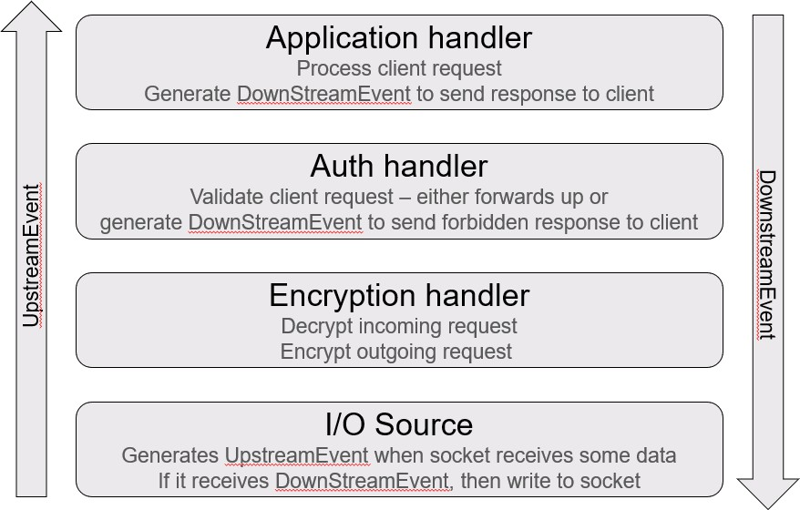In order to deal with these problems different solution have been proposed

* **Reactive libraries** (like RxJava or Reactor) require the programmer to describe the computation to be performed in terms of a chain of functional operators to be applied to an observable stream of events
* **Coroutines** are based on the idea of suspendable computations and leverage on the compiler capability to transform a mostly-imperative code into a call-back-based state machine

Both require new programming styles, but the second option tends to have a lower entry step.

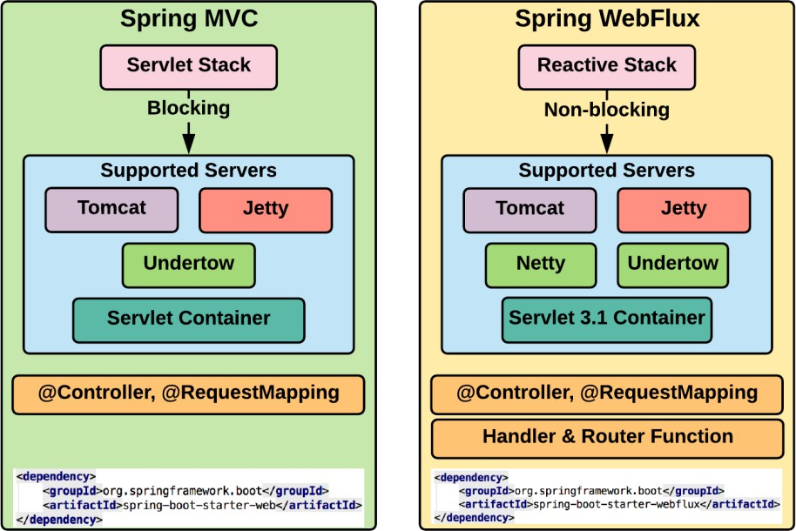

## Improving the overall performance

In order to improve scalability and reduce the quantity of resources needed to power a system, given a load level, a different programming model has been investigated. This is based on using **non blocking functions** for accessing remote resources.

Since the asynchronous approach tends to lead the so called **call-back hell**, functional programming paradigms were explored to create a better modelling of the computational pipeline capable of accounting for all programming corner cases (partial failures, termination, cancellation). This was called **reactive programming**.

## Reactive Programming

In **imperative programming**, an expression is evaluated once, and the value is assigned to a variable. On the other hand, **reactive programming** is all about responding to value changes.

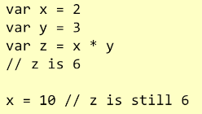

Nell’approccio fornito dal reactive programming, z cambia invece valore e passa a 30 (come succede con le formule excel)

## The Observer pattern

Observer si iscivono ad un subject che a questo punto conoscerà la tua identità e ti manderà il nuovo contenuto quando questo arriverà.

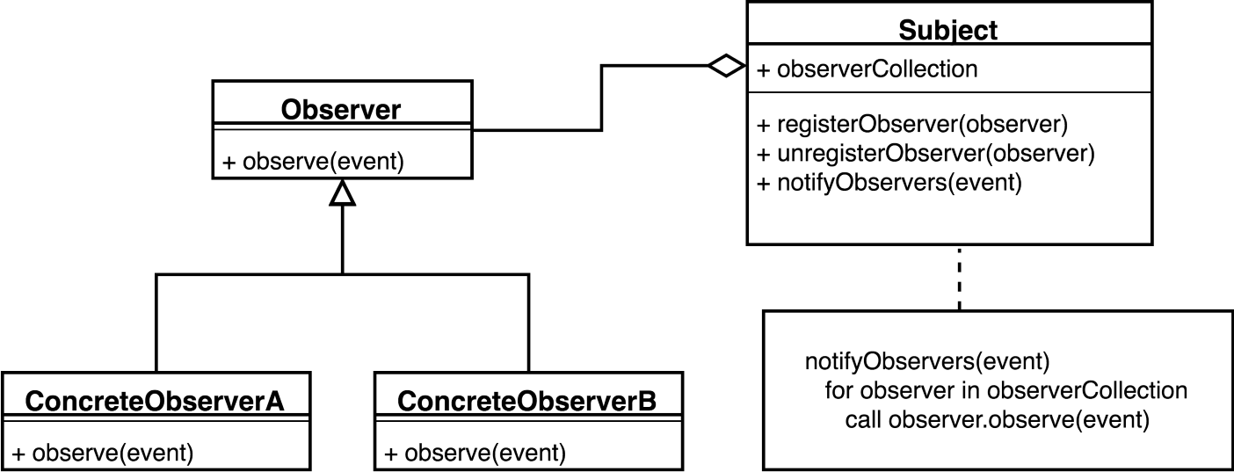

Limitations of the Observer pattern

The observer collections must be **thread-safe** otherwise, it may break unexpectedly. If notifications are sent synchronously a slow observer will slow down all the remaining ones. Some improvement may be introduced by delegating the actual notification to a thread pool:

* If the collection grows too much, a lot of thread will be used
* If an observer is slow, it might receive overlapping notifications
* Push based: no way to exert back pressure
* Cancellation is difficult

## Publish-Subscribe pattern

The Spring framework offers a **generalization of the Observer pattern** that **decouples the sender of the event from its receivers**. The **Event Channel abstraction** is introduced with the aim to separate publishers from subscribers.

The Event Channel may filter incoming messages and distribute them between subscribers. The filtering and routing may happen based on the message

content, message topic. Subscribers will receive all messages published to the topics of interest

By labelling a component method with *@EventListener*, any message matching the method argument type, will be dispatched to it. Further restrictions on message routing can be added via the condition attribute. Spring offers the generic *ApplicationEventPublisher* bean to submit new events of a given type to the system bus.

**Since publishers and subscribers are decoupled, it is difficult to foresee how the system will behave and what is the overall workflow.** Moreover, there is no support for corner cases, such as dealing with failures, termination and cancellation. When the load increases, the implementation of the Event Channel may be significantly stressed possibly making this component the system **bottleneck**. In order to prevent blocking subscribers from slowing down the dispatching process, events must be scheduled in different threads which increase system resources consumptions.

## Reactive frameworks – r33

To deal with these problems and provide a general solution supporting the development of libraries, **Reactive eXtensions (Rx)** were introduced. Package *org.reactivestreams* defines the java/kotlin abstractions for Reactive Extensions. It is a set of tools that allows **imperative languages** to work with both **synchronous and asynchronous** data streams. It offers a combination of the **Observer pattern**, the **Iterator pattern**, and **functional programming.** Although Iterator is often used to inspect a data collection that extends in space (at the same time), it can be conceived as a way to iterate across time, waiting for the next event.

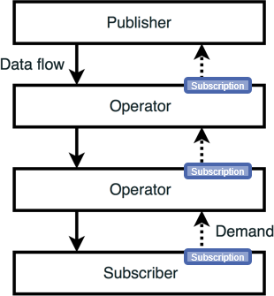It provides the following classes and interfaces:

* **org.reactivestreams.Subscriber<T>**
* **org.reactivestreams.Publisher<T>**
* **org.reactivestreams.Subscription**
* **org.reactivestreams.Processor<T,R>:** represents a transformation logic between a publisher and a subscriber typically implemented as an operator method (map(…), filter(…), reduce(…), …)

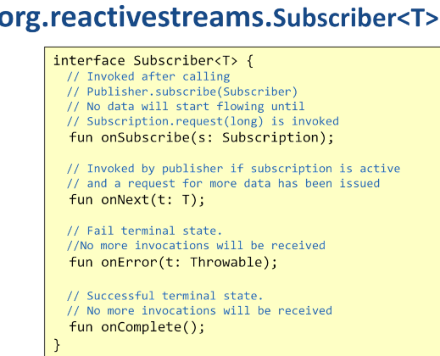

**Subscribe** si iscrive al procuder e ottiene anche un oggetto iniziale (Subscription) che riceve nel momento in cui si iscrive. Questo oggetto gli permette di svolgere alcune operazioni:

* **request**: oltre a iscrivermi, chiedo dati
  + posso invocarlo più volte specificando il numero di dati che voglio ricevere
* **cancel**: non voglio più ricevere dati.

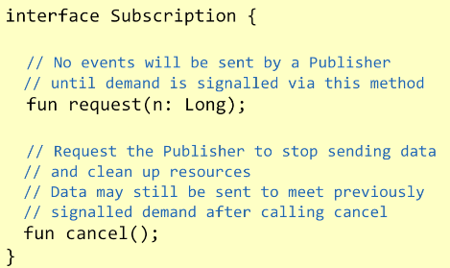

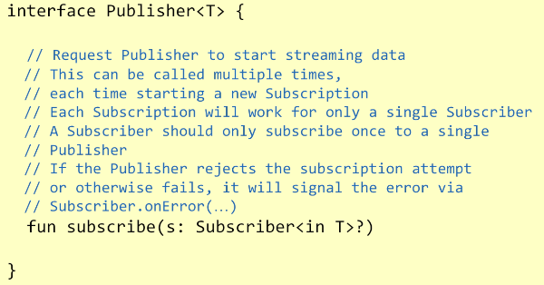

Contiene un singolo metodo che offre a chi è interessato al contenuto di iscriversi.

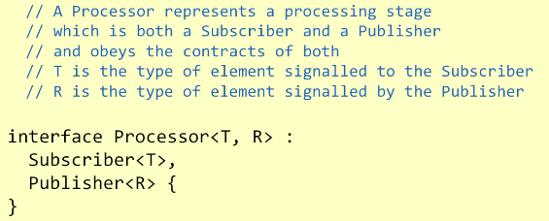

Combinazione tra subscriber e publisher, può iscriversi a qualcosa e essere il publisher di qualcos’altro.

Es: servizio fetcha da db e mappa i dati da entity su un DTO e emette quest’ultimo.

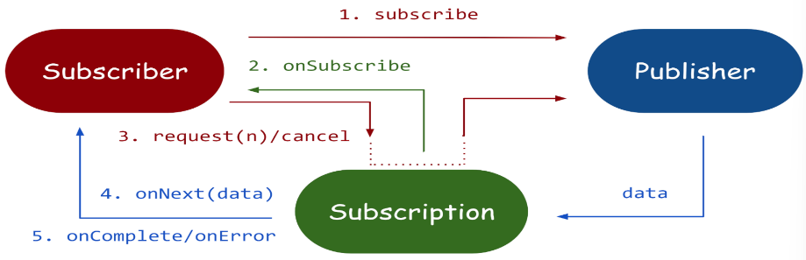Controller saà subscriber del service.

NOTA: Il thread che fetcha dati dal db può essere completamente indipendente dal thread che opera dentro il service che a sua volta pu; essere indipendente dal thread del controller.

Con questo modo, con un oiccolo numero di thread, riesco a gestire un buon numero di dati.

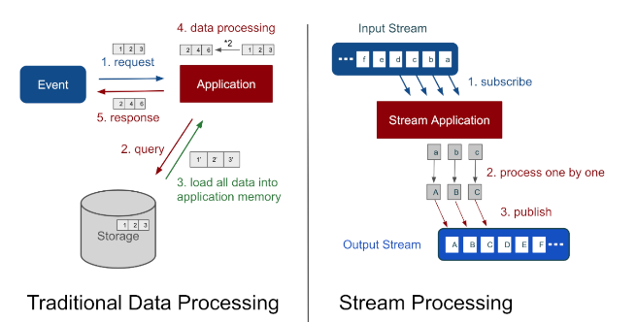

**Nello Stream processing:**

* costruire una pipeline che inizia dal db ( che viene informato su che pezzi di dati vogliamo ottenre)
* db inizia ad trasformare e iniviare ogni chunk dell-infomrazione (in parallelo) usando i thread necessari
* non ho bisogno di aspettare che tutti i dati siano arrivati ma posso iniziare a processare e lavorare quelli che mi arrivano

Tipica **pipeline**:

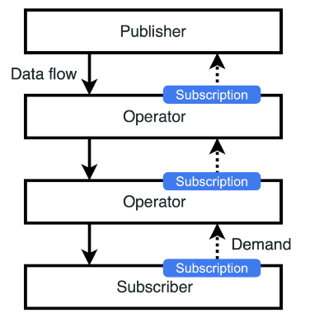

Operatori possono essere>

* filtri
  + scarto ciò che non voglio
* Mapping
  + Es: da entity a dto

## Base concepts

When a Subscriber connect to a Publisher (via the subscribe(…) method), an asynchronous process of event generation is triggered. Subscription acts as an intermediary that provides control over the amount of produced and consumed events.

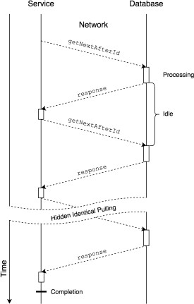**No data is actually transmitted** between the two parties, until the receiver **signals** its will to accept some data via *subscription.request(…).* This avoids the need of introducing queues between the publisher and the subscriber, making the overall system **simpler** and more capable of dynamically adapting to changing work- loads.

## Push- vs. pull-based architectures

A **pure pull-based architecture** is ineffective when working at network boundaries. Large communication times sum up when requesting many elements one at a time. Batching request improves only slightly.

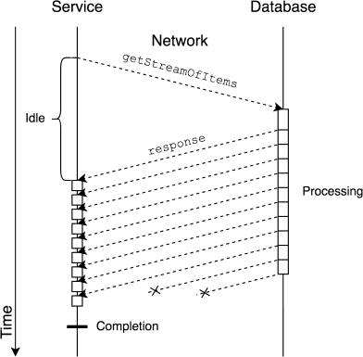By letting the remote source **push items freely**, a large speed up can be achieved. Flow control should allow stopping the sender from overwhelming the receiver.

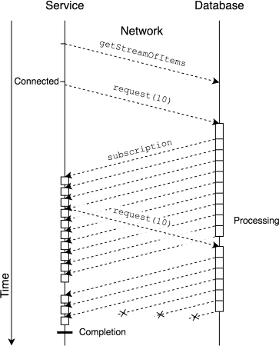Hybrid push/pull

Chiedo 10 item, prima di aver finito, chiedo già altri 10.

Backpressure via subscription

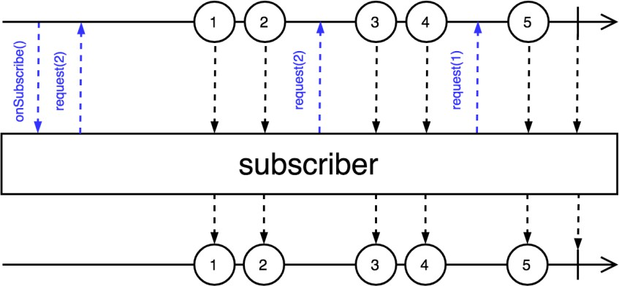

Tempo va da sinistra a dx.

* Dati vanno sa sopra a sotto
  + Sopra: producer
  + Sotto: consumer
* P: fornisce subscription object
* C: richiede 2 item
* P: risponde non appena possibile e invia al subscriber che li prende come input e ne emette una versione trasformata.
* …
* Alla fine avvienne onComplete che segna la fine del flow

Implementing reactive extensions

Two alternatives’ implementations exist:

* **RxJava** (and RxKotlin)

### Project Reactor

Both schedule the events to be sent according to a **well-defined state machine** linking Publisher to Subscriber providing **back pressure and cancellation**. Error and termination corner case are inherently handled by the Subscriber interface. The two libraries differ in the concrete classes that implements the reactive abstractions and in the set of extension operators that allow to describe the processing pipeline.

## **Core reactive types**

Project Reactor provides two alternative implementations of the Publisher<T> interface

* abstract class **Flux**<T> { … }
* abstract class **Mono**<T> { … }

**Flux** defines a reactive stream that can produce **zero, one, or many** elements, potentially an infinite amount of them.   
**Mono** defines a stream that can produce, at most, **one** element.   
This allows a more efficient internal implementation, skipping buffers and synchronizers.

***Nella RxJAva3*** *ci sono concetti simili a flux e Mono ma con nomi diversi:*

* ***Observable:*** *Producer che possono generare 0+ elementi (sincronizzato con request object)*
* ***Flowable:*** *Producer che possono generare 0+ elementi (non sincronizzato dal request object)*
* ***Single:*** *Producer che torna esattamente un elemento*
* ***Maybe:*** *Producer che torna 0 o 1 elemento*
* ***Completable****: Producer che torna o un errore o completato.*

## Creating Flux and Mono sequences

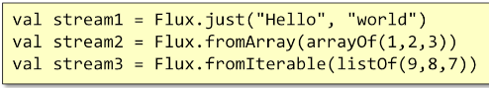Flux and Mono provide many factory methods to create instances based on available data. Mono has similar methods, limited to emitting at most one element (null may be interpreted as an empty content). Sequence of numbers may be created with Flux.range(…) static method. A Mono object can be created using the corresponding factory methods from callables, runnables, suppliers, futures, …

## Consuming sequences

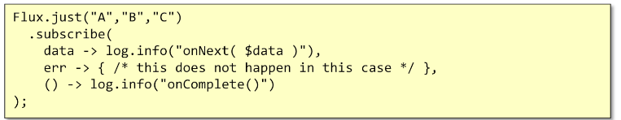To access the elements wrapped into Flux and Mono objects, **it is necessary to subscribe to them**. Several overloaded versions of the subscribe() method exists all return a Disposable object, which can be used to cancel the underlying Subscription.

If a **subscription is cancelled by the subscriber**, the onComplete() signal will not be triggered. onError(…) and onComplete() are only invoked if the (abnormal) termination is determined by something in the producer context.

## Operators

**Flux and Mono offers an extremely rich set of operators**, which can be roughly divided into the following areas:

* Transforming existing sequences
* Peeking data as they are processed
* Splitting and joining sequences
* Returning data synchronously

## Marble diagrams

It is a graphical representation that depicts the time behavior of an operator.

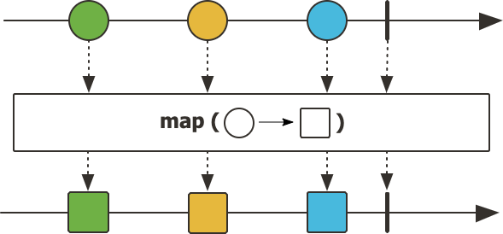Method **map( … )** transform the items emitted by a sequence by applying a synchronous function to each

Item

The **index()** operator wraps each element in a tuple with the sequence number.

The **timed()** operator had time information

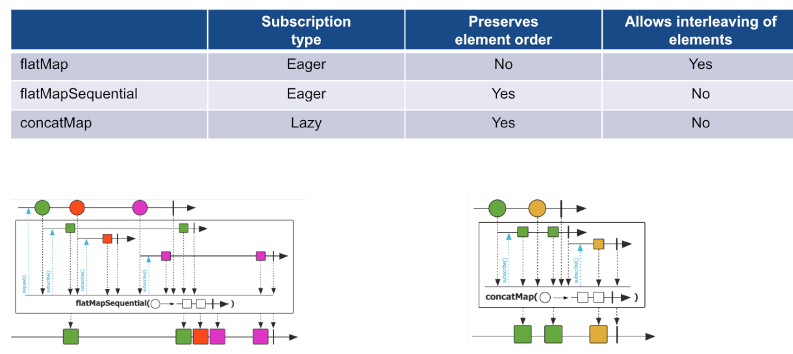Method **flatMap(…)** applies to each element a function that returns another sequence of elements, which is flattened in the result.

* Supply alpha -> emetto a-l-p-h-a
* Se mentre emetto alpha, arriva anche beta -> inizia anche lui e potrebbero sovrapporsi

**flatMapSequential**: garantisce ordine

* Non c’è il rischio che alpha e beta si sovrappongano perché non inizia l’altro elemento se non ha prima finito il primo

concatMap: uguale a flatMapSequential ma LAZY

## Peeking data as they flow

**Methods *doOnXXX(…)***allows to **add behavior**, which is triggered when the given condition arises. It is useful for **side-effects**. Methods **log(…)** observe all Reactive Streams signals and trace them using the Logger system support

## Filtering sequences

**The filter(…)** operator only emits those elements that satisfy the condition. The **ignoreElements()** operator filters out all elements and returns Mono<T>. The resulting sequence ends only after the original ends or fails if the original fails.

It is possible to limit the number of taken elements using the take(…) method

* **takeLast()** returns only the last element of the stream
* **takeUntil(…)** forwards incoming elements, until the given condition is satisfied
* **takeWhile(..)** forwards incoming elements. While the given condition is satisfied

È possibile filtrare anche per:

* **elementAt(n)**: ritorna l’elemento che si trova alla posizione n della sequenza
* **single()**: emette un singolo item dalla sorgente
  + ritorna errore se la sorgente è vuota o ha più di un elemento
* **skip(…)** e **take(…):** permetto di prendere o saltare un elemento su base temporale (es: prendi i primi 10 elementi)
  + elementi possono essere saltati o presi finco alla ricezione di un messaggio da parte di un altro stream

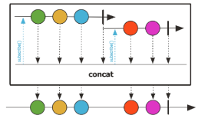Inoltre è possibile **splittare e unire sequenze:**

* **concat** permette di unire due flows
  + 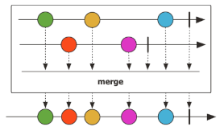faccio due query sul db e unisco
  + consuma tutti gli elementi del primo flow e poi quelli del secondo
* **merge** permette di unire due flow parallelamente
  + 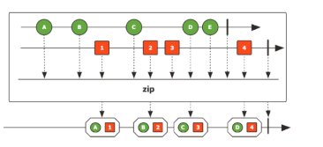prende i dati contemporaneamente dai due flow
* **zip** prende da due sorgenti e li combina
  + ogni elemento di una sequenza, è combinato con quello dell’altra.
  + 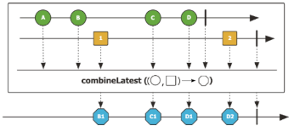Si ferma quando finisce una delle sequenze
* **Combinelatest:** crea un nuovo elemento non appena ottiene uno dei due
  + Nota come A viene buttato
* **Window**: crea sottosequenze di data dimensione, durata
* **Buffer:** quanti ne vuoi insieme, si può definire un overlap parziale sul tempo
* 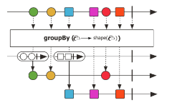**GroupBy:** divide la sequenza in sequenze create dimenticamente per ogni chiave univoca

## Returning data synchronously -> trasforma flow in oggetto sincrono

* ***toIterable*(**) transforms a Flux into a blocking Iterable
* ***toStream*()** transforms the sequence into a lazy, blocking Stream
* ***blockFirst*()** blocks the current thread until the upstream signals its first value or completes

## Hot and cold publishers

Publishers are divided into two different categories:

* **Cold** publishers operate **lazily**: no data is generated without a subscriber and if two different subscribers subscribe, a new data sequence is generated
* **Hot** publishers operate **eagerly**: they encapsulate data sources that exist without the application having requested them (like incoming network connections, event streams, …). When a subscriber connects, it will not receive past values

A cold publisher can be transformed into a **ConnectableFlux<T**> via the **publish()** method. It allows several consumers to subscribe to it. Elements are requested from the original publisher only after the connect() or refCount() method have been invoked.

Method **share()** transforms a cold publisher into a hot one. If there is at least one subscriber, this Flux will be subscribed and emitting data. When all subscribers have cancelled, it will cancel the source Flux. This is an alias for publish().refCount().

## Reactive I/O in Spring

To support reactive abstractions, Spring Frameworks has introduced several abstractions. Interface **DataBuffer** abstracts the concept of a buffer of bytes from the actual strategy used to allocate and access its content, making it easier to interoperate between different non-blocking implementations (java.nio, io.netty.buffer). Class **DataBufferUtils** offers a bunch of methods to read and write files in a reactive way: its methods mostly return Flux<DataBuffer>.

*Generic interfaces Encoder<T> and Decoder<T> have been extended to support encoding/decoding streams of data thus offering a non-blocking way to convert serialized data to Kotlin objects and vice-versa. The spring-core module provides byte[], ByteBuffer, DataBuffer, Resource, and String encoder and decoder implementations. The spring-web module adds JSON, binary JSON (Smile), JAXB2, Protocol Buffers and other encoders and decoders.*

## Reactive web – r34 --flux

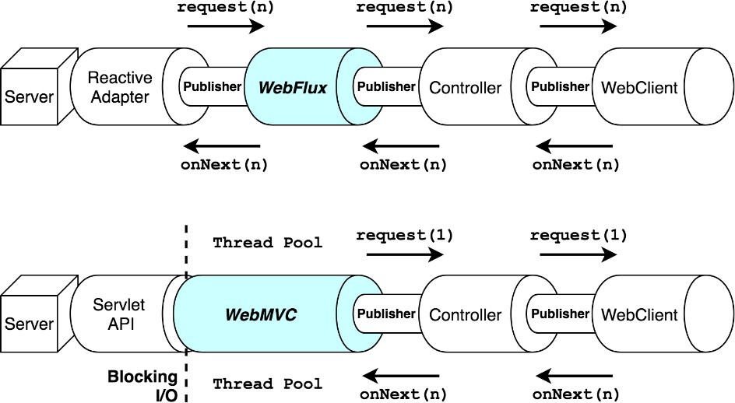Spring module *WebFlux* provides a fully **re-written support for web applications** based on reactive streams.

It provides **integration** with several server engines, both intrinsically non-blocking (like Netty and Undertow) and capable of asynchronous operations (i.e., based on Servlet API 3.1).

A **reactive adapter** replaces the blocking Servlet API, allowing seamless data streaming. Moreover, the non-

blocking **WebClient** has replaced the previous RestTemplate class, allowing to perform streaming access to remote web resources.

## Reactive Spring Data

Several new abstractions have been introduced in the Spring Data project to support reactive streams.

* Interface **ReactiveCrudRepository<T,ID>** offers the entry point for **non-blocking access to the data layer**, rewriting the typical CRUD operations in terms of Flux<T> and Mono<T>.

To properly support asynchrony and back-pressure across process boundaries a set of specific database drivers has been implemented. (es: per Mongo DB o per sqlLite db usando il drivere R2DBC).

## WebFlux main abstractions

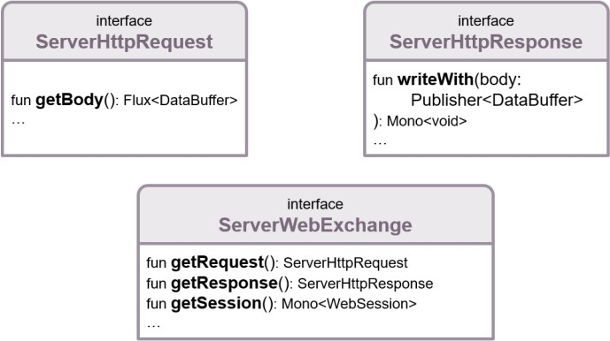To support asynchronous management of the HTTP protocol, the main abstractions have been redefined.

**ServerHttpRequest** models incoming requests. It offers usual methods to access method, URI, headers, cookies, query params, peer details, … as well as a streaming access to the request body (if present).

* permette di leggere I dati in chunks come fosse un producer
  + ogni chunk contiene bytes

**ServerHttpResponse** builds outgoing responses.

Response is built filling the body from the supplied Publisher.  
No data is sent unless the returned Mono<Void> is subscribed. The receiving party may exert back-pressure using the transport protocol control flow.

* Se vogliamo creare manualmente del contenuto, in quanto contiene un publisher, possiamo produrre in chunks dei dati da mandare ad un client (mando al socket che manda al browser)

Interface **ServerWebExchange** models an HTTP **request-response interaction**. Beyond giving access to the HTTP request and response, it also exposes additional server-side processing related properties, like session management and attributes.

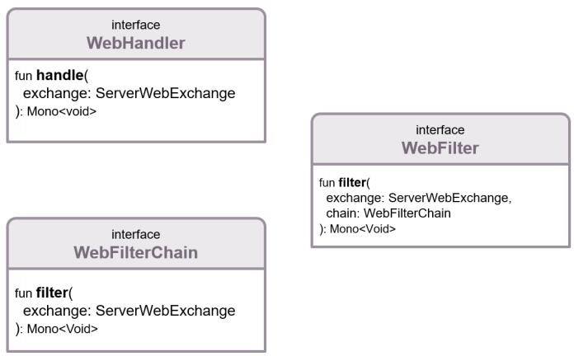To provide a global framework that mimics the functionalities offered by the blocking servlet API, three more interfaces are defined: *WebHandler, WebFilter and WebFilterChain*.

## **The WebFlux architecture**

The incoming request is handled by the underlying server engine (Netty, Undertow, …). Each engine has its own reactive adapter, mapping requests and responses to Spring abstractions. The framework encapsulates this information into a **ServerWebExchange** instance.

This goes through the **WebFilterChain** and, if not filtered out, it is eventually passed to a **WebHandler** instance which is responsible to locate the proper Adapter that will process it. The process mirrors the behaviour of Spring WebMVC thus making it easy to understand what is going on.

## **Router DSL**

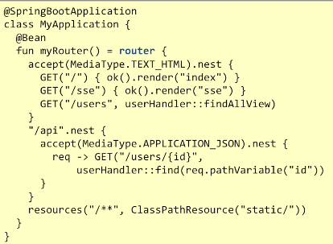Spring idiomatic Kotlin extension allows a different way to specify which verb/URLs pairs are managed by the application and what handler function must be invoked. This is achieved using a **Domain Special Language** (DSL) implemented via **router function**. Router allows the programmer to express complex, programmatic expressions that map requests to HandlerFunctions. The HandlerFunction represents a **function that generates responses for requests routed to them**.

The **advantages** of router functions are:

* All routing configuration is kept in **one place**
* **No loss in expressivity** or flexibility regarding the annotation-based approach. It is possible to access incoming request parameter, path variables, and other important components of the request
* Since a reduced number of annotated classes is needed, application bootstrap times can decrease significantly

**Remote access via WebClient**

WebClient is the reactive replacement for Spring RestTemplate implementation. It provides the ability to perform non-blocking requests to other web services. Instances of this class are created via the **create()** static method or the builder pattern.

* Connetto a remote server per creare un richiesta htpp e ottenere una risposta

In questo caso:

* Retrieve: fa partire richiesta in attesa di rispsota
* Quando ottengo risposta, la provo ad interpretaare come utente
* Subscribe: causa inizio di reactive chain per prendere dati

## Reactive database access

The **ReactiveCrudRepository** interface provides a contract that allows to save, update, or delete entities by consuming not only Entities but also by consuming a reactive **Publisher<Entity> implementation**.

* At the same time it offers methods to query the corresponding table, returning **Mono<Entity>** or **Flux<Entity>**.

This provides effective thread management since no thread is required to ever block on IO operations.

Latency of first result is reduced which is convenient for supporting interactive UI components.

Allows **backpressure propagation** which allows server and DBMS to adapt to each other's pace.

* Se db ci manda tanti dati ma non abbiamo abbastanza potenza per gestirli, possiamo rallentarlo

The *DatabaseClient* provided by the **Spring Data R2DBC** module exposes a reactive API to access SQL databases. It offers a simple, limited, opinionated object mapper. The project was designed valuing ease of use and understanding. Consequently, it **does NOT** offer caching, lazy loading, write behind or many other features of ORM frameworks. Spring Data R2DBC allows a functional approach to interact with your database.

DatabaseClient features are:

* Execution of generic SQL and consumption of update count/row results
* Generic SELECT with paging and ordering
* SELECT of mapped objects with paging and ordering
* Generic INSERT with parameter binding
* INSERT of mapped objects
* Parameter binding using the native syntax
* Result consumption: update count, unmapped (Map<String, Object>), mapped to entities, extraction function
* Reactive repositories using @**Query** annotated methods
* Transaction Management

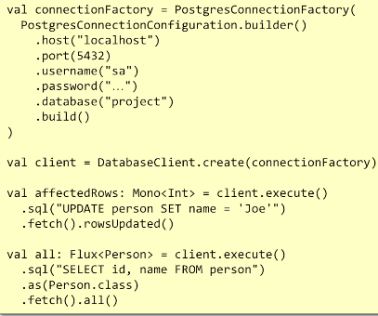

## **Reactive repositories**

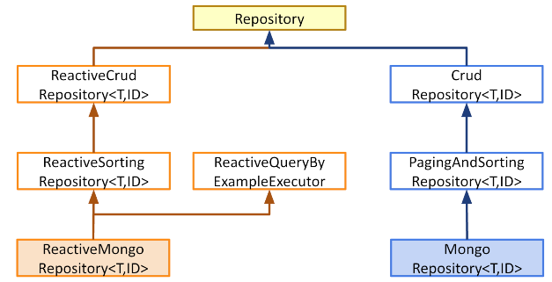Spring Data offers several opportunities to access SQL and NoSQL databases in a reactive way. MongoDB is one of the supported options. Reactive Spring Data Repositories use the same annotations and support the majority of synchronously provided features:

* Method name conventions
* @Query annotations to express custom queries
* @Meta annotations to fine-tune runtime parameters

## **ReactiveCrudRepository<T,ID>**

It is an interface that declares methods for saving, finding, and deleting entities or documents.

* fun **save**(e: T): Mono<T> persists an element and returns its updated representation
* fun **findById**(id: ID): Mono<T> looks for the given element given its primary key
* fun **findAllById**(p: Publisher<ID>): Flux<T> accepts any publisher (Reactor or RxJava) of ID and returns all the matching elements: order is not guaranteed
* *No direct support for paging*

## **Mapping types** *(va specificato converter)*

Nested object can be mapped to database tables using data converters. They are responsible for mapping complex domains objects onto the corresponding columns. Two kinds of converters exists:

* @ReadingConverter – implementing the Converter<Row, Entity> interface
* @WritingConverter - implementing the Converter<Entity, OutboundRow> interface

In order to support conversions, a proper @Configuration class should be declared overriding the getCustomConverters() method.

## **Managing relationships**

Properly handling relationships is cumbersome in R2DBC, according to the authors of library.

**One-to-one** and **many-to-one** relationships can be managed using a **@ReadingConverter**

* and adding a custom query to the repository performing a JOIN SQL operation, to read data.
* Writing must be accomplished in two separate steps, taking care to properly wait for the first one to finish, to get the key to store in the second one.

**One-to-many and many-to-many** relationships **cannot be managed** via @ReadingConverters.

* Explicit query methods need to be added to the repository to fetch related elements and return them as a Flux.   
  This, in turn, requires proper mapping – at the SQL level – of the foreign key constraints, specifying cascading operations to be applied when the referenced key is deleted or updated. Further optimizations can be added in the case of many-to-many to handle fast delivery of aggregated data into the return flux as soon as each object is completed.

# **MongoDB – r35**

Schema-less document-oriented database designed to handle a massive amount of data and ensure high availability.

Available both as an open source tool and as a fully-managed cloud-based platform.

A MongoDB installation can be as small as a single process (or a Docker container) hosted in the developer machine or be as large as hundreds of dedicated hosts, sharding and replicating the data set.

**Mongo può essere configurato in diversi modi:**

* Single host: mongo runna su porta 27017 e possiamo connetterci usando apposito driver
  + 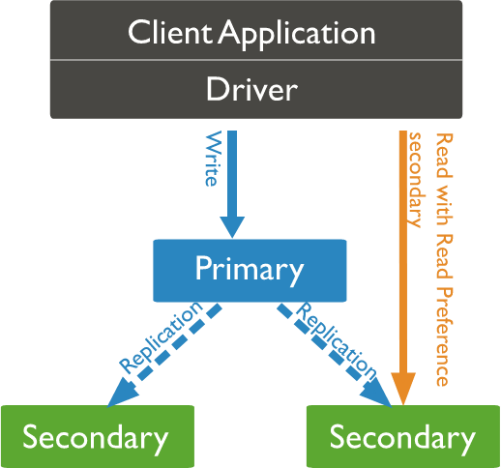Va bene se c’è single server che fornisce db
    - Tutto carico su quel server (non proprio scalabile)
    - Se ci sono errori, crolla tutto
    - Massima quantità di informaizoni salvabili dipende dalla macchina
* **Replica Set:** gruppo di macchine che runnano lo stesso programma (Mongo server)
  + Una delle macchine decide di comportarsi come PRIMARY server
    - Accetta le richieste e propaga le copie ai secondary server
* **Sharding**: cluster di molte macchine
  + **Router**: app si connette qui
    - App si connette al mongo router
    - Quando riceve una richiesta, si connette al config server per comprendere dove eseguire la richiesta e la esegue

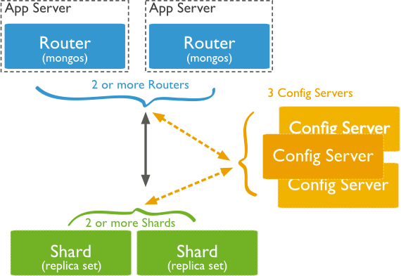

* + **Shard**: contenitori
    - Per decidere in quale contenitore vanno salvare le cose si possono usare delle funzioni di hash
    - Possono essere macchine con informazione o possono essere connesse a server secondari con informazione
  + **Config** **server** (3): come l’informazione è divisa nei vari shard

Dal punto di vista della connessione finale, non cambia nulla il modo in cui mongo è stato implementato.

Mongo Ha deciso di scegliere consistency nel CAP theory.

## **Documents**

The unit of storage in MongoDB is a document, *which is a binary encoded JSON object, consisting of multiple key/value pairs, where keys are strings*.

Values can have one of the following types: Null, Boolean, Numerical *(32-bit int, 64-bit long, 64-bit double, 128-bit decimal),* String, Temporal (date, timestamp), Binary data, ObjectID, Objects, recursively containing zero or more key/value pairs, Arrays of all the above types.

Each document has a distinctive key, named **"_id"** containing a unique value acting as the document primary key.

* Unico nella collezione

Document size cannot exceed the hard limit of **16Mbytes**.

## **Collections**

MongoDB stores documents in **collections**. Collections has some analogy to tables in relational databases: like a table, a collection groups a set of semantically-related documents.

Differently from tables, collection are not homogeneous: **each document in a collection can have a different structure**.

Collection have a name which is used to designate it in queries. A collection is automatically created as soon as the first document is saved into it or an index is added.

**Capped collections** are fixed-size collections that support high-throughput operations that insert and retrieve documents based on insertion order.

* They work in a way similar to circular buffers: once a collection fills its allocated space, it makes room for new documents by overwriting the oldest documents in the collection.

## **Database**

Collections are logically grouped in a **database**. A database stores one or more collections of documents. If a database does not exist, MongoDB creates the database when the first data is stored in it. A MongoDB installation can consist of **zero or more databases**, each having zero or more collections, each having zero or more documents.

## Immagine che contiene testo, schermata, Carattere, linea Il contenuto generato dall'IA potrebbe non essere corretto.Data modelling

The document structure consents different approaches when storing data in MongoDB:

* A document can refer to another document by storing its primary key (_id) in one of its fields (**normalized** data model).
* 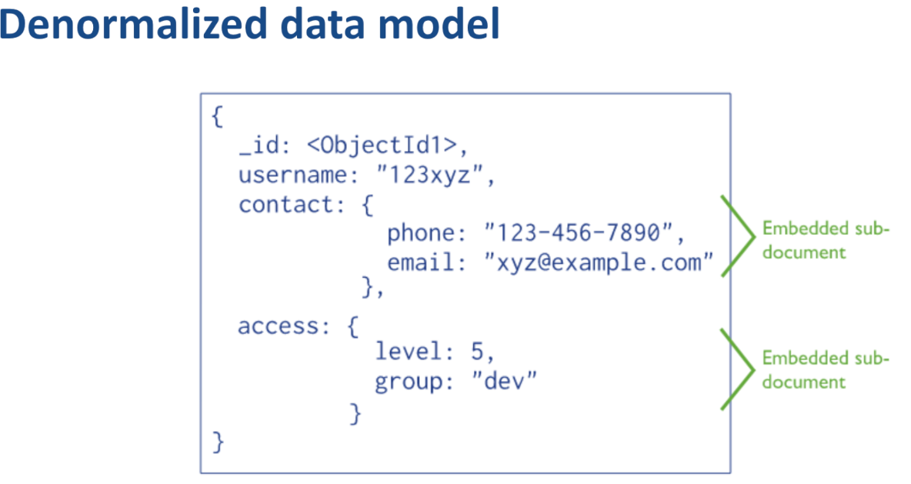The target document can be embedded in the source one: if it must be referenced by more than one source, many copies of it will exist (**embedded** or **denormalized** data model)

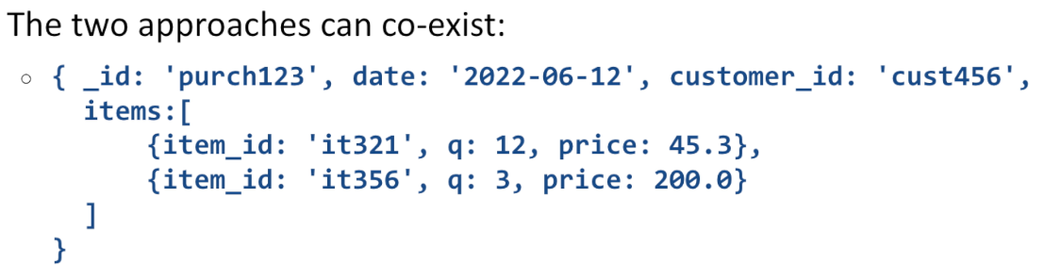

**Embedding** provides better performance for read operations, as well as the ability to request and retrieve related data in a single database operation. It also makes it possible to update related data in a **single atomic write operation**. If the same data is referenced by two or more documents, **multiple copies** of it exist: this may be problematic in case of update. Embedding should not violate the size limit of BSON documents.

**Normalized** data models allow to represent more complex relationships as well as large hierarchical data set. A special kind of query, based on the aggregation pipeline need to be created to perform data joins across collections of the same database. A recursive search on a collection, with options for restricting the search is provided, to navigate trees and graph structures. Join performances are **not as high as** in RDBMS, if the field storing the foreign key is not indexed

## **CRUD operations**

Write operations target documents in a **single collection**. If the collection does not exists and the operation is an insertion, the collection is automatically created. All write operations are atomic on the level of a **single document.** Update and delete operations use filters that specify which documents need to be updated or deleted.

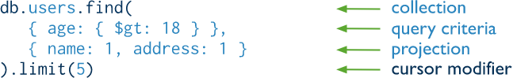Read operations retrieves documents from a collection. The basic operation is find(…) and it operates on a single collection.

Queries that span over several collections are possible via the **aggregation framework**. Aggregation operations group values from multiple documents together, and can perform a variety of operations on the grouped data to return a single result.

## **proj.pngProjections**

Determines which fields are returned in the matched documents. Reduces the overhead due to transferring useless data. Field *_id* is included in the result by default. Fields are included/excluded setting their value to 1 or 0 (true or false)

## **Inserimenti:**

Gli oggetti vengono inseriti nello stesso modo in cui vengono scritti

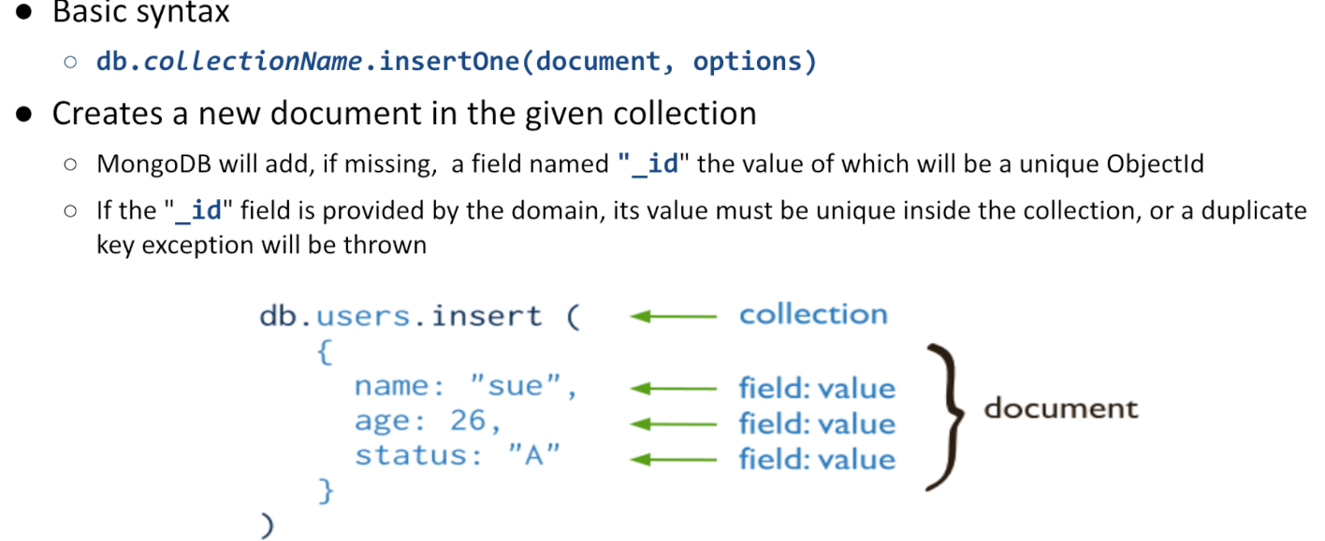

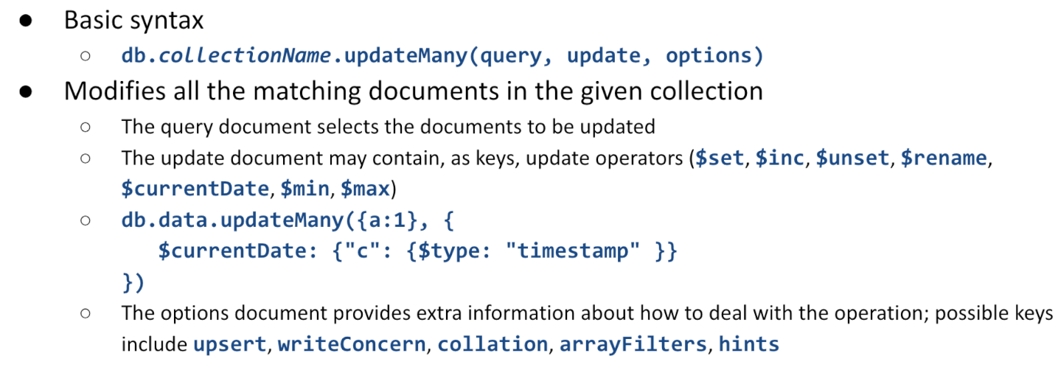$unset: rimuove una chiave

$rename: mantiene valore ma rinomina chiave

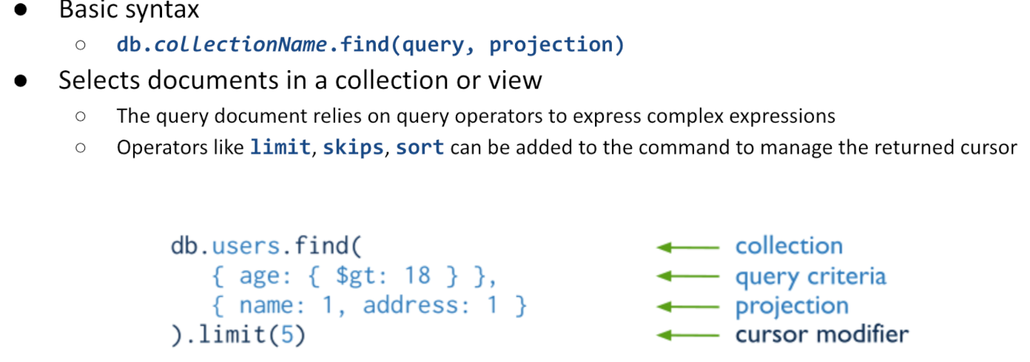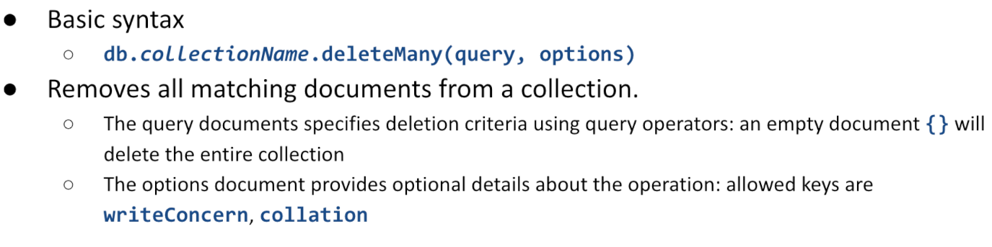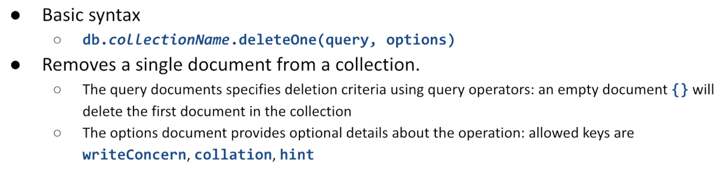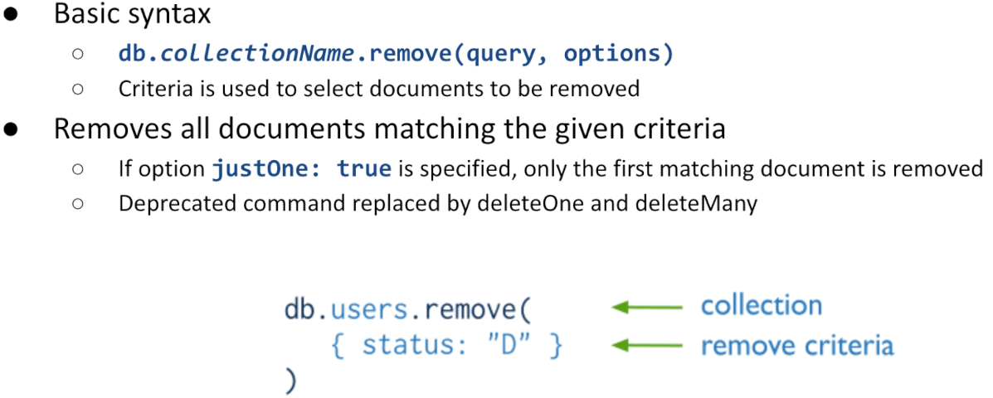

## **Aggregations**

Aggregation operations process data records grouping values from multiple documents together. Several operators are provided to transform selected documents into an aggregated result. MongoDB provides three ways to perform aggregations:

* The aggregation pipeline
* Single purpose aggregation methods

**Aggregation pipelines** are modelled as data processing pipelines:

* Documents enter a multi-stage pipeline that transforms the documents into an aggregated result
* Each stage can produce zero or more output documents per each input one, which are fed to the next stage or returned if it is the last one
* A given operation can appear more than once in the pipeline

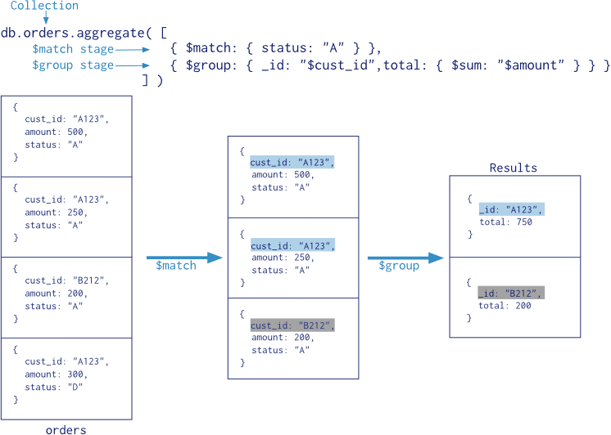

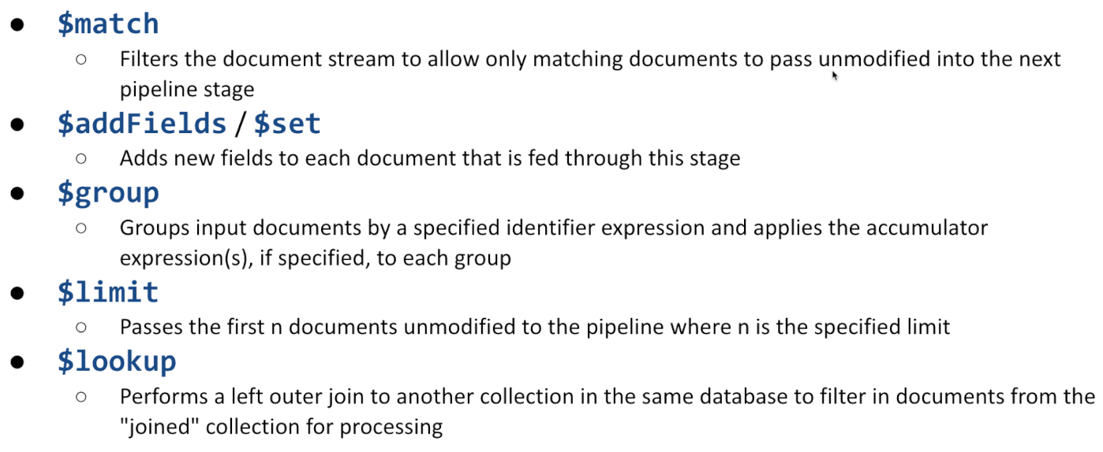

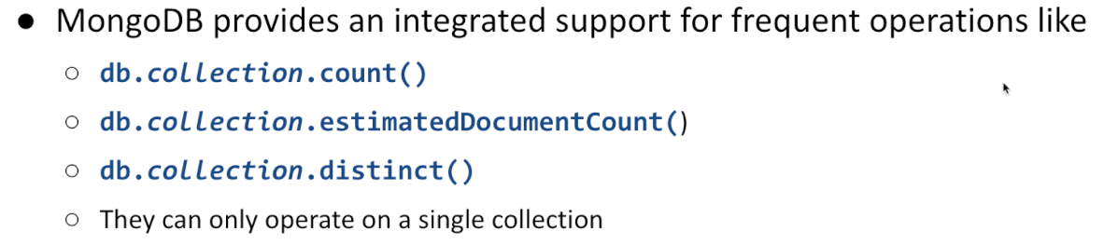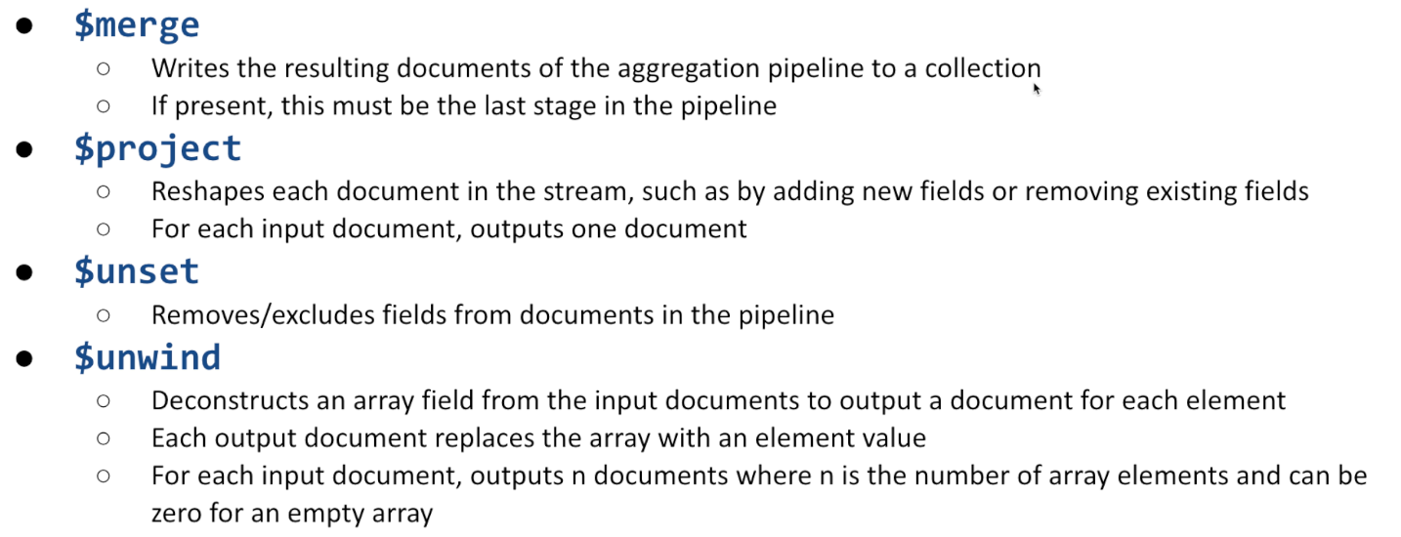

## Indices

MongoDB offers several index types optimized for various query lookups and data types:

* **Single Field Indexes** are used to an index single field in a document
* **Compound Field Indexes** are used to index multiple fields in a document
* **Multikey Indexes** are used to index the content stored in arrays
* **Geospatial Indexes** are used to efficiently index geospatial coordinate data
* **Text Indexes** are used to efficiently index string content in a collection
* **Hashed Indexes** are used to index the hash values of specific fields to support hash-based sharding

Indices exchange query speed up with memory and write penalties especially on **sharded clusters**, inserting an indexed document can become expensive.

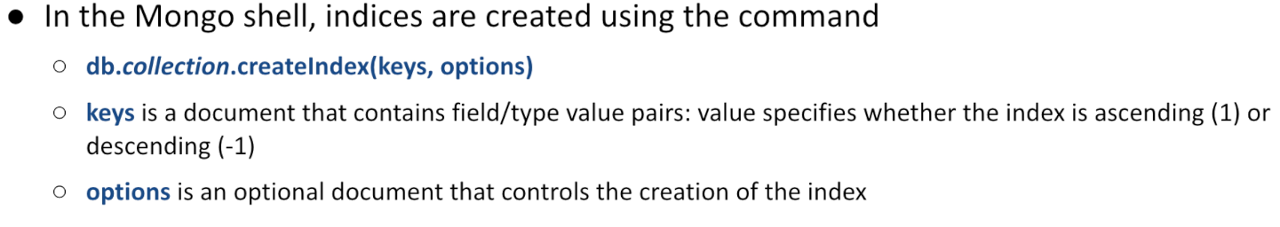

* Se collezione vuota -> creazione indice veloce
* Collezione piena -> ci vuole tempo per creare indice
  + Conviene decidere prima

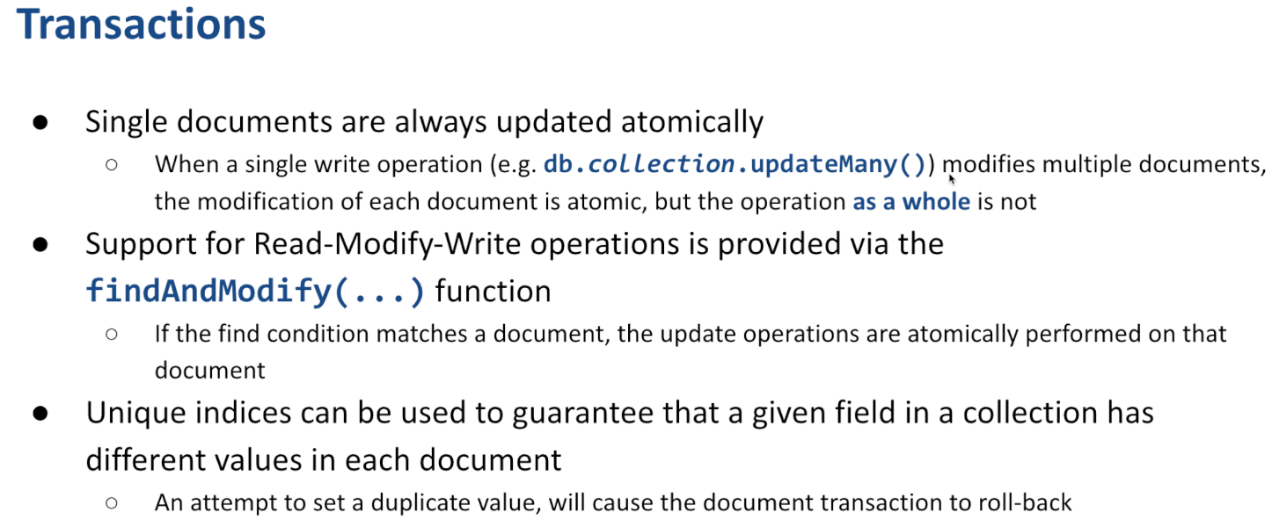

Se ho 2+ thread che eseguono query su db, rischio inconsistenze. MongoDB garantisce che ogni modifica ad un singolo documento è atomica.

Il documento comprare agli altri o prima della modifica o dopo la fine della modifica.

Non è invece garantita l’atomicità se nella stessa operazione provo ad aggiornare dati di documenti diversi.

Per ridurre questo problema ci sono funzioni come finAndModify -> prova a selzionare un documento e esegue aggiornamento solo se il valore è ancora quello. Mi da così la possibilità di operare come una macchina di stato.

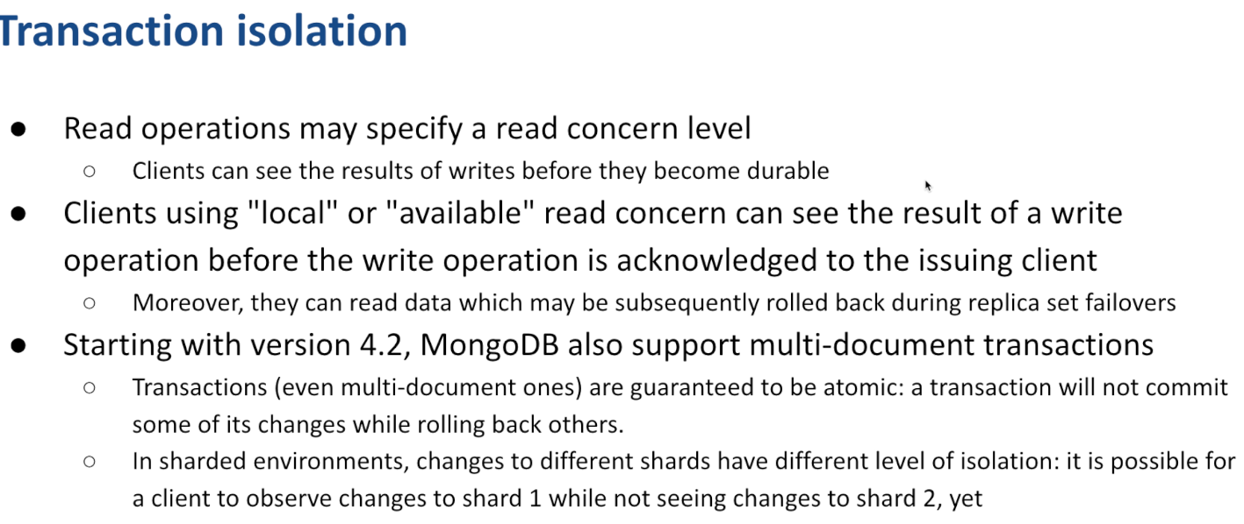

MongoDb può eseguire transazioni isolate multi-documento usando il 2-phase commit. Questo però causa forti rallentamenti e non è sostenibile.

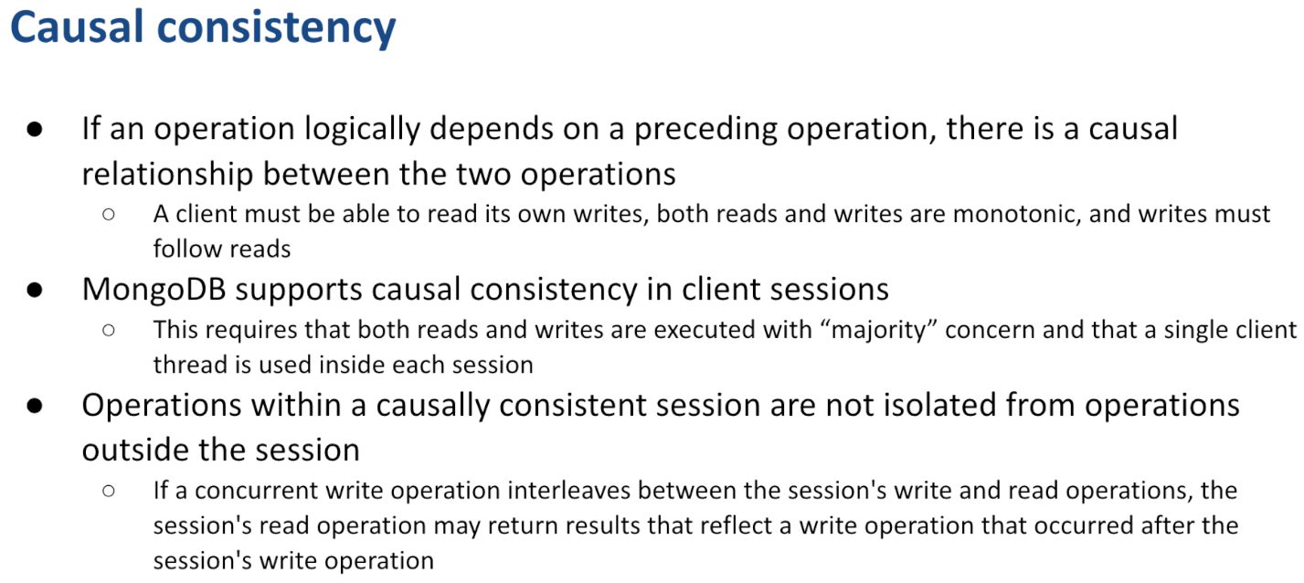In termini di isolation, posso avere diversi problemi:

* Mando query che viene eseguita parzialmente sul server1, parzialmente sul server 2, parzialmente sul server3…
* I 3 server possono essere carichi in maniera diversa, quindi possono avere velocità di esecuzione diverse
* Quando eseguo una seconda query, potrebbero non essersi aggiornati ancora tutti
* Se query arrivano da diversi client, non c’è modo di difendersi
* Se le richieste arrivano dallo stesso client -> Casual consistency

# **MongoDB in Spring**

Spring provides integration with MongoDB via the **Spring Data MongoDB project**. Spring Boot provides both the   
*spring-boot-starter-data-mongodb* dependency based on a **blocking** client and the *spring-boot-starter-data-mongodb-reactive* one to support **web-flux-based** implementations.

Major abstractions are provided respectively by the *MongoTemplate* and *ReactiveMongoTemplate* helper classes. They make it easy to perform common operations, leaving application code to provide BSON documents and extract results.

Libraries also provide automatic implementation of Repository interfaces including support for custom query methods, geospatial queries, aggregation framework and map/reduce. -> MongoRepository<D,Id>

## Immagine che contiene testo, Carattere, schermata, linea Il contenuto generato dall'IA potrebbe non essere corretto.Defining **documents**

Domain objects are named **documents**. They can be modelled by immutable data classes prefixed with the **@Document annotation**.   
**@Id** is used to mark the distinguished identifier: supported types are String, ObjectId, and BigInteger.

**@Field** può essere usato per rimappare il nome di una proprietà ad una diversa chiave del documento

**@Indexed** causa la creazione di un indice su quel campo, se non esiste già

## **Relationships (Between docunents)**

Possono essere utili in quanto mongo limita la dimensione massima di un documento a 16MB. Quando ho bsiogno di informazioni che potrebbero eccedere questa quantità, ho bisogno di modificare la struttura dei miei dati per dividere l’informazione.

* Posso rappresentare il mio documento in un modo denormalizzato (basato su replicazione dei dati)?
  + Ignoro relazioni -> bella per mongo
* Posso garantire che l’insieme delle informazioni sia meno di 16Mb?
  + Sì -> Bella per mongo
  + Non si sa -> Mmhh da capire se si può dire che è bella per mongo
    - Posso provarci in vari modi

Come posso fare?

* Fully denormalized information -> esame contiene id dell’utente e quando mi serve, faccio sottoquery per ottenere quel dato.
* Parizally denormalized -> Copia di alcuni pezzi rilevanti
  + Copio quelli che mi possono interessare più di frequente (duplico)
  + Mantengo riferimento al documento per ottenere tutti i dati se ne ho bisogno

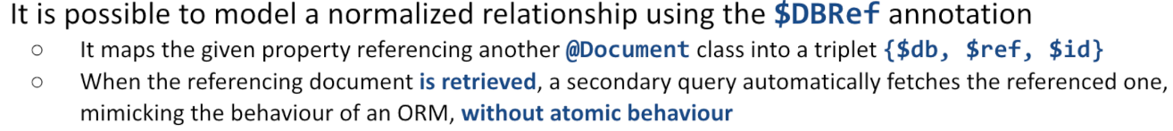

Per la non reactive version:

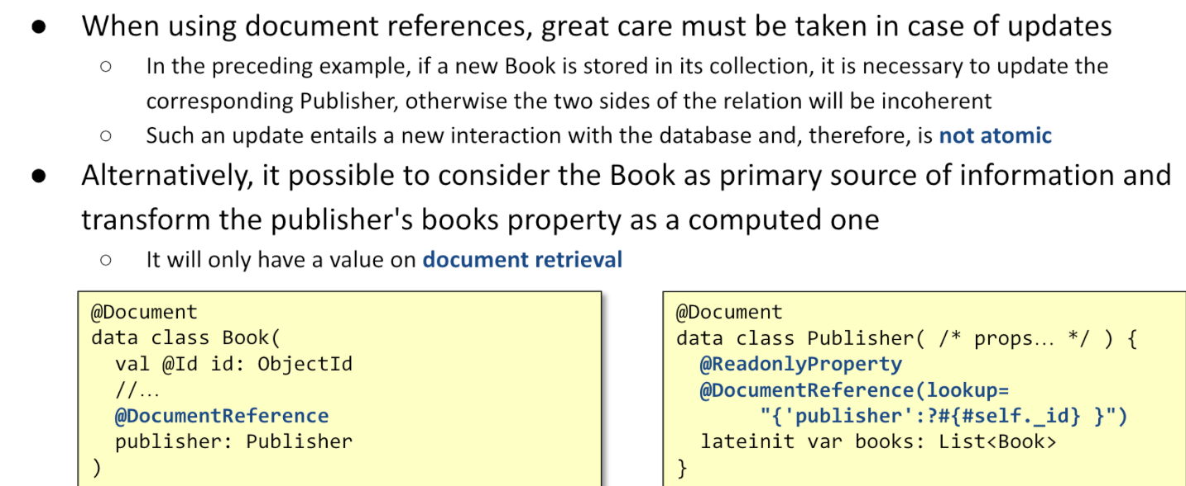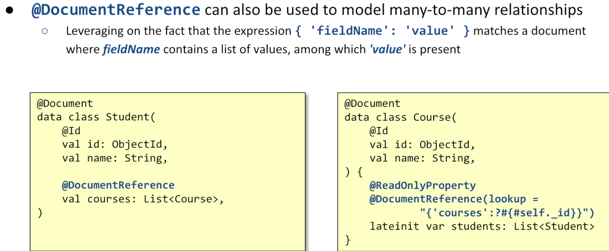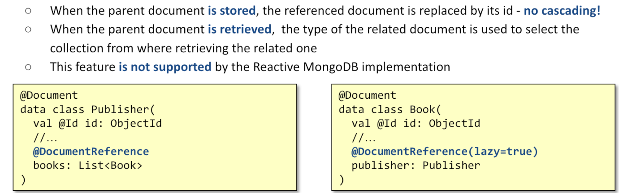

## **Repositories**

Interface **MongoRepository<T, ID>** extends *PagingAndSortingRepository<T, ID>.*

* It is used as a base interface for defining custom repository based on MongoDB.
* It is supported by class SimpleMongoRepository.

**Custom methods** can be defined using the standard naming conventions used by Spring Data.

* The **@Query** annotation can be used to provide a custom query: attribute value represents the matching condition; attribute fields is used to convey the projection.
* Query expressions can be combined with SpEL expressions to create dynamic queries at runtime.



## Aggregations

The repository layer offers means to interact with the aggregation framework via annotated repository query methods.

The aggregation pipeline is expressed via the **@Aggregation** annotation in front of custom methods.

**@Meta** annotation can be used to express additional options, such as a maximum run time, additional log comments, or the permission to temporarily write data to disk.

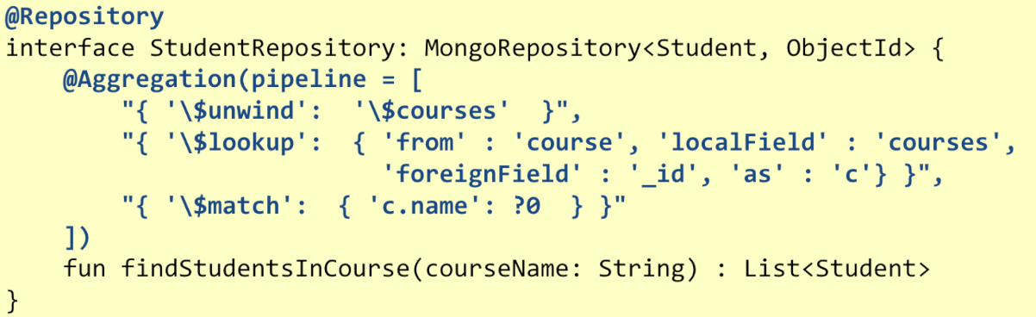

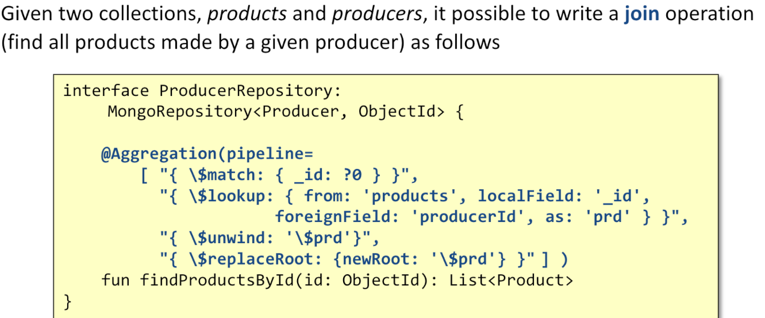

Quando si effettua lookup, conviene avere indici.

Nel caso in cui si voglia aggiornare documenti si può anteporre Update (*non ne ha parlato)*

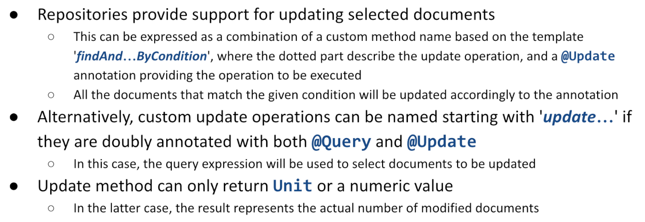

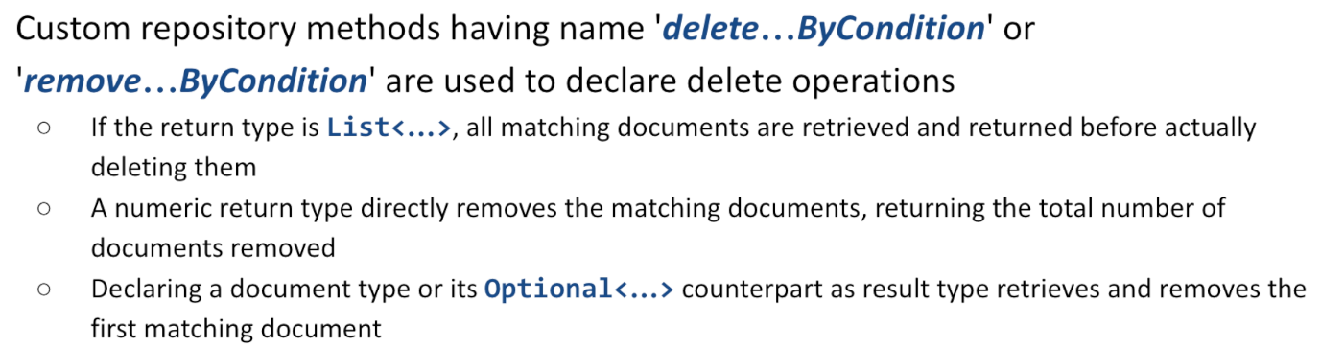Per Delete (non ne ha parlato):

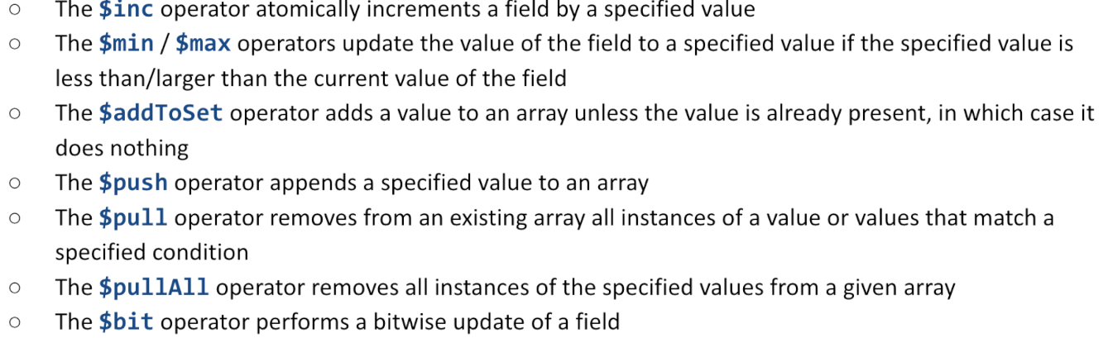SUPPORTA OPERAZIONI ATOMICHE come:

## Supporto per operazioni atomiche

## 

## Transactions

All write operations in MongoDB are **atomic** on the level of a **single document**, even if the operation modifies multiple embedded documents within it. When a single write operation modifies more than one documents, each single modification is atomic, but **the operation as a whole is not**. Starting from version 4.2, MongoDB fully supports multi-document transactions, even on replicated and sharded clusters.

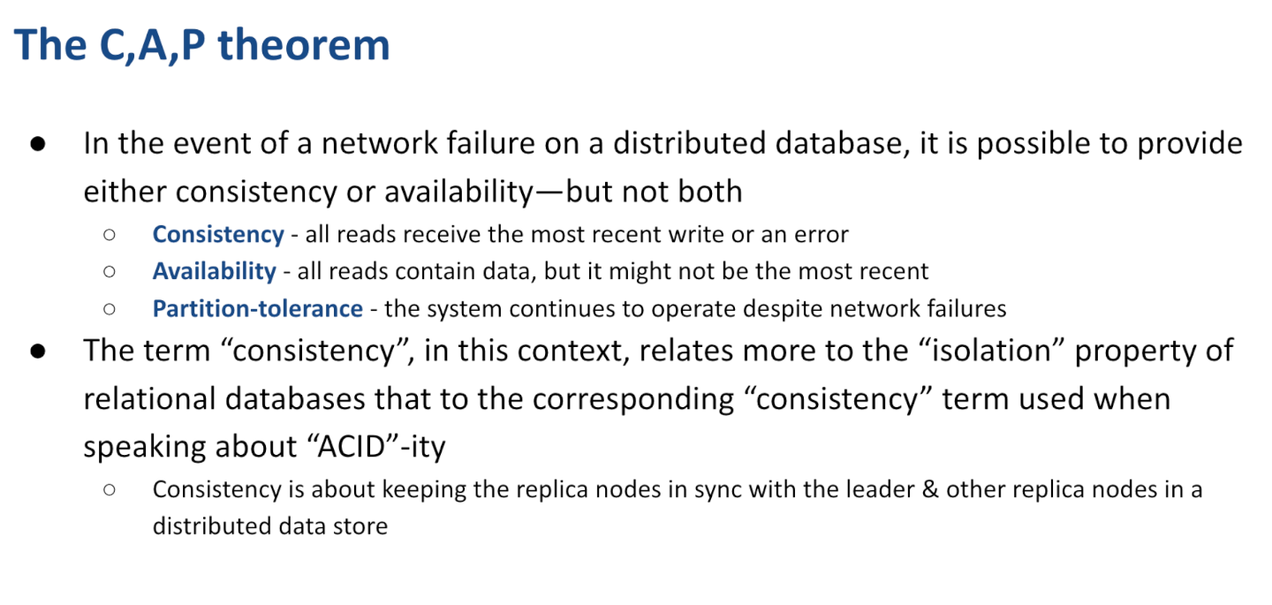

2/3 … Si scegllie uno tra consistency e availability…

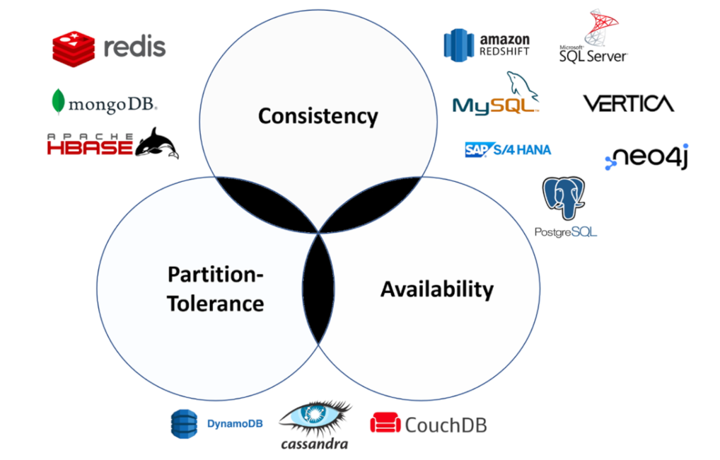

Esistono diverse fomre di consistenza, tra cui Eventual Consistency: in questo caso vuol dire che il nostro sistema prima o poi ritornerà in uno stato consistente

# **MICROSERVIZI – R37**

I microservizi portano benefici ma hanno anche degli aspetti ngativi.

* 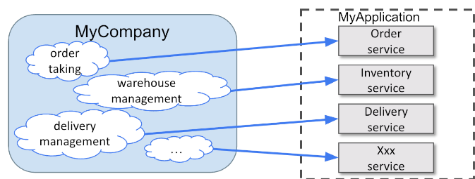Decomporre la nostra applicazione in un insieme di servizi quasi indipendenti.

I **servizi** non sono direttamenti esposti all’internet ma sono tipicamente **mascherati da un gruppo di applicazioni**

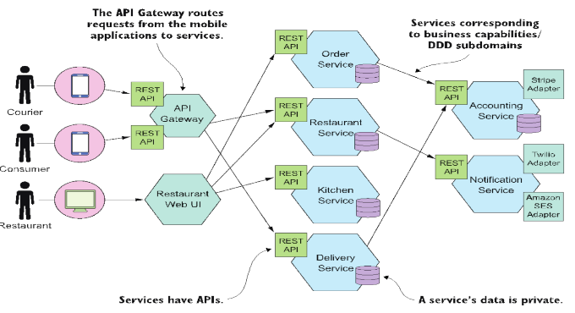

Alcuni servizi possono essere acceduti direttamente, altri sono nascosti

Come dividere le cose in un insieme di servizi?

* Domain Driven Design
* Classical Segmentation

La nostra applicazione ha:

* 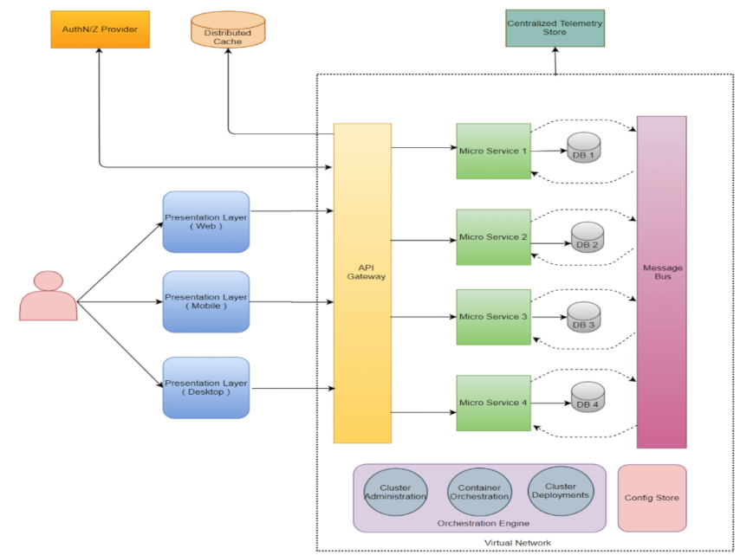**API gateway**: aperto ad internet
* **Microservices**: con db privato
  + In alcuni casi indipendenti tra loro, in altri casi hanno bisogno di comunicare tra loro e usiamo un message buffer (es: kafka)
* Codice per **amministrare cluster**
* **Servizi esterni** per authentication, authorization… (keycloak)
* Servizi esterni per cache

Un **servizio** è un componente di sviluppo indipendente

* Che offre un’interfaccia client ben definita (end-points, metodi, tipi di dati, relazioni)
  + Altri componenti possono essere definiti a loro volta partendo dalle loro funzioni
* Conforme con un dato livello di servizio

Un servizio può comportarsi da **client di altri servizi**

* Connettersi a un bus condiviso di comunicazioni quando eventi rilevanti sono pubblicati

Un servizio ha il **proprio database** per mantenere dati persistenti e replicare dati di altri servizi quando necessario

* Con dati privati
* Se due servizi devono collaborare, non accedono ai db altrui, si connettono via API

I servizi devono avere delle **caratteristiche di base**:

* Altamente testabili e manutenibili
* Poco dipendenti da altri servizi
  + Devono conoscere il meno possibile gli altri
* Sviluppabili indipendentemente da un piccolo team di sviluppo
  + Ogni servizio deve avere il proprio codice base
    - Con propria pipeline di sviluppo

**Nota**: Anche se db dei servizi sono diversi, possono essere ostati su singolo DBMS

**Nota**: **Transazioni** tra servizi diversi richiedono particolare attenzione -> conviene seguire **SAGA** pattern

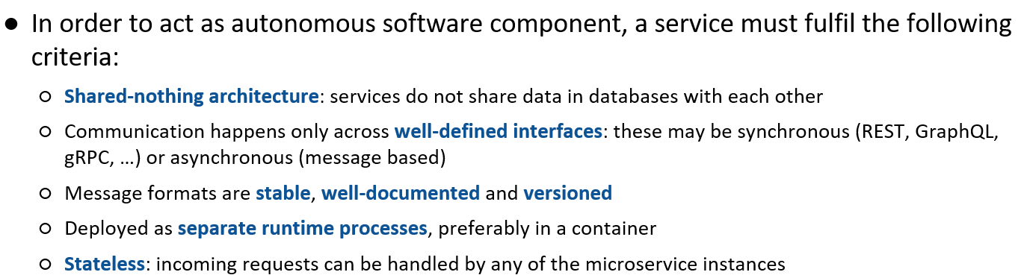

Un modo per ottenere questo è l’**architettura esagonale:**

* Business logic centrale: contiene tutte le logiche di business
* Porte per comunicare

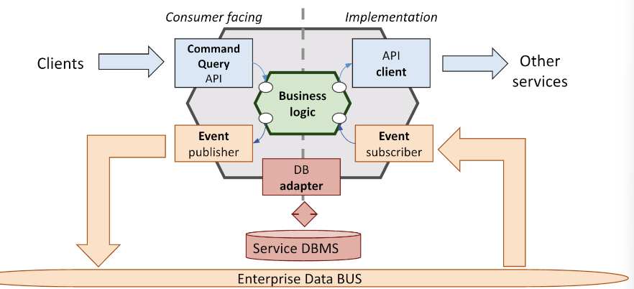

Si possono usare API attraverso semplice http oppure usando **GRAPHql** che si occupa di dividere le richieste provenienti dal client in due gruppi differenti:

* Queries: fetchano dati e non cambiano nulla
* Mutations: possono chiedere il livello che vogliono

**Command qyery API:** si prende carico di trasformare la domanda ricevuta nel linguaggio e nella forma richiesta dalla logica di business

La logica di business alcune volte generano risposte, altre volte notidficano la ricezione pubblicando un evento che può essere consumato da chiunque nell’enterprise data bus.

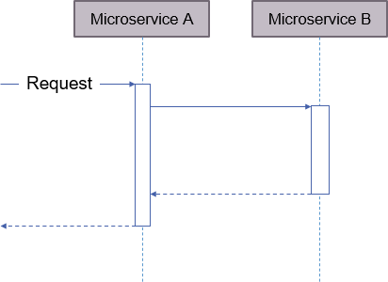

## Microservice architectures

A microservice system can be implemented according two different approaches: **synchronous** or **asynchronous**. A microservice is **synchronous** if it makes a request to other microservices while processing requests and waits for the result in order to provide a full response. It is **asynchronous**, if the incoming request only returns an indication that it was accepted/rejected, and providing a way of later informing the requester of the outcome of the operation (via events or polling)

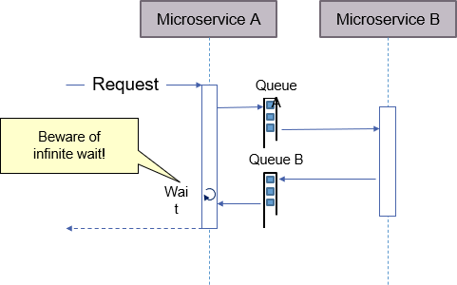

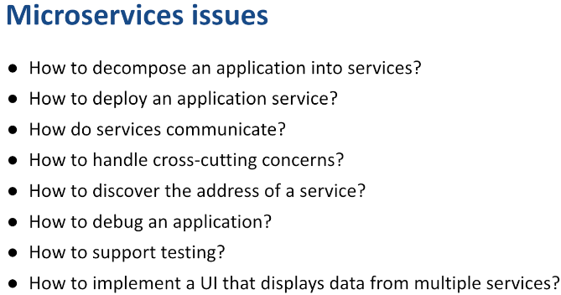

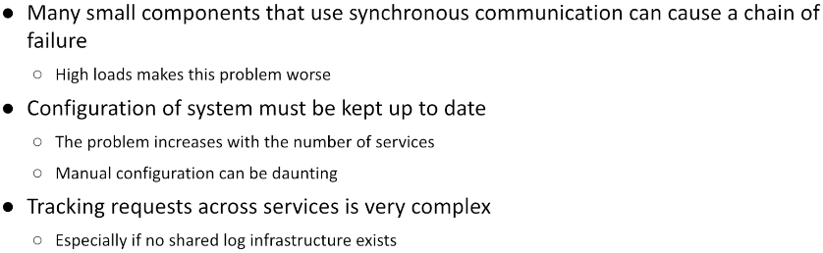

**Nota aggiuntiva: Design patterns:**

soluzione ad un problema riusabile in un particolare contesto

* Problema
* Soluzione
* Requisiti per soluzione

Patterns assume a landscape of cooperating microservices where communication can be both synchronous (via HTTP) or asynchronous (via a message broker).

## **Decomposing an application -R38**

The process that leads to defining a microservice infrastructure stems from the application requirements

* The first step requires **identifying system operations**:
  + commonly depicted as user stories that narrates how the different users of the system interact with it issuing commands or performing queries
* The second step **decomposes the system into services**:
  + organized around business concepts rather than technical ones
* The third step **determines each service's API**: a service may:
  + implement an operation by itself
  + or it might require support from other services

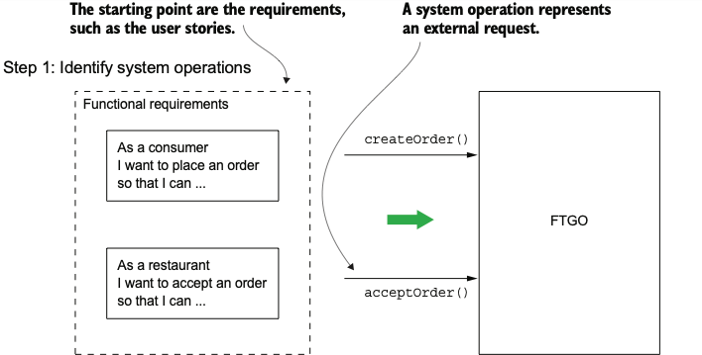

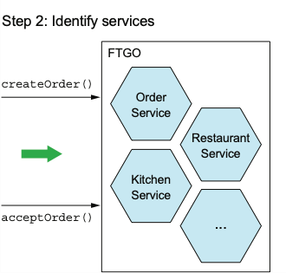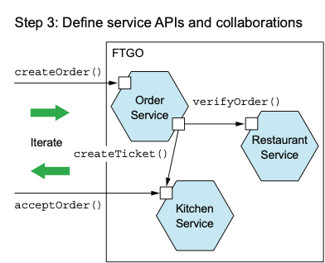

Capisco che il sistema avrà richiesta da esterno

Capisco i vari servizi e come collaborano tra loro

Scegliere questo approccio funziona quando si parte da 0, ma solitamente si parte da situazioni pre-esistenti e in uso. Per questo motivo si usa il stangler pattern.

## **The strangler pattern:**

Inizio piano: creo il pezzo più piccolo che posso deployare basandomi su quello che esiste, e così via:

* aggiungo qualcosa della parte nuova
* rimuovo qualcosa della vecchia

Questo ci da la possibilità di eseguire un cambiamento progressivo all’applicazione esistente.

The consequences of the decomposition are that a given request coming from the client may translate into **several sub-requests directed to other services** that need to be recomposed into a single response.

This introduces various operational risks:

* **Network latency** - round trip delays add up and may result in unacceptable response time
* **Reduced availability** - synchronous communication requires both parties to be alive at the same time
* **Consistency problems** - often, data managed by different services need to be updated transactionally as a consequence of a single request
* Getting consistent views of data spanning across several services contrasts decomposition

## The CQRS pattern

Sometimes, system have very different usage patterns: **few updates** that need to provide transactional guarantees (ACID) and **large number of read operations**. One possible approach is based on partitioning commands and queries:

### CQRS – Command Query Resource Segregation

### Mantengo due copie dell’informaizonie

### Master copy: salvata in database relazionale che garantisce ACID

### Usata per updates

### Contenuto di questo db viene scaricato da un secondo db dove l’informazione viene trasformata per semplificare l’operazione di lettura

### Read copy: usato per operazioni di lettura

### Tante repliche di questo db

### Se un cambiamento avviene nella master copy, la read copy viene aggiornata

### GitHub - thanhtinhpas1/ViSpeech: A Node.js CQRS and Event Sourcing Microservice Example Using Nest.js, Event Store, and Swagger

### Dunque:

* + All commands (write operations) are directed to a system that implements the business logic and updates the master data copy
  + All reads are directed to a system that operates on a slave copy of the data
  + Master and slave data set are **kept in sync by an asynchronous process** based on a **message broker.**
  + Master and slave data representation can be different:
    - Materialized views (with duplicated data) can be used in place of the normalized representation adopted in the master DBMS, if this can be convenient in providing faster responses to the clients
  + Change propagation needs to be **transactional** *(conviene usaretool come debezium)*
    - *Since master and slaves can fail independently of each other and of any infrastructural component, care must be taken to guarantee that all changes occurring to the master copy are properly (and sequentially) propagated to all the slave ones*
    - *Message exchange must guarantee* ***idempotency*** *(duplicate reception of the same message should cause no harm to the system)*

In altri casi abbiamo bisogno di gestire db servizi offerti da diverse persone.

## Approaches to transactionality

How to reliably/atomically update the database and send messages/events? If the database transaction commits messages must be sent. Conversely, if the database rolls back, the messages must not be sent. One approach is based on the **2-phase commit protocol:**

* Two messages are sent: one before writing to the DBMS, the other after it commits
* The receiver only reacts to the second one
* If the sender fails, when in resumes, it must read back sent messages, looking for begin messages not followed by the corresponding commit and re-execute the DB operation, publishing the corresponding commit event
* TROPPO LENTO

Altri approcci:

* 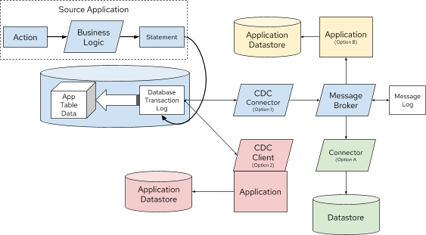**Outbox pattern:** 
  + Cambiamento sul primo db
  + Eseguo serie di cambiamenti che sono necessari
  + Salvo in un’altra tabella (sempre all’interno della stessa transazione), i cambiamenti che voglio propagare
  + Committo (outbox table viene riempita solo se tutto ok)
  + Dall’altro lato:
    - Dato che Most DBMS already offer a **stream of all write operations** performed to their data via the **Change Data Capture** (CDC) hook.
    - Gli altri db: By observing the Write- ahead transaction journal it is possible to replicate the state of the DB in several ways

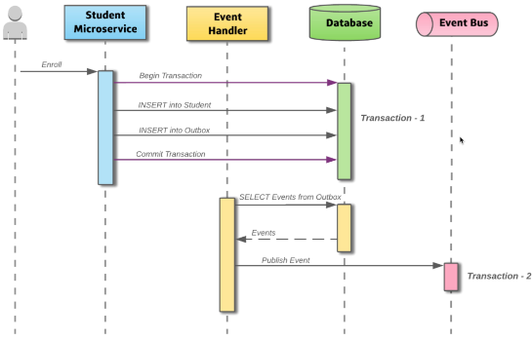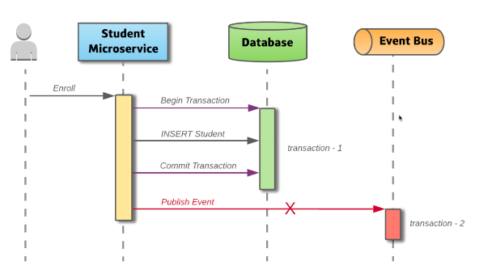

**Nota**: alla fine della transazione, non vedo nulla nell’outbox table in quanto elimino l’entità aggiunta.

* + - Tutto funziona in quanto
      * Nel log vedrò insertion e deletion, filtrando per le insertion
        + Posso reagire alle insertion e usarle per pubblicare sull’event bus
* **Sagas**
  + When a command causes a change to happen in several services, guaranteeing a transactional behavior, a saga can be implemented.
    - It consists of a **sequence of local transactions**.
    - Each local transaction updates data within a single service using the familiar ACID transaction frameworks and libraries.
    - The completion of a local transaction triggers the execution of the next local transaction.
    - In case of failure of a local transaction, the **saga is interrupted,** and a set of **compensating transactions** need to be executed to revert the transactions committed so far.

## **Implementing sagas**

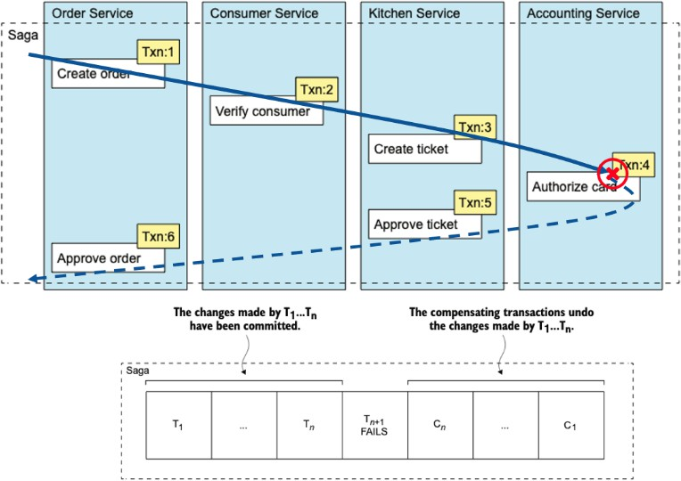Sagas can be implemented using two alternative approaches:

* **Choreography** - distributes the decision making and sequencing among the saga participants that communicate by exchanging events
* **Orchestration** - one service is responsible to act as a coordinator, sending commands to saga participants and collecting their responses

Whichever the approach, sagas requires that operations happen in a **transactional way**:

* Care must be taken to update the local database and publish the resulting event atomically
* Failure to do so will cause data loss or incoherences if a service fails abruptly when managing a message
* The transactional outbox pattern provided by Debezium helps in this case, too

